* **LO1**. demonstrate an ability to construct and present effective written and oral communication appropriate to IT practitioners
* **LO2**. analyse and criticise wider issues and problems concerning professional practice in IT
* **LO3**. evaluate the impact of information technology on individuals and organisations within our globalised world
* **LO4**. demonstrate awareness of and have gained skills in aspects of professional practice including conflict resolution, contract negotiation, team formation, leadership and team dynamics
* **LO5**. understand issues relating to ethics and professional responsibility in the IT profession and be able to analyse and resolve ethical dilemmas
* **LO6**. understand aspects of intellectual property and its protection
* **LO7**. analyse current trends in human resource management in the IT industry
* **LO8**. understand issues related to, and select approaches for managing, software testing, data security, data quality, and quality assurance in the IT industry
* **LO9**. define the use of IT in different industries
* **LO10**. describe and apply skills relating to professional practice in IT project management
* **LO11**. select and apply investigative research methods, models and tools to IT professional practice; identify and critique changing information on the area of interest; and interpret the potential validity of results

**Week 1 Nature of Industry** **3**

A1.1. The Changing Role Of IT In The Future Of Business 3

A1.2. 2020-2029 timeline contents 4

A1.3. 17 ways technology could change the world by 2025 4

**Week 2 People and Teams** **4**

A2.1. The different models of project teams in project management 5

A2.2. Forming project teams – the right mix is key to success 5

A2.3. Team Building in Project Management 6

A2.4. 5 Stages of a Team Development Tuckman | Better Explained 8

A2.5. Project Success and Failure: Factors that make for Project Success or Failure 10

A2.6. Top 10 Reasons Why Projects Fail 11

A2.7. Critical success factors in project management. To fail or not to fail, that is the question! 13

**Week 3 IT Lifecycles** **18**

A3.1. Information Technology and Business Alignment: Why it is Important 18

A3.2. Waterfall vs. Incremental vs. Spiral vs. Rad Model: Key Difference 20

A3.3. Top 6 software development models and how they influence the SDLC 21

A3.4. The Ultimate Guide to...IT Project Management 27

A3.5. IT Project Management 28

A4.1. What are sources? 30

A4.2. Primary Research vs Secondary Research: Definitions, Differences, and Examples 31

A4.3. Step-by-Step Guide & Research Rescue: Evaluating Credibility 33

A4.4. Why and how to use sources 34

A4.5. External Analysis Research 35

**Week 5 Project Data** **36**

A5.1. The Ultimate Guide to Project Tracking 36

A5.2. Six Reasons Why Research Is Important 39

A5.3. Differences Between Qualitative and Quantitative Research Methods 41

A5.4. Research Methods: What are research methods? 42

A5.5. The benefits of business analytics 43

**Week 6 Project Scoping** **44**

A6.1. What is project scope? Defining and outlining project success 44

A6.2. 6 Successful Project Estimation Techniques in 2021 46

A6.3. <SKIM>Project Estimating - Analogous, Bottom-up, Parametric, three point 47

A6.4. <SKIM>Project failure--12 mistakes to avoid 50

A6.5. Why do projects really fail? 55

**Week 7 Quality Assurance/Risk** **56**

A7.1. The Difference Between Quality Assurance and Quality Control 56

A7.2. Difference Between Quality Assurance And Quality Control (QA Vs QC) 58

A7.3. What is Auditing? 60

A7.4. IT risk management -1 63

A7.5. IT risk management -2 63

A7.6. IT risk management -3 64

**Week 8 Testing Management** **65**

A8.1. How much Testing is Enough? 65

A8.2. The different types of Software Testing 67

A8.3. QA Roles and Responsibilities: Who Do You Need on Your Software Testing Team? 69

A8.4. Types of Software Testing 69

A8.5. Seven Principles of Testing 71

**Week 9 Security Management** **71**

A9.1. Cyber Security: How You Can Protect Your Company’s Assets with a Few Simple Steps 71

A9.2. Data Security 101: Understanding the Crisis of Data Breaches, and Best Practices to Keep Your Organization's Data Secure 74

A9.3. The 15 Most Common Types of Cyber Attacks 75

A9.4. Security Incidents: Types of Attacks and Triage Options 77

A9.5. Cyber Security Threats and Attacks: All You Need to Know 79

A9.6. Top 5 Most Common Incident Response Scenarios 83

**Week 10 Communication** **86**

A10.1. What Is Effective Written Communication? 86

A10.2. Essential Skills for Written Communication 87

A10.3. Practical guide to effective written communication 88

A10.4. Seven C’s of Effective Communication 92

**Week 11 Ethics & Regulation** **93**

A11.1. Different types of Ethical Theories 93

A11.2. Ethics in the workplace - making them work 96

A11.3. Personal Ethics: What They Are and Why They're Important 97

A11.4. Differences and Similarities in Personal and Professional Ethics 99

A11.5. Code of Ethics 100

**Week 12 Decision Making** **101**

A12.1. Decision Making Process 101

A12.2. An Overview of Decision-Making Models 102

A12.3. The different decision making models you need to know – and their pros and cons 107

A12.4. Problem Solving and Decision Making (Solving Problems and Making Decisions) 109

A12.5. Important Decision-Making Skills That Employers Value 112

A12.6. 5 decision-making models to try if you’re stuck 116

# Week 1 Nature of Industry

## A1.1. The Changing Role Of IT In The Future Of Business

The way we approach business is changing. As we continually pivot to keep pace with rapidly evolving technology, individual departments within an organization are becoming as agile as the larger companies themselves. IT departments are experiencing tremendous changes as their roles expand to impact customer service, sales, and even business strategies. As a result, organizations are increasingly turning IT into a driving force in all aspects of business.

**Become Leaders, Not Supporters**

One thing to understand when managing the growing pains of IT is that it’s no longer the work of a single department. Research from Accenture found that 34% of companies [see the IT department](https://www.forbes.com/sites/danielnewman/2016/alhummel/AppData/Local/Temp/CCA_TalkingTree_4.28.docx) as the main driver of innovation, which is down from 71% two years ago. I see the reason for this as a change in IT infrastructure itself. The modern IT worker is a tech-savvy innovator who creates change across the organization’s entirety, not just a single department. As employees create change across all levels of an organization, the new face of IT defies boundaries.

IT workers aren’t just facilitating business goals; they’re driving change at an organizational level. CEOs are leaning on IT to deliver a competitive advantage as much as they do for a marketing strategy. It seems to me that this shift is directly related to “The Internet of Everything” movement, which refers to the near future in which nearly every aspect of our lives will be connected to the Internet. Since our reliance on technology increases with each passing day, IT is steadily moving to the front end—not the back—of business.

**Demand An Evolved IT Skillset**

The IT world is experiencing a need for upskilling in its employees, especially as the role of IT continues to evolve into a more interdisciplinary field. Machines are becoming increasingly intelligent, so we need to train our employees working alongside them to remain agile.

Just as workers across the enterprise must become more tech-savvy, workers in the IT department must understand the nuances of marketing. CIOs must increasingly hire employees with business acumen, not just good technology support skills. Enterprises will need to adjust in response to a changing talent ecosystem.

**Renovate The Workforce**

A few months ago, I expressed every brand’s need for [continuity among marketing, sales and customer service](http://www.v3b.com/2016/03/brands-need-continuity-marketing-sales-customer-service/). It’s clear that IT has a finger or two in all these pies. For a company to embrace these connections, it must see IT not as the lone geek pack, but rather as a field that supports the ebb and flow of business.

IT departments are now the linchpin of agile organizations. Their influence is spreading within the organization, and CIOs must transform the workforce along with it. Consider how you’ll construct a workforce and culture that drives innovation, as well as one that will facilitate the customer experience and encourage business growth. It seems like a tall order, but CIOs are confronted with these issues as the world around us becomes smarter. As CEOs realize their role in successfully launching new products, I believe we’ll rely on IT with increasing frequency.

Sourcing so-called “jack-of-all-trade” talent for the new business ecosystem is one thing, but CIOs must also consider legacy systems as they relate to company goals. Reskilling existing teams will be necessary to maintain agility, so it’s important to construct a team of employees who can handle the peaks and valleys of business.

This all sounds easier said than done, but there’s one prevailing attitude in business that will never change: adapt or fail. Current employees must be on board with the changing face of IT in business, while new talent should enter a role with clear expectations. It’s the CIO’s role to facilitate these processes by reskilling legacy processes and seeking out adaptable talent. Collaboration with the CMO and CEO will also be key in identifying and addressing skill gaps.

Technology is constantly evolving, and we’re at a juncture in which IT drives operations at every level of an organization. Changing the old model of IT as a separate entity into a breathing part of the business will mean a thriving enterprise—and one that runs smoothly.

## A1.2. 2020-2029 timeline contents

<https://www.futuretimeline.net/21stcentury/2020-2029.htm>

## A1.3. 17 ways technology could change the world by 2025

<https://www.weforum.org/agenda/2020/06/17-predictions-for-our-world-in-2025/>

1. **AI-optimized manufacturing**
2. **A far-reaching energy transformation**

**3. A new era of computing**

**4. Healthcare paradigm shift to prevention through diet**

**5. 5G will enhance the global economy and save lives**

**6. A new normal in managing cancer**

**7. Robotic retail**

**8. A blurring of physical and virtual spaces**

**9. Putting individuals - not institutions - at the heart of healthcare**

**10. The future of construction has already begun**

**11. Gigaton-scale CO2 removal will help to reverse climate change**

**12. A new era in medicine**

**13. Closing the wealth gap**

**14. A clean energy revolution supported by digital twins**

**15. Understanding the microscopic secrets hidden on surfaces**

**16. Machine learning and AI expedite decarbonization in carbon-heavy industries**

**17. Privacy is pervasive – and prioritized**

# Week 2 People and Teams

## A2.1. The different models of project teams in project management

When embarking on a new project, one vital aspect to consider is the project teams who will be taking on the work. There is no one correct or right team structure that applies to all project teams. As with the nature of projects, project teams vary from project to project. This can depend on many factors, including what resourcing is available as well as what the project deliverables are. What remains common in building a project team is the goal of successful project completion with an effective group of people.

**The basics of project teams:**

A project team’s make-up is generally dictated by the specifics of the project, and the organization’s structure. Depending on the organization, project teams may align closely with functional teams, or they may be more project-based. Three organizational structures that affect project teams are:

* **Functional organizational structure:** teams are based on specialized functions, giving project managers less power and control as functional team leads are the ultimate authorities (e.g. Marketing, Development, Sales).
* **Project organizational structure:** teams are created based on the project’s needs, and the project manager has ultimate authority (e.g. large construction projects).
* **Matrix organizational structure:** team members work in functional roles as well as project-based roles, and responsibilities are shared between project managers and functional leads.

These organizational structures depend largely on the size of the company, but aside from that factor, there is no definitive guide to which structure is “right” or proper; it depends on the organization itself. In any of the three cases, it’s clear that someone must take on the role of lead, to be accountable for the project, whether it’s a project manager, functional lead, or both. Aside from this crucial role, the team’s structure can be functional in nature, or project-based. In the case that the project team is quite large, there may be sub-teams for functional pieces or sub-modules of a project. For each of these sub-teams, there may be a lead who deals directly with the project lead, or perhaps the project lead themselves manages each of the sub-teams. One factor that affects project team make-up is whether or not there is an offshore or virtual team, as that group will need to have their own dedicated lead to liaison with the rest of the team.

**The higher echelons:**

In terms of project management itself, the concepts of team structure also apply. In some organizations, there may be a team of project managers that steps in and manages projects that span across functional groups. This team of project managers is usually led by a senior project manager who oversees and manages which members of their team are available to manage various projects that are taking place throughout the organization. There might also be project managers who specialize in leading projects that are more technical in nature or focused around a certain methodology, like Scrum or Agile. At smaller companies, project managers may also find themselves in multiple roles, blurring the lines between positions and structure on a team. These are all things to be aware of when forming project teams.

## A2.2. Forming project teams – the right mix is key to success

It is well known, that teamwork is essential for projects. Many research papers, books and standards (like the IPMA ICB) highlight this fact. Bruce Tuckman´s stages of team development – forming, storming, norming, performing and adjourning – are well known in the community and explained in nearly all project management trainings. However, little attention has been paid so far to the team composition. Whilst observing teams in real life we often recognise that they are basically formed with people from the functional department being available at the moment of the request. It would be merely coincidence that those people fit together. The project manager may form them throughout the project lifecycle to a performing team. Nevertheless, it is more likely that they underperform or stall.

Another problem is, that project managers often do not know which people they need for their project. A team is a social system, which builds on a “good” match of motivation, competences and interactions of its constituents parts, like an orchestra. If one person does not fit, the whole team will most likely underperform. Thus, the project manager needs to analyse the project tasks and derive key requirements for all team members. It does not necessarily need to be a “perfect” team, all three, the motivation, competences and interactions could be developed along the project lifecycle. This is the main leadership task of a project manager, but also the team itself can help individual members and the interactions between them to grow. It is the self-organisation of the team that helps to overcome some deficiencies of the original team composition. However, if the basic requirements of the team members are not fulfilled, the “healing forces” of self-organisation and leadership might not be enough for a successful completion of the project.

**How to reach the right mix of a project team?** This is a joint effort of three parties involved: *1. the project manager, analysing the project with its requirements regarding people and developing the team systematically along Tuckman´s five stages.*

*2. the project sponsor, ensuring the deployment of the “right” team members from the functional departments in order to help the project to succeed, and*

*3. the project team members themselves, performing assigned tasks in the best possible way through motivation, competences and interaction.*

The right mixture of people can be seen from various perspectives, one could be the mixture of competences available, e.g. in an investment project the mix of technical, commercial, legal and / or social competences to realize the investment in the best possible way. Or it could be a team mixture of people with high motivation that keep the team spirit up, some others being selected due to specific competences needed to perform the project and finally, some people that are instrumental for the interactions in the team or from the team towards other parties. Additionally, a good mixture of people may also build on other criteria, such as age, gender, cultural background, personalities and disciplines. There is enough evidence through research that diversity of the team helps to be more innovative and to overcome challenging situations in projects. **Thus, the focus of the project manager (together with the sponsor) should be on forming project teams with a mixture that allows the team to dynamically grow throughout the project lifecycle and successfully achieve what is expected from them.**

## A2.3. Team Building in Project Management

**Suggestions For Handling The Newly Formed Team**

A major problem faced by many project leaders is managing the anxiety which usually develops when a new team is first formed. This anxiety experienced by team members is normal and predictable. It is a barrier, however, to getting the team quickly focused on the task. In other words, if team members are suffering from anxiety, their attention consciously or subconsciously will be focused on the resolution of their own anxieties rather than on the needs of the project.

This anxiety may come from several sources. For example, if the team members have never worked with the project leader, the team members may be concerned about his leadership style and its effect on them. In a different vein, some team members may be concerned about the nature of the project and whether it will match their professional interests and capabilities. Other team members may be concerned whether the project will be helpful or a hindrance to their career aspirations. Our experience indicates that team members can also be highly anxious about lifestyle/work-style disruptions which the project may bring. As one project manager recently remarked to one of the authors:

Moving a team member's desk from one side of the room to the other can sometimes be just about as traumatic as moving someone from Chicago to Manila to build a power plant.

As the quote suggests, seemingly minor changes can result in unanticipated anxiety among team members.

Another common concern among newly formed teams is whether or not there will be an equitable distribution of the work load among team members and whether each member is capable of pulling his/her weight. In some newly formed teams, team members not only might have to do their own work but they also must train other team members. Within reason this is bearable, necessary and often expected. However, when it becomes excessive, anxiety increases and morale can fall.

We've found that certain steps taken early in the life of a team can pay handsome dividends in terms of handling the above problems. First, we recommend that the project leader at the start of the project talk with each team member on a one-to-one basis about the following:

1. What the objectives are for the project.

2. Who will be involved and why.

3. Importance of the project to the overall organization or work unit.

4. Why the team member was selected and assigned to the project. What role will he/she perform.

5. What rewards might be forthcoming if the project is successfully completed.

6. A candid appraisal of the problems and constraints which are likely to be encountered.

7. What are the rules-of-the-road which will be followed in managing the project, e.g., regular status review meetings.

8. What suggestions does the team member have for achieving success.

9. What are the professional interests of the team member.

10. The challenge the project is likely to provide to individual members and the entire team.

11. Why the team concept is so important to project management success and how it should work.

A frank, open discussion with each team member on the above is likely to reduce his/her initial anxiety. As a consequence, the team member is likely to be more attentive to the needs of the project. Of course, the opposite reaction is possible, too. A frank discussion, for example, may actually increase a team member's anxiety level. Often, however, the source of the anxiety can be identified and dealt with in a timely manner.

The importance of dealing with these anxieties and helping team members feel that they are an integral part of the team can result in rich dividends. First, as noted in Figure 1, the more effective the project leader is in developing a feeling of team membership, the higher the quality of information which is likely to be contributed by team members. Team members will not be reluctant to openly share their ideas and approaches. By contrast, when a team member does not feel like part of the team and does not believe he/she can trust others in team deliberations, information will not be shared willingly or openly. One project leader emphasized this point as follows:

There's nothing worse than being on a team when no one trusts anyone else.. .Such situations lead to gamesmanship and a lot of watching what you say because you don't want your own words to bounce back in your face...

Second, the greater the feeling of team membership and the better the information exchange (flow) among team members, the more likely the team will be able to develop effective decision-making processes. The reason is that the team members feel committed to the project and they feel free to share their information and develop effective problem-solving approaches. Third, the team is likely to develop more effective project control procedures. Project control procedures can be divided into two basic areas. The first is the quantitative control procedures traditionally used to monitor project performance, e.g., PERT/CPM, networking, workbreakdown structures, etc. The second “control procedure” (and perhaps the most important) is the willingness and ability of project team members to give feedback to each other regarding performance. Again, trust among the project team members makes the feedback process easier and more effective. Without a high level of trust, project personnel are often reluctant to give negative or constructive feedback to fellow team members.

**Figure 1**  
Team Building Outcomes

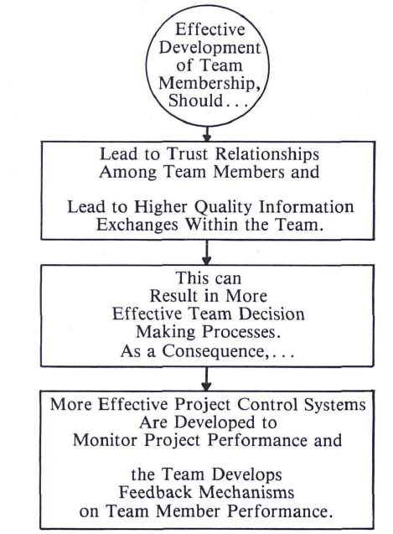

## A2.4. 5 Stages of a Team Development Tuckman | Better Explained

Dr. Bruce W. Tuckman, a psychologist at Ohio State University, published a theory in 1965 called ‘Tuckman’s Stages of Group Development.’

Initially, it was a 4-stage model, Forming, Storming, Norming, and Performing, but later in 1977, a fifth stage of Adjourning was included by Mary Ann Jensen and Dr. Bruce Tuckman, both jointly worked on the last stage. It is also known as the Tuckman ladder model.

As you know, a [project](https://project.pm/) has a definite start and a definite end. It means the same will happen to every [stakeholder of the project](https://project.pm/project-stakeholders/).

**5 Stages of Team Development**

Most of the teams follow these stages on the way to deliver high performance. These stages start when a group first meets and are then separated as the project ends.

Let jump in straight to see the five stages and have a brief discussion on;

1. Forming
2. Storming
3. Norming
4. Performing
5. Adjourning

I will try to explain these 5 stages by a graph to get a simple way to get into your memory.

**Team Development Process**

Let’s have a graphical representation of this process with time and team effectiveness point of view on any project;

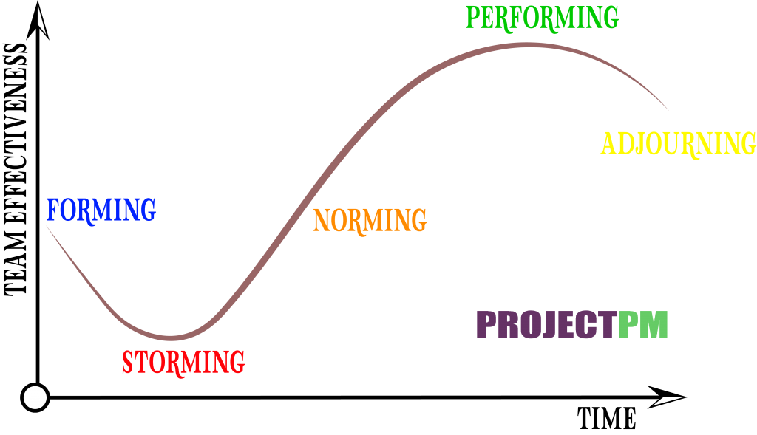

You can see clearly that effectiveness is almost the same for the Forming & Adjourning stage but is way down in storming. As a [project manager](https://project.pm/how-to-become-a-project-manager/), your primary task is to handle this stage effectively than other stages.

Let’s see these stages one by one now;

**Forming Stage**

Here, in this stage, team members meet for the first time.

Team members are

* Positive
* Polite
* Anxious
* Excited

In this stage, the team members are like independent entities; no bond with others, and responsibilities are clear. Your role as a leader is to make efforts and let them mingle and introduce with frequent meetings.

**Storming Stage**

As you can on the above graph, any team’s effectiveness is drastically dropped in this storming stage. The named storm is justified here. Storming is the stage where most teams fail. As a leader, make sure to discuss the below in meetings

* Each Member’s skills
* Background
* Interests
* Set Ground Rules

Team members are not able to understand, and the following factors play an important role and hence need to understand correctly;

**Boundaries –** Members start to push against the established informing stage

**Workload –** Each Member think I am only working the most

**Working styles –** Each Member has their own natural style. This can cause unforeseen issues and may frustrate other members.

**How to Handle Storming Stage**

Set proper ground rules to follow as soon as possible. Team members can challenge your authority – show them the Project charter. Define the responsibilities clearly with proper authority for everyone. This will reduce the chaos among all. Some members may resist taking a task that is not clearly defined in their domain; hence make sure to identify and assign to a related one as soon as possible.

**Norming Stage**

In the above graph, this is the stage where team effectiveness should go up exponentially. If not, then you are in big trouble for successful completion.

In this stage, the behavior of team members completely changed;

* They appreciate each other’s strengths.
* They socialize together
* They ask one another for help.
* They provide constructive feedback.
* They develop a more substantial commitment to the project objectives.
* As a team leader, you observe more respect in your authority. Also, you start to make good progress towards set goals.

You may often see a prolonged overlap between storming and norming because new tasks come up. And the team may go back into the storming stage. Sit and help the members take responsibility for the goal.

**Performing Stage**

You will see the maximum possible effects on your team at this stage. All the issues are resolved, and the team is fully involved in the project goals and organizational objectives.

Here, you will see the fruit of your efforts in making that structure. Work leads without friction, no resistance.

In the performing stage, you feel easy to be part of the team, and you can easily accommodate new people and makes no difference if some leave at this stage.

Now, you can start to focus on other goals and areas of work.

**Adjourning Stage**

This is the sad part and is the reality of project life that ends – a definite end. The team you have developed was only for a fixed period of time. I have seen permanent teams are disbanded as per organizational structures. Most of the people here need to find new opportunities, or else they need to merge on a new existing team.

You can say it is the emotional part as a bond is going to be broken. The working relationship one has developed is going to end. Hard times friends are gone, and the future is uncertain.

But!

Being a leader always takes the time to appreciate and must celebrate the team’s achievements.  You can find them again or retain them if possible. It is rather easy to work still with people you have already been involved in earlier.

This Tuckman model has many questions on a [PMP Exam.](https://project.pm/pmp-certification-requirements/)

**Final Words**

If you are still looking at handling the new Member in the existing team, you need to review that you got a member at which stage. If you get a membership at the performing stage, it may affect an overall team, but if you got in the storming phase, then it is the issue. The same is the case if anyone leaves the project depends on which stage you are in. Always make sure to establish processes and structures, earn trust, and build relationships, resolve conflicts.

## A2.5. Project Success and Failure: Factors that make for Project Success or Failure

**Fundamentals**

1. The management should recognize that project mgt authority conflicts exist and have to be resolved.

2. Match right people and right jobs.

3. Allow adequate time and effort for layouts. Project groundwork and work definition.

                     Work breakdown structure

                      New Work Planning

 4. Ensure that work packages are the proper size.

                      Manageable in size

                      Realistic in terms of effort and time

 5. Establish and use planning and control systems to

                      Know where you are going

                      Know when you have gotten there

6. Be sure information flow is realistic communication pitfalls are a large contributor to project difficulties.

7. Be willing to replan and do Change in inevitable

8. Tie together responsibility, performance and rewards

                      (key to motivation)

9. Long before project end, plan for its end with managers to

a.       Disposition of personnel

b.      Disposition of resources

c.       Transfer of knowledge (records)

d.      Close out of workorders

e.       Final payments

**GENERALLY DESIRABLE**

1. That project manager has right to select key project members
2. That key members have a proven track record in their fields
3. A sense of mission and commitment is present
4. Good relationship is maintained between clients, team members, top mgt
5. Have key members involved in decision making and problem solving
6. Have backup strategies to deal with possible problems
7. Have an appropriate structure in place

(Flat & Flexible)

1. That project manager goes beyond formal authority to influence his teams actions and decisions being made
2. Stress the importance Of meeting the goals
3. Keep changes under control
4. Project manager ensures job security and acts as a buffer for effective project team members.
5. Avoid overoptimism

**SOME MAJOR CAUSES OF PROJECT FAILURE**

1.      Doing a project that does not have a sound basis, forcing a change when time is not appropriate

1. Selecting the wrong person as project manager not a doer
2. Unsupportive Top Mgr.
3. Inadequately defined tasks (Overlap, not adequately, wrongly assigned, etc.)

Poor estimating

1. An adequate planning and control system in place to maintain proper balance between cost, schedule and technical performance
2. Doing more than is required by contract
3. Project termination not formally planned so that its impact is not defined

## A2.6. Top 10 Reasons Why Projects Fail

As a project management consultant at JPStewart Associates, I have discovered that many projects fail outright. And further, that many of these failures occur for the same reasons. So I have compiled a list of 10 reasons why projects fail, largely from my own experience.

I’ve also tried to share some ideas about how each of these problems can be overcome. Read on to see how defining clear objectives, undertaking commonsense project planning, exercising good leadership skills, and setting reasonable goals can turn project failure can be turned into project success.

**Top 10 Reasons Why Projects Fail**

**1. Scope Creep**

Project scope is everything that you are going to do and conversely, not going to do. So once you’ve defined the objectives of project work, usually via a Work Breakdown Structure, you need to freeze it and zealously guard against unplanned changes.

Notably, project plan changes initiated via a change management board are ok, since then the project management professional can issue a new schedule, conduct risk estimation, and budget plan around new objectives as needed. Otherwise, you will surely miss your target deliverables, and the scope creep will lead to project failure, making both the team and customer unhappy.

**Read more:** [The Discovery Phase: Is It Important?](https://project-management.com/importance-of-discovery-or-requirement-analysis-phase/)

**2. Overallocated Resources**

Going hand in hand with scope creep, often there are too few resources working on too many failed projects at the same time. In conjunction with that, many managers don’t seem to have a grip on what their resources are doing all the time.

Project team members are left to figure out for themselves what projects they should be working on and when. It’s better for managers to meet weekly to discuss resource usage, perhaps using project management software to stay on track.

**3. Poor Communication**

Many team members on a project will know the project manager only through their (often poor)communication. Teams will know them by how their voice comes across over the Zoom call, or by how well-written their emails are.

By striving to define unclear objectives and communicate goals and processes to teams, the project manager strengthens team collaboration. If the project manager, and other organization leadership, are not [clear, unambiguous communicators](https://project-management.com/organizational-communication-project-management-software/), then chaos, confusion, and failure will ensue.

**4. Bad Stakeholder Management**

Stakeholders and company leadsership have a vested interest in the project — for the good or ill of the project. It is the project manager’s job to not only identify all stakeholders, but know how to manage and communicate with them in a timely fashion. This is why developing a communication plan is an integral part of avoiding project management failure.

**Read more:** [Why Is Executive Involvement in Projects so Important?](https://project-management.com/why-is-executive-involvement-in-projects-so-important/)

**5. Unreliable Estimates**

Project managers rely on work estimates in their planning, but estimates are very often just guesstimates by project team members who are trying to calculate duration of tasks based on [how long it took them last time](https://www.developer.com/project-management/the-importance-of-post-project-reviews/).

This may turn out to be totally accurate or may be completely wrong. If they’re wrong, poor estimation leads to a flawed schedule, unachievable objectives, and increased risk — and ultimately, project failure. Historical records kept between projects help project teams to refine their goals.

**6. No Risk Management**

Every project is unique and hence, project management is full of uncertainty. When we try to qualify and quantify that uncertainty, we call it risk. It is incumbent upon the project manager to proactively anticipate things that might go wrong; this is why proper [risk management](https://project-management.com/risk-management-software/) leads to success.

Once they have identified risks, then the project manager and the team can decide during project planning on how to mitigate and avoid those specific risks, should they occur.

**Read more:** [Best Risk Management Software for 2021](https://project-management.com/risk-management-software/)

**7. Unsupported Project Culture**

I was once asked to consult for a company and discovered that a complex project was being handled by an untrained secretary using 20 Excel spreadsheets.

In this case of project failure, project sponsors and leadership clearly did not fully understand what it took to manage a project — either in project management software or using trained personnel. This form of failure is not easily solvable, because it requires education of senior management and a [cultural shift](https://www.techrepublic.com/article/3-primary-ways-project-teams-are-changing/).

**8. The Accidental Project Manager**

This is similar to, but not exactly the same as unsupported project culture. In this instance of project failure, what typically happens is that a technical person (software developer, chemist, etc.) succeeds at the job.

Based on that success, this person gets promoted to project manager and is asked to manage technical projects. The problem is they often don’t get training in project management, and may well lack the social and leadership skills the job calls for. And so they flounder and often fail despite previous successes.

This is not to say that only certified PMPs can be good project managers, but training is essential. At the very least, all new PMs should be familiar with setting accurate project goals and objectives, developing project schedules, people management, and proper project implementation. And they should first be assigned small projects to better hone their skills.

**Read more:** [Creative Projects vs Technical Projects: What They Are, and How to Run Them](https://project-management.com/creative-projects-vs-technical-projects/)

**9. Lack of Team Planning Sessions**

This failure scenario is easily avoided, as there is no more effective way to kick off a project than to have the entire team come together for a planning session. This enables everyone to not only work together on project artifacts — such as project schedules and WBS — but also to develop teamwork and buy into the project management process.

**10. Monitoring and Controlling**

Many project managers will create a schedule and never (or rarely) update it. Or if they do, they’ll just fill in percent done, which is an arbitrary number often picked out of the air by team members.

It’s no surprise, then, when missed deadlines are rampant and projects fail. Avoid this failure by recording project management actuals, such as date started, work accomplished, and estimate of remaining work. This is another area where project management software is a lifesaver.

**Read more:** [10 Must-Have Project Management Skills New PMs Overlook](https://project-management.com/top-8-overlooked-project-management-skills/)

**Project Management Software Can Help**

Using project management software to manage communication, task management, and scheduling will keep managers and team members on top of each phase of a project. Easy access to collaboration tools and dynamic task updates, as well as organized resource allocation, are just some of the benefits that one of the following tools can provide.

Though project management software does not remove the possibility of project failure, it helps teams to proactively prepare for each successful project, and eliminates some of the reasons why projects fail.

## A2.7. Critical success factors in project management. To fail or not to fail, that is the question!

Spalek, S. (2005). Critical success factors in project management. To fail or not to fail, that is the question! Paper presented at PMI® Global Congress 2005—EMEA, Edinburgh, Scotland. Newtown Square, PA: Project Management Institute.

**Abstract**

Why do some project fail and some succeed? What went wrong? What are the key factors for the result of a project? These questions are asked by professionals dealing with projects thousands of times per year globally. To answer some of these questions research was carried out with a group of experts on factors influencing the project management process and identification of critical success factors.

Based on the research, out of the sixty one factors influencing project management process, fifty four were identified as significantly influencing the project management process. These factors were grouped, based on assumptions in the paper's classifications as having: substantial, large, medium, small and negligible influences on the success of the project.

Based on the assumed factors classification the critical success factors were determined within a group of factors having substantial influence on the success of the project.

**Introduction**

Every Project Manager would like to run a project that finishes with success but only the minority do in reality. According to Standish Group (2003) the majority of projects (67 % in 2002) run out of budget or time significantly. Why does it happen? What are the reasons that a project could fail? Are there any factors that could influence the project management process and as result lead to the project success or failure? To determine these factors a group of Project Managers was asked to review their realised projects and point out the factors that had influence on the project success and failure.

**Experts Research**

A research poll was done throughout the Project Managers (as Experts) having at least five years of experience and having completed at least three projects. The poll was based on the questionnaire placed on the Web site and covered the following areas:

* - project integration,
* - project scope,
* - project communication,
* - staff fluctuation,
* - project schedule,
* - project budget,
* - project resources,
* - reporting and monitoring the project,
* - resistance to the project,
* - project context.

**The survey method**

82 experts were invited to participate in the research as experts. The questionnaire was divided into three parts. In the **first part** Project Managers were asked to rank the factors on the scale from “-3” to “+3” the influence of a given factor on the project success or failure (Exhibit 1), where “-3” means strong influence on the project failure and “+3” means strong influence on the project success. The factors presented to the project managers were grouped into 10 already mentioned areas and the total number of factors were 61.

**The second part** was to collect the information about the knowledge and experience of the Project Managers have and how they acquire it.

**The third** part was to collect the information about the project realised by Project Managers in terms of type, budget and time.

The total number of questions was 205.

To fulfil the purpose of this paper the results of the first part of research are presented and discussed in this paper.

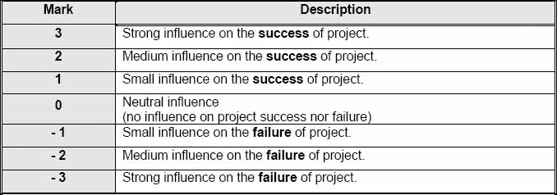

Exhibit 1. Assumed scale of marks for the factors influence to the project success or failure.

**Research Description**

All the experts taking part in the research know at least one project management methodology. The biggest number (83%) knew PMBOK as described by Project Management Institute (PMI®). The next best known was PRINCE 2 (41%). After this 32% were methods and technique worked out by the companies themselves.

The PM experts found out about formal methodology during their work (61%). They acquired the knowledge from the professional press and books (43%), during the training and courses (10%) and dedicated studies (6%).

All the experts with different areas of knowledge of methodology in their work are conceptualised in Exhibit 2.

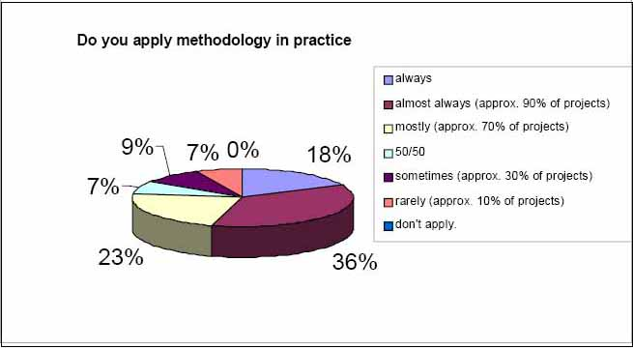

Exhibit 2 – Structure of the application of the project management methodology in experts work

The experience of the experts on the project management field was as follows: working with projects on average for 9 years (median: 7 years); planned on average 21 projects (median: 10), completed on average 20 projects (median:14), with average budget of 2 million $ (median: 150 thousand $) and average project team of 10 people (median: 8).

The majority (80%) of the researched experts managed:

* Project Scope.
* Project Resources.
* Project Budget.
* Project Communication.
* Project Time.

Only 50 % of experts managed in practice:

* Project Integration.
* Project Risk.
* Project Quality.
* Project Procurement.

**Results presentation**

Absolute mean values from the range 2 to 3 were obtained by the following factors: (Exhibit 3):

* Formal establishing of the Project Manager A1
* The project goal clear and measurable set B1
* Project Manger's competencies A13
* Formal establishing of the Project Team A2
* High authority of the Project Manager A5
* Top Management support for the project A14
* Project Managers experience A16
* Effective communication procedures C1
* Project team competencies A11
* Adequate style of management of the Project Manager A6
* Monitoring and change control within the project H5
* Motivation of the Project Team A19
* Motivation of the Project Manager A18
* Monitoring and risk management for the project H6
* Periodical reports for the Project Manager H3
* Different types of interested people involved in the project I3
* Ad-hoc meetings of the project team C4
* Bottlenecks in the information flow C6
* The same project manager in the project planning and execution phases A8
* Using tools and techniques H7

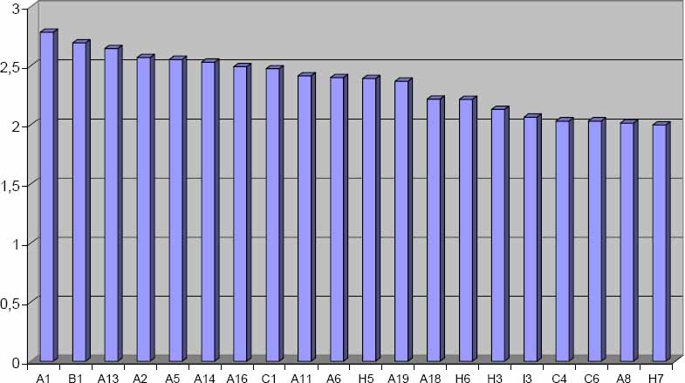

Exhibit 3. Factors absolute mean values from the range [2;3].

For result categorisation presentation and understanding of the assumed scale of results from 0 – 3, it was divided into ranges [0,0 - 1,0]; (1,0 – 1,5]; (1,5 – 2,0]; (2,0 – 2,5], (2,5 – 3,0]. For better results presentation it was assumed that the percentage scale would be introduced as follows: 0 means 0% and 3 means 100%, which makes the following ranges: [0% – 33%], [34% – 50%]; [51% – 66%]; [67% – 83%], [84% – 100%]. Based on assumptions in the study classifications of ranges was projected as having: substantial, large, medium, small and negligible influences on success of the project (Exhibit 4) and the groups of factors determined (Exhibit 5).

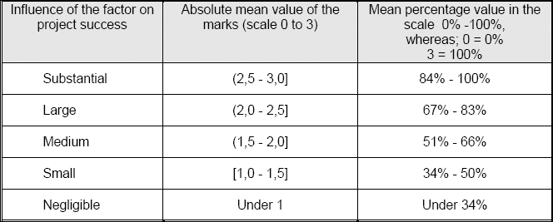

Exhibit 4. Classification of the factors influencing project success

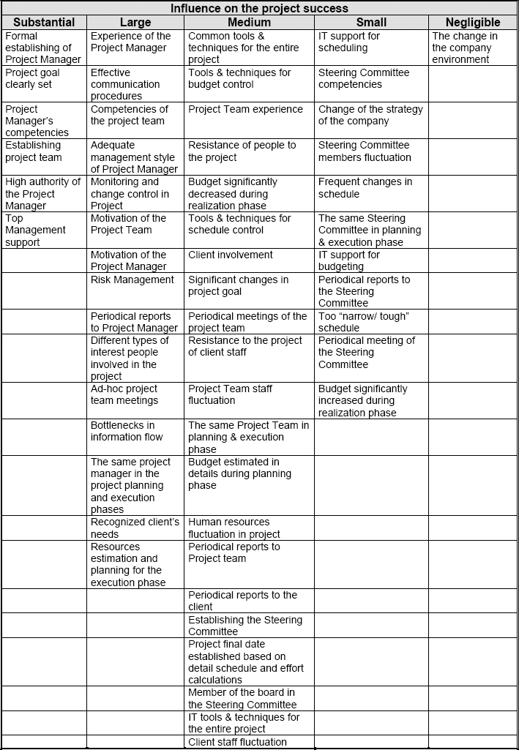

Exhibit 5. Groups of factors having substantial, large, middle, small and negligible influences on success of the project

Based on the assumed factors classification the Critical Success Factors (CSF) were determined within a group of factors having substantial influence on project success (Exhibit 6).

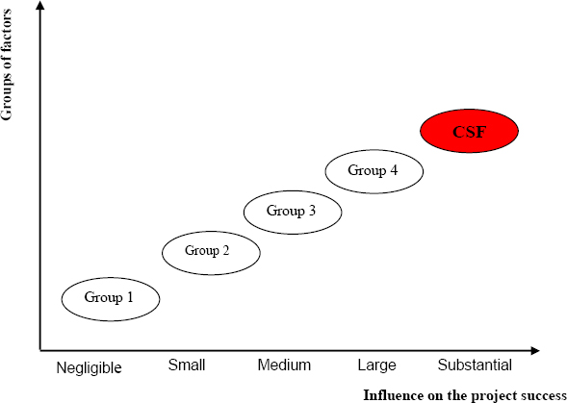

Exhibit 6. Critical Success Factors (CSF) in the assumed classification of the factors influencing project process

**Summary**

Among the whole factors classification the most important are factors having substantial influence on project success which are:

* a) Formal establishing the Project Manager, with 93% influence on the project success;
* b) Project Manager competencies, with 88% influence on the project success;
* c) High authority of the Project Manager, with 85% influence on the project success;
* d) The project goal set in a clear and measurable way, with 90% influence on the project success;
* e) Formally establishing a Project Team, with 86% influence on the project success;
* g) Top Management support for the project, with 84% influence on the project success.

As the first three factors (a, b, c) are thematically bounded, the Critical Success Factors are assumed as:

* Project Manager formally established who is competent and has a high level of authority.
* The project goal clearly set.
* Establishing an experienced and competent project team.
* Top management support for the project.

# Week 3 IT Lifecycles

## A3.1. Information Technology and Business Alignment: Why it is Important

**Introduction: What is IT Business Alignment and Why it is Important**

*The saying about the Blind Men and the Elephant in which three blind men touch the Elephant and state different things without knowing that it is an Elephant, firms and organizations must ensure that their IT and business strategies are complementary and supplementary to each other and not like the blind men in the parable quoted above.*

IT Business alignment is defined as the dynamic actualization of organizational goals and objectives and the Operationalization of the IT strategies according to those objectives. Typically, the organizational objectives are expressed in terms of improved financial performance and sustained market competitiveness. For instance, organizations can state that using IT, they hope to increase sales and revenues by 20% and reduce costs by 10% and increase profits by 15% and achieve profitability. Further, organizations might also want to state their market based objectives such as increased market share wherein they hope to penetrate into newer segments and extend their reach in established segments with IT. Thus, IT business alignment is the organizational capacity to leverage the former for the success of the latter. This means that for an organization to claim that its IT and business strategies are aligned, there must be harmony between them and little or no friction between the decision makers in corporate/business departments and the IT department.

IT business alignment is also defined as the organizational imperative to actualize a positive relationship between the use of information technologies and stated and accepted measures of financial and business performance. However, IT business alignment is easier said than done in practice as there exist significant gaps between what the business wants and what the IT systems deliver. This is mainly due to an inadequate understanding of how IT systems work and how they deliver value as well as due to cultural aspects in addition to a lack of coordination and cooperation between the business and IT departments. Often, one hears the complaint that IT staff talks in arcane terms, which is the refrain among the business and corporate executives. On the other hand the IT staff point to how the business and corporate departments expect the moon from an IT system when in reality an IT system delivers more or less what the realistic requirements state. Many CIOs also complain that CEOs, CFOs, and COOs often think of the CIOs as Magicians who can help the organizations reach the stars. Further, they also are frustrated because in practice, IT systems and their Operationalization are according to the mutually accepted requirements and not something, that manifests from thin air.

**The Six Steps to Actualize IT Business Alignment**

IT business alignment is usually referred to as the “Holy Grail” which the organizations must strive for as there are substantial benefits of aligning IT and business strategies in terms of the significant value that can be added to the organizations provided they leverage IT strategically, efficiently, and efficaciously. To do this, organizations can do six things or six characteristics that would ensure that IT and business are aligned with each other. The first step is to recognize and realize that IT can be used as a transformative tool in organizations. To do this, businesses have to realize the potential of IT to integrate disparate and discreet business functions and processes into a holistic business stream as can be achieved when the entire sales and marketing cycle starting with cold calling customers and including the bidding and finalization of the contract and ending with the post sales customer service are automated in a single value chain that would result in eliminating redundancies, reducing duplication, and simplifying complex steps. The second step follows from the above wherein organizations must use IT to target customers both from within and externally using IT.

The third aspect is related to the manner in which the IT and business staff must “talk to each other” in a manner that is mutually comprehensible. We have already described how there exist significant communication gaps between these staff. Therefore, to actualize tighter IT business alignment, the organization must rotate staff between these functions so that they have a working knowledge and a personal experience of how it feels to be on the other side. This is the reason why many organizations prefer IT professionals who have specialized in business management as well as business management graduates who have specialized in IT to staff the roles of CIOs and to some extent, in the corporate and business executive functions.

The next aspect is to do with defining the goals and objectives for the IT department in a clear and coherent manner. This entails management by objectives wherein the IT department is given the financial, operational, and strategic objectives that are expressed in the SMART (Specific, Measurable, Achievable, Realistic, and Time Bound) model. The fifth and perhaps the most important aspect in the road to actualizing closer IT business alignment is to devise foolproof and near accurate as well as reliable and measurable Returns on Investment (ROI) from the IT systems. Often, organizations fail to devise as well as define the ROI from the IT investment, which results in a lack of clarity on whether the IT spends, is worth the time and the effort. This is the reason why many organizations resort to expressing the ROI in terms of every dollar spent on the IT systems.

Finally, the sixth aspect is to get all these aspects together into a (preferably) written document that enumerates the IT and business strategies and how they are expected to work together. At the risk of sounding repetitive, we want to emphasize that unless the IT staff are given a requirements and a specifications document wherein the former is couched in business terminology (developed by the business departments) and the latter in technical terminology (developed by the higher level IT staff for the use of the programmers), the resultant IT systems usually resemble a chaotic and wasted effort. It is often the case that the CIO and the CEO or the COO sit together and come up with the business requirements, which are then signed off by both the parties, and then the technical specifications are prepared by the IT staff, which is again signed off by the CIO. Further, the key imperative here is the existence of a “single source of truth” which is the artifact describing the IT business alignment and how the organization wishes to actualize the same.

**IT Business Alignment, Governance, and Transformation**

The key to successful IT business alignment is the creation of value at each step of the value chain of the organizations’ internal and external processes. This value is created through technology as well as process improvements. Since we are discussing the role of IT in creating value, we can think of IT as the enabler and transformer of organizational processes that lead to increased productivity and higher value at each chain of the internal and external value chain for the organizations. Further, IT is used by many organizations to automate, integrate, assimilate, and deliver real time information in the business processes. Thus, the business driver in these cases is the leveraging of synergies between these processes that were otherwise inefficient. Moreover, organizations also use IT to ramp up their operations which are known as actualization of the benefits from the economies of scale. Apart from that, IT is used to expand into newer geographical and virtual market segments as automating and using IT often results in an anywhere, anytime, everywhere, every time experience for the end users.

For all these to happen, the IT and the business functions must work together as a team and in a synergistic manner. IT must become a tool of transformation as well as a source of sustained competitive advantage. For instance, if your bank offers 24/7 virtual banking as well as an extensive network of ATMs would you prefer a competitor whose banking hours are restricted and which forces you to visit the branch for even minor transactions? This is the power of IT and which can only be achieved if the business strategies and the IT strategies complement and supplement each other.

**Conclusion**

In real world organizations, it is often the case that there are ego clashes, turf battles, resistance from vested interests, and pushback from established power centers for any new initiative. Considering the fact that IT is seen as a positive force for change, it is in the interests of the organization to avoid these friction points and instead align their IT and business strategies for the continued success of the organization.

## A3.2. Waterfall vs. Incremental vs. Spiral vs. Rad Model: Key Difference

**Comparison of Various SDLC Models: Waterfall vs. Incremental vs. Spiral vs. Rad Model**

The following [SDLC models](https://www.guru99.com/software-development-life-cycle-tutorial.html) comparison table presents the differences between Water-Fall Model Vs. Incremental Model Vs. Spiral Model and Rad Model.

| **Properties of Model** | **Water-Fall Model** | **Incremental Model** | **Spiral Model** | **Rad Model** |
| --- | --- | --- | --- | --- |
| **Planning in early stage** | Yes | Yes | Yes | No |
| **Returning to an earlier phase** | No | Yes | Yes | Yes |
| **Handle Large-Project** | Not Appropriate | Not Appropriate | Appropriate | Not Appropriate |
| **Detailed Documentation** | Necessary | Yes but not much | Yes | Limited |
| **Cost** | Low | Low | Expensive | Low |
| **Requirement Specifications** | Beginning | Beginning | Beginning | Time boxed release |
| **Flexibility to change** | Difficult | Easy | Easy | Easy |
| **User Involvement** | Only at beginning | Intermediate | High | Only at the beginning |
| **Maintenance** | Least | Promotes Maintainability | Typical | Easily Maintained |
| **Duration** | Long | Very long | Long | Short |
| **Risk Involvement** | High | Low | Medium to high risk | Low |
| **Framework Type** | Linear | Linear + Iterative | Linear + Iterative | Linear |
| **Testing** | After completion of coding phase | After every iteration | At the end of the engineering phase | After completion of coding |
| **Overlapping Phases** | No | Yes (As parallel development is there) | No | Yes |
| **Maintenance** | Least Maintainable | Maintainable | Yes | Easily Maintainable |
| **Re-usability** | Least possible | To some extent | To some extent | Yes |
| **Time-Frame** | Very Long | Long | Long | Short |
| **Working software availability** | At the end of the life-cycle | At the end of every iteration | At the end of every iteration | At the end of the life cycle |
| **Objective** | High Assurance | Rapid Development | High Assurance | Rapid development |
| **Team size** | Large Team | Not Large Team | Large Team | Small Team |
| **Customer control over administrator** | Very Low | Yes | Yes | Yes |

## A3.3. Top 6 software development models and how they influence the SDLC

**Despite the complications induced by the Covid-19 pandemic,** [**enterprises continue to invest in software,**](https://www.statista.com/topics/1694/app-developers/) **with global spending striking as high as $425 billion U.S. in 2020.** To understand how quality enterprise software is made, let’s start by understanding the different areas of software development life cycle models and phases, and how they can influence the speed and cost of delivery.

Software development models are basically a set of specific tools and approaches used during the project’s life cycle. Their objectives are to boost productivity while reducing operating costs, which means that the software development model you choose can often make or break your project. To avoid unexpected hiccups in the flow, let’s go through the components of the software development life cycle (SDLC) and how they can influence your choice of software development models.

What is the SDLC?

The SDLC comprises all stages of software production — from analysis to deployment and support, and it will differ depending on the software engineering model you follow.

Software development phases

The SDLC can be broken down into several phases. Below is a simplified breakdown of these phases, which are present in most software engineering operating models:

1. **Planning (requirements analysis)**. During this phase, the software delivery and business teams collect information to outline the product’s business objectives. In managed IT services and outsourcing, the vendor gathers information from their client and other stakeholders. Afterward, the outsourcing vendor’s team creates a *Software Requirements Specification (SRS)* — a document that includes the objectives, goals, and system requirements for the product. This document should also document key agreements between stakeholders. The requirements-gathering process helps to align business objectives with the product being developed.
2. **Prototype design**. During this stage, the software delivery team defines how the project will be developed and reflects this information in the *Design Document Specification (DDS)*. This document covers the frameworks, platform specifications, limitations, and delivery estimates. Ideally, this documentation is made available to all parties involved in the development process (developers, testers, managers, and the client).
3. **Development (implementation)**. This is the core phase of all software process models, during which engineers develop the solution according to the requirements. This step involves a lot of code-writing and fine-tuning. Organizations should take note of the [latest trends in software testing](https://fortegrp.com/latest-innovation-trends-in-software-testing-technologies/) if they want to keep up with industry trends in this phase, as it changes frequently to keep pace with new development strategies.
4. **Quality assurance (QA) and testing**. This phase consists of code reviews and module assessment. It’s a continuous process, especially for the Agile life cycle model, which we will discuss in further detail below. When people talk about testing, they usually refer to unit and integration testing. Unit testing verifies specific sections of the app to ensure it works as planned, while [integration testing](https://fortegrp.com/how-to-create-a-top-down-integration-testing-strategy/) ensures that all modules work as one system. Mature product development practices will include testing into every facet of the development cycle to ensure higher QA standards in a practice called [continuous testing](https://fortegrp.com/landing/continuous-performance-testing/).
5. **Delivery**. Once engineers and testers are done with their work, the project manager, the client, and the stakeholders have to approve the project. After they do, it’s time for the product to hit the market.
6. **Maintenance**. Many models include the post-deployment software development modeling phase. In fact, most applications require regular maintenance to remain relevant. This phase covers compatibility upgrades, performance optimization, and monitoring, as well as bug fixes.

Why following the SDLC process is important

Sticking to the SDLC process of your software development model will help you deliver the project on schedule and within budget. Here’s how:

1. **It helps the project stay on track**. Two-thirds of software development projects [exceed their budget](https://www.infoworld.com/article/3258799/the-secret-to-ensuring-your-software-project-stays-on-budget.html). However, a robust SDLC methodology helps outline the objectives. Moreover, it will allow managers and clients to account for schedule shifts and expenses.
2. **It maximizes productivity**. The application of development models like Agile or DevOps can help you achieve more with fewer resources. [Research](https://images.reg.techweb.com/Web/UBMTechweb/%7B6966690d-b811-418c-a95d-1ccf27e3ab4c%7D_State_of_DevOps_Final.pdf) indicates that 59 percent of IT organizations experience a substantial productivity boost by adopting [*DevOps*](https://fortegrp.com/what-are-the-core-devops-principles/) practices.
3. **It reduces development time**. A flexible approach to the software design cycle helps teams cooperate more effectively. According to McKinsey’s research, selecting the right methodology can speed up the development process by [up to six times](https://www.mckinsey.com/business-functions/mckinsey-digital/our-insights/beyond-agile-reorganizing-it-for-faster-software-delivery).
4. **It provides better management**. A defined SDLC will improve the collaboration between engineers, QA analysts, managers, and the client. If you want more control over your project, an accomplished **managed services** provider will map out the development with you and provide feedback throughout the software implementation lifecycle.

*Learn more about the* [*benefits of managed services*](https://fortegrp.com/benefits-of-managed-it-services/) *for software development.*

Now that we’ve covered everything you need to know about the SDLC, it’s time to finally dive into the advantages, disadvantages, and peculiarities of different software engineering models.

Types of SDLC models

Below are six of the most popular software engineering models, their advantages, and use cases.

**1. The iterative model**

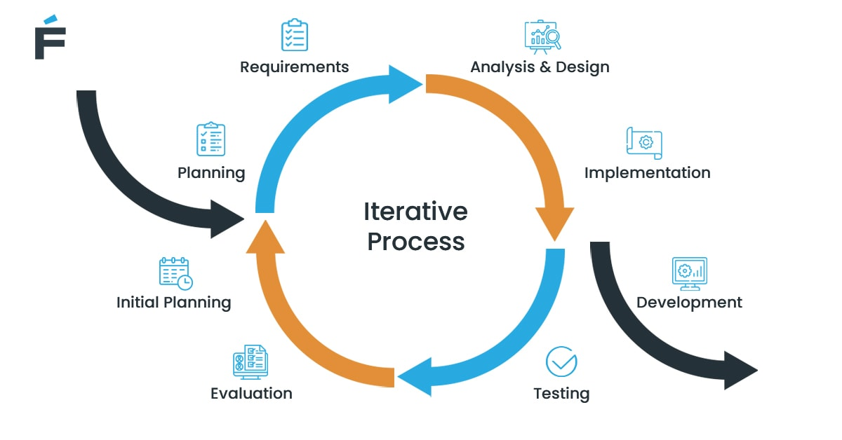

Iterative software process models begin with a smaller set of requirements. Developers use these requirements to analyze and gradually implement features. Afterward, these features are evaluated and tested to identify new requirements. This cycle is called an “iteration.”

This life cycle repeats numerous times, introducing new design choices, coding, and requirements changes.

**Advantages**:

* Coding begins early on
* A cost-effective way to implement requirement changes
* Streamlined management because the production is divided into smaller pieces (iterations)
* Bugs and defects are easy to spot at earlier SDLC phases

**Disadvantages**:

* Difficult to analyze risks
* Potential design and architecture issues in the later phases
* Too reliant on the baseline plan
* A resource-heavy model

**Suitable for**:

* Large-scale projects with multiple modules (such as web services or microservices)
* Projects with clearly defined objectives and tasks

**2. The Agile model**

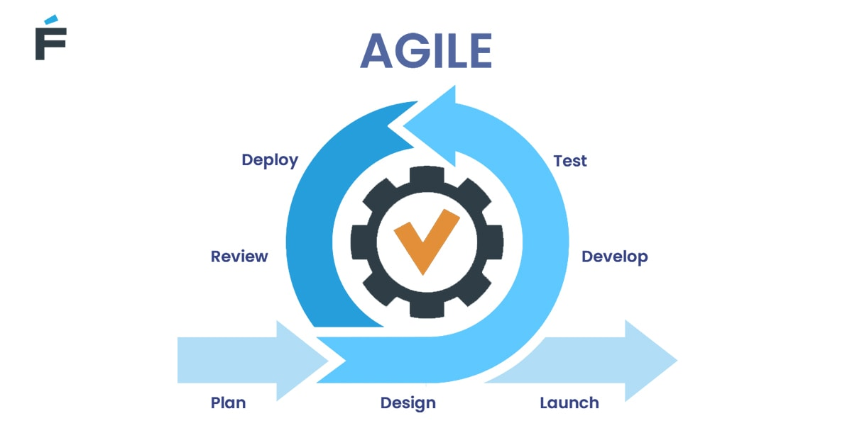

Agile focuses on continuous release cycles and cross-functional development. It’s one of the most flexible and [popular](https://www.pmi.org/-/media/pmi/documents/public/pdf/learning/thought-leadership/pulse/pulse-of-the-profession-2017.pdf) types of SDLC models. The driving factors for its recognition are the 27 percent cost reduction and productivity improvements, according to the CollabNet [2019 State of Agile](https://www.collab.net/news/press/collabnet-versionone-releases-13th-annual-state-agile-report) Report.

Agile is quite similar to Iterative, where teams work in repeated increments. However, unlike Iterative, Agile doesn’t rely on the baseline plan. The plan, along with the requirements, is continuously modified throughout the life cycle.

The most popular sub-groups and techniques within Agile are:

* **Scrum** (developers work in iterations, aka “sprints” 2-3 weeks long)

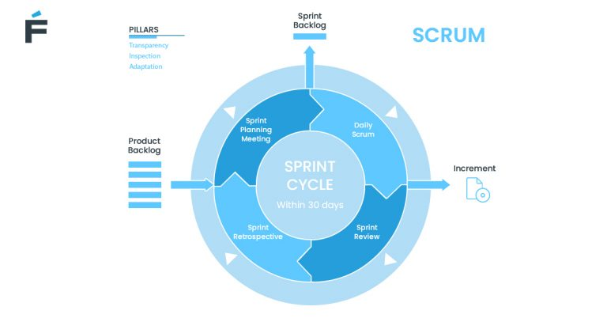

* **Kanban** (emphasis on plan visualization and short daily “sprints”)

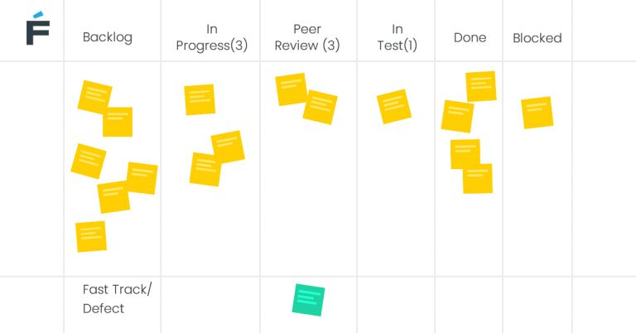

That said, this methodology doesn’t impose specific techniques. There’s no Agile development cycle diagram, so to speak. This means you’re free to experiment by merging it with other models if it fits you.

**Advantages**:

* Easy to change requirements and the baseline plan
* Fast release of the prototype
* Focus on communication between developers and the client
* Client’s engagement integrated into the life cycle
* Continuous evaluation and feedback

**Disadvantages**:

* Difficult to estimate the final production costs
* Possible architecture conflicts due to constant requirement changes

**Suitable for**:

* Large-scale and smaller projects
* Outsourcing and managed IT services
* Adding new features to a working prototype

**3. The DevOps model**

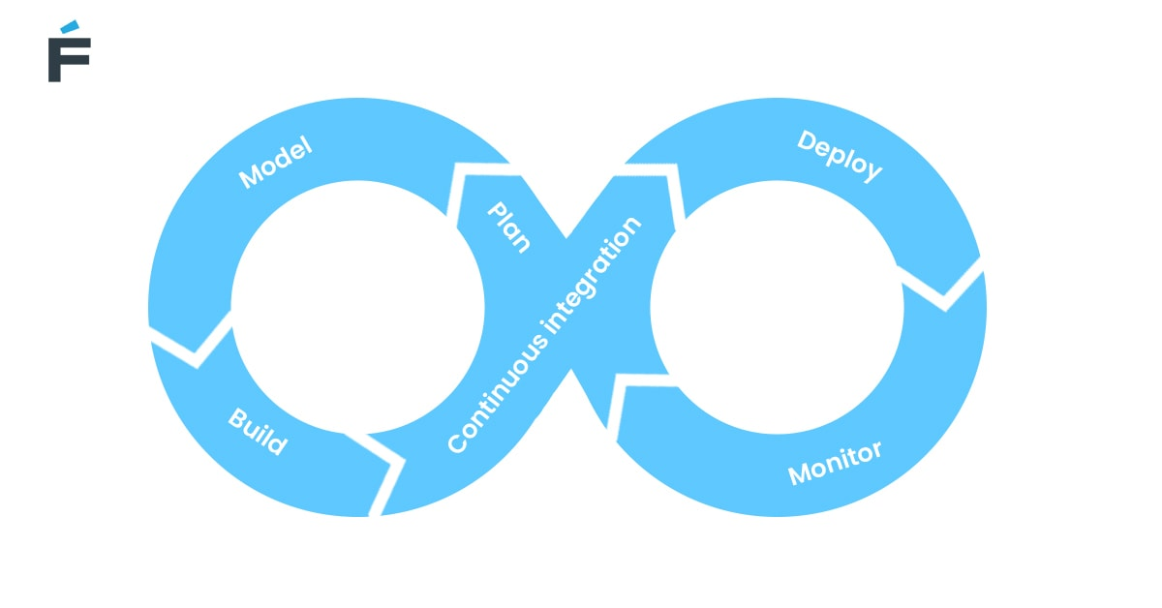

DevOps is built around the principles of automation and collaboration. This model’s primary goal is to enhance cooperation between the operations team and developers (hence, its name) thanks to continuous feedback.

The model shares many similarities with Agile, but there’s one fundamental difference: DevOps focuses on interactions between the technical departments and managers. Agile, on the other hand, emphasizes direct client (or product owner) involvement.

**Advantages**:

* Automation and optimization of processes
* Continuous feedback cycle between engineers and testers
* Streamlined product delivery
* Significant productivity improvements for in-house departments
* Error and defect detection early on in SDLC

**Disadvantages**:

* Lack of focus on documentation
* Difficult to manage emerging product features
* A challenging adoption curve

**Suitable for**:

* Complex projects that require a lot of QA and testing
* Large teams with multiple departments

**4. The Waterfall model**

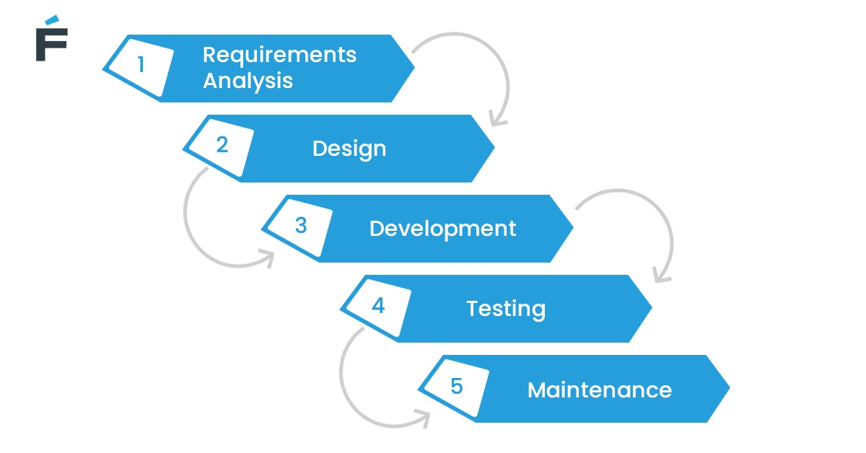

Waterfall is one of the oldest types of software development life cycle methodologies. It focuses on a linear approach with SDLC phases following one another sequentially.

The outcome of each phase affects the input of the next one. Therefore, it’s much more difficult and costly to return to earlier phases.

**Advantages**:

* Straightforward and easily manageable
* Clearly defined deliverables and milestones
* Easy to prioritize tasks

**Disadvantages**:

* Lacks the versatility of the Iterative and Agile approaches
* Phases can’t overlap
* Time-consuming
* Too costly to return to prior phases

**Suitable for**:

* Smaller and mid-sized projects with clearly defined requirements

**5. Verification and Validation (V-shaped)**

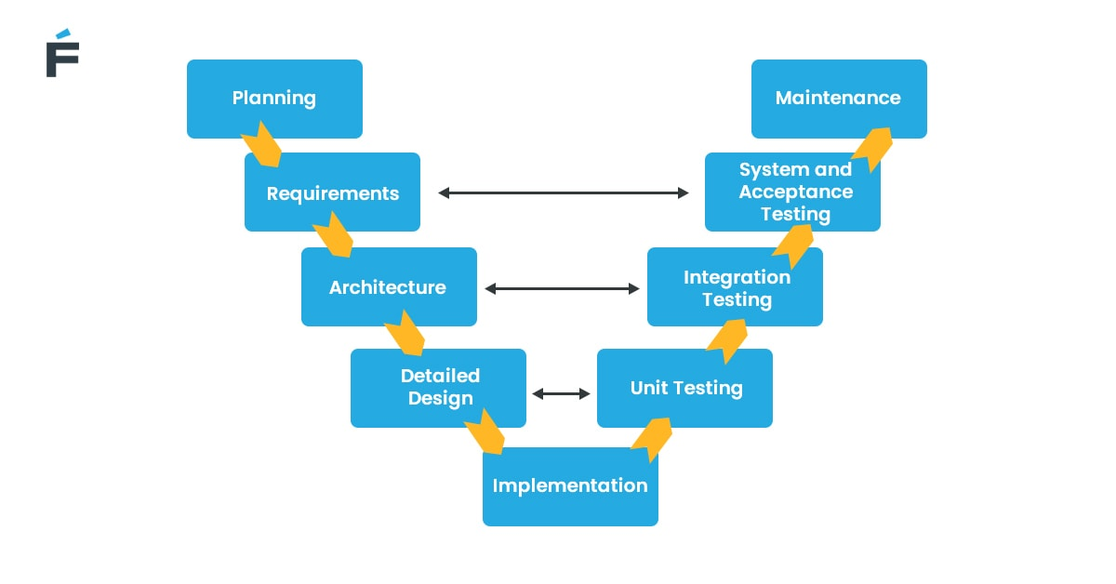

Verification and Validation is a sequential methodology, just like Waterfall. But there’s a difference — in this methodology, every step goes in parallel with testing.

For example, the first phase includes both planning and acceptance *testing*. Then come prototype design and unit *testing*, and so on. The coding stage is the final step of the V-shape model.

**Advantages**:

* Simple and straightforward
* Critical issues are taken care of during earlier phases
* In-depth requirements documentation

**Disadvantages**:

* Lack of flexibility
* Too costly and time-consuming

**Suitable for**:

* For mid-sized and large projects with explicit objectives and requirements

**6. The Spiral model**

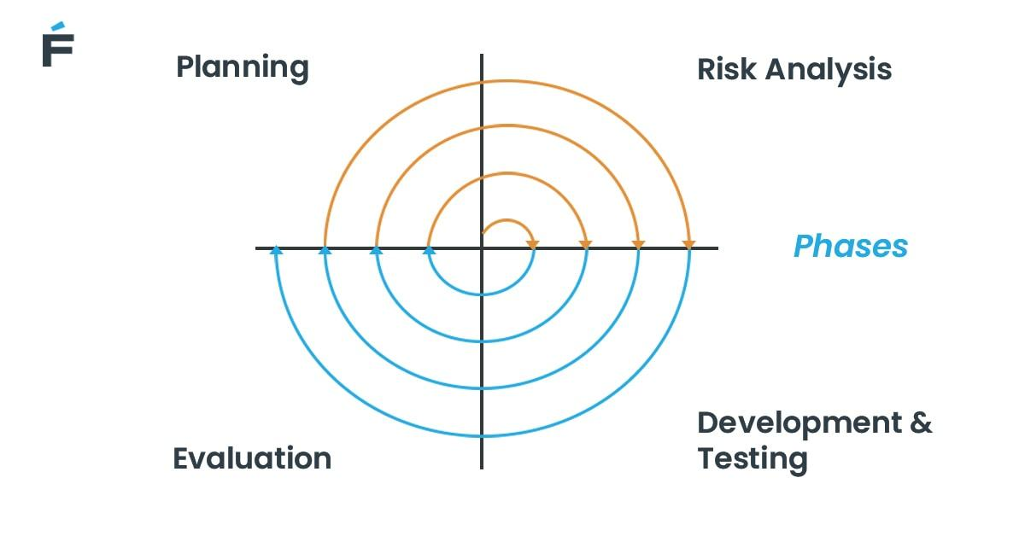

Spiral combines the **Iterative and Waterfall methodologies** with an emphasis on risk assessment. It consists of the usual SDLC phases built on the baseline spiral.

Each cycle repeats in “spirals” that allow teams to evaluate risks and get precise estimates. The loop repeats until the product complies with requirements.

**Advantages**:

* Precisely documented
* Accurate time and budget estimates
* Excellent risk assessment
* Engineers can apply changes to new iterations

**Disadvantages**:

* Success depends on skilled risk managers
* Requires a large resource pool
* Time-consuming

**Suitable for**:

* Larger projects with complex requirements
* New products with multiple testing stages

The bottom line

If you’re serious about producing software solutions more efficiently, with fewer bugs, and within budget, you should follow proven methodologies or software development models. But before selecting one, make sure to learn all about their pros and cons to discover the methodology that will fit your project best.

## A3.4. The Ultimate Guide to...IT Project Management

**What Is an IT Project?**

**An information technology (IT) project is a type of project that deals with IT infrastructure, information systems or computers.** Examples of an IT project include web development, software development, mobile app development, network configuration, software implementation, hardware installation, database management, and IT emergency recovery.

**What Is IT Project Management?**

IT project management (ITPM) is the planning, scheduling, execution, monitoring and reporting of IT projects. While many industries focus exclusively on IT projects, IT is unique in that most, if not all, industries have some level of an IT component.

Since they are often very wide in scope, IT project managers must deal with risk, interdependent integrations, software updates, scope creep and so on. Therefore, IT projects require more than the typical project management tools and skills to complete.

[Specialized IT project management software](https://www.projectmanager.com/industries/it-project-management) complete with online Gantt charts, kanban boards, dashboards and reports provide the essential functions necessary for successful IT projects.

**What Are the Six Phases of an IT Project?**

The six phases of an IT project are based on the six phases of [project management](https://www.projectmanager.com/project-management), which are used in conjunction with the IT phases to manage the project. They are as follows:

**Initiation**

During the first phase of an IT project, one must ask “why is this project needed?”—in other words, the objective of the project must be identified. Then, a [project proposal](https://www.projectmanager.com/templates/project-proposal-template), including a business plan, that meets the needs of the project must be written. In addition, a [feasibility study](https://www.projectmanager.com/training/how-to-conduct-a-feasibility-study) might be conducted to ensure the proposal is airtight.

**Definition**

After the project proposal has been approved, the project moves into the definition phase. This is where the objectives of the project are finalized and the requirements for a successful project are identified. The project scope can also be outlined, and a [project plan](https://www.projectmanager.com/project-planning) may be created during this phase. Budgets are also set, and resources are determined.

**Design**

The design phase of an IT project is when the project team sets out to find the best solution for achieving their goal. This includes creating multiple designs and prototypes. Once a suitable design has been chosen, specifications for the development team are created and shared.

**Development**

The development phase is when the development team is assigned tasks and [project management tools](https://www.projectmanager.com/software) are selected. Additionally, technicalities are outlined, raw materials are requested and so on. The main goal of this phase is to make the entire plan as crystal clear as possible to avoid issues in the implementation phase.

**Implementation**

The implementation phase is where the final deliverable of the IT project is developed; unsurprisingly, this is often the longest phase of the project. The project team sets out to complete their tasks, while the manager [monitors and controls the work](https://www.projectmanager.com/project-tracker), resources, cost, quality and risk.

**Follow Up**

Finally, once the implementation phase is complete, the final project is delivered to the customer/client/stakeholder. The follow up phase is all the work that comes after the project is delivered, and includes setting up support teams, training the end-users, creating a postmortem and ultimately ending the project.

Most IT projects and their phases are managed with a traditional, structured [waterfall](https://www.projectmanager.com/waterfall-methodology) methodology. An [agile](https://www.projectmanager.com/agile-sprints) framework, though, can minimize risk when adding functionality. DevOps deployment can be a good fit within an organizational culture. Rapid application development (RAD) is a low-investment, high-quality process.

**What Does an IT Project Manager Do?**

An IT project manager is responsible for overseeing an organization’s IT department and managing teams to execute IT projects on time and within budget. Some of the duties of an IT project manager include:

* Setting project goals and creating plans to meet them
* Maintaining the [project schedule](https://www.projectmanager.com/project-scheduling) and budget, creating status reports
* Managing resources, including the team, equipment, etc.
* Assigning tasks to team members
* Developing strategy to deliver projects on time and within budget
* Using IT project management tools to [track progress](https://www.projectmanager.com/project-tracker) and performance
* [Assessing risk](https://www.projectmanager.com/training/how-to-analyze-risks-project) and responding adequately
* Leading regular meetings with team and [stakeholders](https://www.projectmanager.com/stakeholder-management)

IT project managers are expected to have advanced knowledge of computers, operating systems, network and service desk administration. They must also be good communicators and be able to clearly explain complex technical issues. Other required skills include experience with scheduling, budgeting and [resource planning.](https://www.projectmanager.com/resource-management)

While the skill sets of project managers across different industries are generally the same, an IT project manager is unique in that they’re focused solely on the IT needs of an organization. But like all project managers, the way an IT project manager handles their varied duties and responsibilities is with the help of robust IT project management software.

## A3.5. IT Project Management

In IT, projects have become more complex as technologies rapidly change and end-users demand greater ease-of-use and flexibility. For an IT project manager to achieve their objectives, it is imperative that these initiatives are completed on time and on budget.

Discover what it means to manage IT projects, common challenges faced by IT project managers, and tips to make your next IT project a success. You’ll also find helpful resources, like guides and free templates.

**What Is IT Project Management?**

IT project management (ITPM) is the process of managing the plan, organization, and accountability to achieve information technology goals. Since the reach of IT spans across most of a business or enterprise, the scope of these projects can be large and complex.

The magnitude of IT project management often means that it’s more than just applying knowledge, aligning skills, and using regular tools and techniques to drive a project to completion. IT project managers deal with the challenges of interdependent integrations, rapid technology upgrades, and version changes that can occur throughout the project timeline.

**Additional Resources:**

* [An Indispensable Guide to On-Time, On-Budget IT Project Management](https://www.smartsheet.com/it-project-management)
* [Optimize Your IT PMO Operations, Fast](https://www.smartsheet.com/blog/optimize-your-it-pmo-operations-fast)

**The IT Project Management Lifecycle**

The ITPM lifecycle includes the five basic phases of project management, but the main difference for IT project management is how the project lifecycle is managed.

The most common ITPM method is the Waterfall methodology, which involves a predictive linear process. The entire project is defined before starting, and each phase is initiated and completed before moving on to the next phase.

Another lifecycle method is the Iterative method, which uses a more incremental approach. The iterative or incremental approach repeats phases, and each iteration completes the planning, analysis, and design phases with the ability to deliver on a specific goal at the end of the iteration.

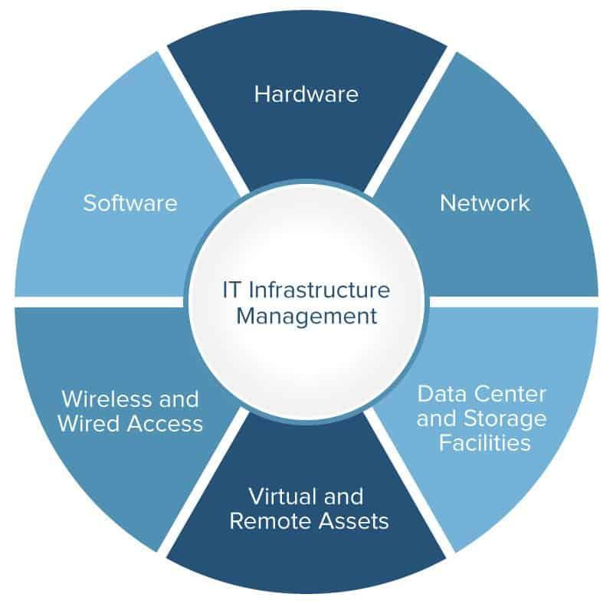

IT project management may also use an adaptive lifecycle, such as those found in Agile methodologies. This style is even more flexible than the iterative approach by condensing timelines into shorter activity bursts called sprints.

**Additional Resources:**

* [Infrastructure Management 101: A Beginner’s Guide to IT Infrastructure Management](https://www.smartsheet.com/it-infrastructure-management-services-guide)
* [How to Implement an Effective IT Ticketing System](https://www.smartsheet.com/how-use-smartsheet-it-ticketing-system)

**Main Responsibilities of an IT Project Manager**

Today’s IT project managers (IT PM) must be able to juggle a wide range of tasks and responsibilities. They must be able to handle firmware and software integrations, website construction, database storage and management, and also build complex and geographically diverse infrastructures and networks, all while planning for potential security and data risks.

Throughout their projects, an IT PM is responsible for setting goals, communicating and motivating team members and stakeholders, identifying the right resources for each task, researching, managing change, performing needs assessment, and properly sequencing tasks.

Additional responsibilities of the IT project manager include the following:

* Project planning and overall management
* Promoting and achieving project support
* Ensuring overall capability with existing technology
* Minimizing duplicate work
* Utilizing team member skills
* Controlling costs and maintaining budgets

**Additional Resources:**

* [Understanding IT Compliance](https://www.smartsheet.com/understanding-it-compliance)
* [IT Roadmaps and Successful Technology Roadmapping](https://www.smartsheet.com/technology-roadmapping-getting-started-and-staying-focused)

**Challenges Faced by IT Project Managers**

The complexities and interdependencies of large-scale, long-term, diverse IT projects are among the most challenging issues of IT projects. Here are a few more top challenges faced by IT project managers:

* Making multiple assumptions when integrating different hardware, networks, and software to the existing system.
* Unclear expectations from the business, end-users, and stakeholders.
* Rapidly changing technology, leading to necessary mid-project upgrades that can affect timelines.
* Geographically diverse offices and remote work associated.

**Additional Resources:**

* [What Experts Say About IT Demand Management](https://www.smartsheet.com/expert-tips-for-ITIL-demand-management-for-2017-and-beyond)

**Tips for Successful IT Project Management**

Successful IT project management combines the implementation of standard project management best practices with the art of managing conflict, change, expectations, and more.

The first step is selecting a project management methodology that fits the skills of your team and the project objectives. Once you have that set, here are some tips to help make your next IT project a success:

* **During initiation:** Be sure you have assessed whether the project is a good use of resources and whether the project outcome will satisfy a business need.
* **During planning:** Complete your project charter, and have a good understanding of task dependencies and how missed milestones could impact overall timelines.
* **During execution:** Over-communicate and host daily stand-up meetings to discuss status and any project blockers.
* **During monitor and control:** Ensure you have the right PM tool in place that enables you to monitor progress in real time.
* **During closeout:** Do a project retrospective that answers what went well, what could have been better, and what you would change next time.

**Additional Resources:**

* [The Ultimate IT Dashboard: What Should It Measure?](https://www.smartsheet.com/ultimate-it-dashboard-experts-answer)
* [Three Tips to Streamline IT Project Management](https://www.smartsheet.com/blog/3-tips-streamline-it-project-management)
* [Deploy Proven IT PMO Business Solutions, Fast](https://www.smartsheet.com/solutions/accelerators/it-pmo)

## A4.1. What are sources?

|  | **Primary Sources** | **Secondary Sources** | **Tertiary Sources** |
| --- | --- | --- | --- |
| **Proximity to original event** | A secondary source of evidence is one step removed from the original (primary) source. It is usually based on the primary source. | A secondary source of evidence is one step removed from the original (primary) source. It is usually based on the primary source. | A tertiary source is one more step removed from the original (primary) source. It is usually based on a range of secondary sources. |
| **Examples** | * an original letter * an original diary or journal * original notes from an experiment or piece of research * a novel, poem or play * an art work, theatrical performance or musical score or performance | * a literary critique based on a poem, play or novel * a history book based on primary historical sources * a scientific report based on primary experimental notes | * a journal article reviewing a number of different approaches (secondary sources) to a subject * a book of readings presenting different perspectives on the subject matter you are studying * a text book reviewing and interpreting a number of scientific discoveries, experiments or approaches |

**Which sources to use?**

In academic writing, you should assume that you are required to use secondary and tertiary sources unless:

* your lecturer or tutor specifically indicates that you should focus on the primary source(s), or
* you are asked to write an entirely personal response to a primary source such as a poem, a piece of music, a performance, an artwork, or a video clip.

## A4.2. Primary Research vs Secondary Research: Definitions, Differences, and Examples

**What is primary research?**

Primary research refers to research that has involved the collection of original data specific to a particular research project (Gratton & Jones, 2010). When doing primary research, the researcher gathers information first-hand rather than relying on available information in databases and other publications.

This type of research is often carried out with the goal of producing new knowledge, which is why primary research is also referred to as original research. By doing primary research, researchers aim to answer questions that haven’t been answered or even asked before. This degree of originality sets primary research apart from secondary research.

Additionally, original research is crucial for researchers aiming to be published in academic journals, which currently number over 40,000. The degree of originality of the research is a major criterion for publication (Callaham, 2002).

**Types of Primary Research**

Primary research can be done through various methods, but this type of research is often based on principles of the scientific method (Driscoll, 2010). This means that in the process of doing primary research, researchers develop research questions or hypotheses, collect and analyze measurable, empirical data, and draw evidence-based conclusions. If you want to understand more about conducting an empirical study, you can check out the guide on [what is empirical research](https://research.com/research/what-is-empirical-research).

The most common types of primary research are outlined below.

* **Surveys** – This is a data-collection approach where individuals are asked to provide answers to particular questions, such as about their emotions, beliefs, attitudes, and behavior (Mrug, 2012). This form of questioning tends to be less flexible than interviews due to the fixed nature of the questions. However, surveys are useful for collecting information from large groups of people.
* **Interviews** – Interviews are a convenient way of collecting information from individuals or small groups of people. Researchers can also use interviews to get expert opinions on their fields of study.
* **Observation** – This primary research method involves observing people, occurrences, and other variables important to the research or study. Observation entails measuring and recording quantitative or qualitative data. This research method is useful for gaining knowledge without the biased viewpoint sometimes present in interviews.
* **Data analysis** – Data analysis requires collecting data and organizing them according to criteria developed by the researcher. This primary research method is useful for discovering trends or patterns in data.
* **Focus groups** – Researchers can also gather information through focus groups, which typically comprise up to 12 people. Focus groups participate in a guided discussion of the topic, usually facilitated by the researcher. This qualitative data-gathering method is often used as gain a deeper appreciation of social problems (Nyumba et al., 2018).

Research methods used can also vary, depending on the industry for which the research is needed. For instance, the chart below indicates the emerging research methods used in market research.

**What is secondary research?**

While primary research involves active participation from the researcher themselves, secondary research involves the summary or synthesis of data and literature that has been organized and published by others. When doing secondary research, researchers use and analyze data from primary research sources.

Secondary research is widely used in many fields of study and industries, such as legal research and market research. In the sciences, for instance, one of the most common methods of secondary research is a systematic review. In a systematic review, scientists review existing literature and studies on a certain topic through systematic methods, appraising all available studies to synthesize their findings (Fitchburg State University, 2020).

The following table highlights the key differences between primary research and secondary research.

| **Example: The result of the Brexit referendum was driven by Britons' worries with existing EU immigration policies, caused by the quickly growing immigrant population and the insufficient integration of immigrants into British society.** |  |
| --- | --- |
| Topic | the result of the Brexit referendum |
| Position | driven by Britons' worries with existing EU immigration policies |
| Reasons for the position | quickly growing immigrant population, the insufficient integration of immigrants into British society |

**Sources of Secondary Research**

Researchers have plenty of options to explore when it comes to doing secondary research. The following sources can assist researchers in doing secondary research:

* **Academic peer-reviewed journals** – These often include original research undertaken by authors or researchers themselves.
* **Published books and articles** – Many books reference primary-source materials, along with an analysis from the author.
* **Government agencies** – Many government agencies maintain archives or databases of documents and reports, which contain data that can prove to be useful to researchers.
* **Educational institutions** – Colleges and universities do a significant amount of research and produce data that can be requested by researchers.
* **Commercial information sources** – Information sources such as newspapers, magazines, and TV shows can also prove to be useful sources for secondary research. These sources provide firsthand information and insights to political agendas, market research, and economic developments for instance (Bhat, 2020).

The Internet makes secondary research significantly easier for researchers today. Many government agencies and educational institutions, for instance, make their data available online so researchers can easily download information for their use. There are even web applications for creating world clouds to visualize the frequency of keywords for topics in databases. If you are interested in these applications, you can check out our [best word cloud generator](https://research.com/research/best-word-cloud-generators) list.

**How to Use Primary and Secondary Research**

A researcher can choose to use either or both primary or secondary research methods, depending on their objectives. For instance, primary research is ideal if a researcher seeks to make new discoveries or explore new aspects of their field of study. Primary research can also be used to provide authoritative, credible evidence about a topic (Streefkerk, 2018).

Moreover, primary research can be used to produce data that is not only reliable but also specific and relevant to the researcher’s needs. The customized nature of research instruments, such as surveys and interviews also makes primary research ideal for researchers who need a high level of control over data collection methods.

On the other hand, researchers who want to gain more knowledge about their chosen topic will do well to start with secondary research. According to Foley (2019), secondary research serves as a good starting point for any research process. Through secondary research, researchers can determine and understand how their peers have previously approached the topic. Secondary research also allows researchers to collect data in a shorter period and at a lower cost.

Despite their differences, however, primary and secondary research will both prove to be useful in the research process. Foley suggests that both research methods are most effective when used together. Studying existing literature and published materials (secondary research) helps researchers determine the extent of existing knowledge on the topic. If insufficient data is present, researchers have the option to devote time and effort to do primary research.

## A4.3. Step-by-Step Guide & Research Rescue: Evaluating Credibility

**Evaluating Your Sources**

In your search for information, you eventually face the challenge of evaluating the resources you have located and selecting those you judge to be most appropriate for your needs. Examine each information source you locate and assess sources using the following criteria:

**Timeliness**  
Your resources need to be recent enough for your topic. If your paper is on a topic like cancer research, you would want the most recent information, but a topic such as World War II could use information written in a broader time range.

**Authority**  
Does the information come from an author or organization that has authority to speak on your topic? Has the information been peer-reviewed? (You can use [Ulrichsweb](http://dbs.lib.byu.edu/ulrichsweb) to determine if a journal is peer-reviewed). Do they cite their credentials? Be sure there is sufficient documentation to help you determine whether the publication is reliable including footnotes, bibliographies, credits, or quotations.

**Audience**  
Who are the intended readers and what is the publication's purpose? There is a difference between a magazine written for the general public and a journal written for professors and experts in the field.

**Relevance**  
Does this article relate to your topic? What connection can be made between the information that is presented and your thesis? An easy way to check for relevance is by reviewing the Abstract or Summary of the article before downloading the entire article.

**Perspective**  
Biased sources can be helpful in creating and developing an argument, but make sure you find sources to help you understand the other side as well. Extremely biased sources will often misrepresent information and that can be ineffective to use in your paper.

**Evaluating Websites**

Websites create an interesting challenge in evaluating credibility and usefulness because no two websites are created the same way. The TAARP method described above can be used, but there are additional things you want to consider when looking at a website:

**The look and feel of the website** - Reliable websites usually have a more professional look and feel than personal Web sites.

**The URL of your results** - The .com, .edu, .gov, .net, and .org all actually mean something and can help you to evaluate the website!

* **Informational Resources** are those which present factual information. These are usually sponsored by educational institutions or governmental agencies. (These resources often include **.edu** or **.gov**.)
* **Advocacy Resources** are those sponsored by an organization that is trying to sell ideas or influence public opinion. (These resources may include **.org** within the URL.)
* **Business or Marketing Resources** are those sponsored by a commercial entity that is trying to sell products. These pages are often very biased, but can provide useful information. (You will usually find **.com** within the URL of these resources.)
* **News Resources** are those which provide extremely current information on hot topics. Most of the time news sources are not as credible as academic journals, and newspapers range in credibility from paper to paper. (The URL will usually include **.com**.)
* **Personal Web Pages/Resources** are sites such as social media sites: blogs, Twitter pages, Facebook, etc. These sources can be helpful to determine what people are saying on a topic and what discussions are taking place. Exercise great caution if trying to incorporate these sources directly into an academic paper. Very rarely, if ever, will they hold any weight in the scholarly community.

**Are there advertisements on the site?** - Advertisements can indicate that the information may be less reliable.

**Check the links on the page** - Broken or incorrect links can mean that no one is taking care of the site and that other information on it may be out-of-date or unreliable.

**Check when the page was last updated** - Dates when pages were last updated are valuable clues to its currency and accuracy.

## A4.4. Why and how to use sources

This section provides some reasons for using sources in your academic writing.

**How are sources used in academic writing?**

In the Western academic tradition we use sources and the evidence contained in them:

* to gather ideas and information so that we can expand and enrich our own knowledge and understanding (and possibly that of the academic community generally) of particular disciplines, subject areas and topics.
* to identify, build and support arguments or research which demonstrate the understandings we have acquired.

**Why use sources?**

**To satisfy the expectations of the academic community you are writing for**

When you write in an academic context, you are not writing for yourself. You become a member of an academic community which has particular expectations, including expectations about honesty and rigour in academic research and writing. Using and acknowledging sources is part of the 'currency' of this community; and, as with most communities, if you do not observe the rules and adopt the language of this community, your input and perspectives will be less valued.

**To show evidence of wide, informed and relevant reading**

University assignments provide you with an opportunity to broaden your knowledge within your chosen discipline or subject by extensive reading on particular topics. It is essential to show that your reading has acquainted you with a range of perspectives relevant to the assignment topic.

**To show that your writing does not rely mainly on personal opinion**

Although there are exceptions (see Module 2, Unit 2: Potentially questionable sources) personal opinion, personal experience and anecdotal evidence are not usually highly valued in academic writing. Part of the reason you are encouraged to read widely is to acquaint yourself with the research and perspectives of others so that you can see and experience things differently. Your own writing needs to acknowledge these other perspectives and the part they have played in taking you beyond your own experience and current level of understanding.

Note: It is your responsibility to find out whether personal opinion is expected, or allowed in your assignment topic or subject.

**To show the process by which you have arrived at your own conclusions about the topic**

When you write about a topic, you are usually not only presenting the perspectives of others. Your reading should help you to form and present your own conclusions. You need to acknowledge the contributions other writers and researchers have made in helping you develop strong, persuasive arguments to support your own perspectives and conclusions. You need to demonstrate that you have made this material your own.

**To show your ability to integrate material from a range of sources**

In academic writing you do not simply list what you have read - your bibliography or reference list does that. Your writing needs to show how you have grouped and categorised information from a wide range of sources and organised this information around central points, arguments or sections.

**To show evidence of an analytical and critical approach to your source material**

To develop a considered argument and present your own perspectives on a topic you need to be selective in the way you use evidence from your sources. You will want to:

* foreground some sources and use others as background or supporting information.
* align yourself strongly with some sources and distance yourself from others.

However, you need to make your reader aware of the basis on which you are doing this. You cannot do this effectively without taking an analytical and critical approach to the differing perspectives you are drawing on in your source material (see Module 2, Unit 4: Reporting Evidence for ways to do this).

**To enable readers to follow up references or perspectives of particular interest to them**

In an academic community, people learn from each other. Even though you may be writing for assessment purposes, your readers may want to improve their knowledge too, by following through on references they were unaware of, or new perspectives you have outlined in your writing. For them to do this, you must acknowledge your sources. Your references must also be complete, genuine and accurate.

**To enable the reader to evaluate the ideas and information you are presenting**

The reader needs to know whether your ideas and information come from reliable sources. If the sources are not identified (by correct referencing), readers may conclude that the idea or information you present is not reliable at all.

**To avoid plagiarism**

You should own what you have written. Although you have consulted other people's research and writing, you have used these sources mainly to clarify your own perspectives on the topic and to develop your own position. You cannot show that you have done this if you plagiarise other people's work - that is, if you use someone else's ideas or words without acknowledging where they came from.

## A4.5. External Analysis Research

**Evaluating Information Sources**

As a student, you will be gathering information from a variety of types of sources for your research projects including books, newspaper articles, magazine articles, specialized databases, and websites. As you examine each source, it is important to evaluate each source to determine the quality of the information provided within it. Common evaluation criteria include: purpose and intended audience, authority and credibility, accuracy and reliability, currency and timeliness, and objectivity or bias. Each of these criteria will be explained in more detail below.

**Purpose and intended audience**

* What is the purpose of the source? For example:
  + To provide information (e.g., newspaper articles)
  + To persuade or advocate (e.g., editorials or opinion pieces)
  + To entertain (e.g., a viral video)
  + To sell a product or service (e.g., advertising or marketing materials on a company website)
* Who is the intended audience? For example:
  + Scholars and academic researchers with specialized knowledge
  + The general public (without specialized knowledge)
  + Students in high school, college or university (e.g., textbooks for students learning a new subject).

**Authority and credibility**

* Who is the author?
  + Is it a person?
  + Is it an organization such as a government agency, nonprofit organization, or a corporation?
* What are the qualifications of the author?
  + What is the author's occupation, experience, or educational background?
  + Does the author have any subject matter expertise?
  + Is the author affiliated with an organization such as a university, government agency, nonprofit organization, or a corporation?
* Who is the publisher?
  + For books, is it a university press or a commercial publisher? These types of publishers use editors in order to ensure a quality publication.
  + For journals or magazines, can you tell if it is popular or scholarly in nature? See: [Peer-reviewed, popular magazine, or journal?](http://brocku.ca/library/help-lib/writing-citing/general-essay-help/what-is-scholarly)
  + For websites, is it an organizational website, or a personal blog?

**Accuracy and reliability**

* Is the information well researched?
  + Are there references (e.g., citations, footnotes, or a bibliography) to sources that will provide evidence for the claims made?
  + If the source includes facts or statistical data, can this information be verified in another source?
  + If the data was gathered using original research (such as polling or surveys), what was the method of data collection? Has the author disclosed the validity or reliability of the data?

**Currency and timeliness**

* When was the information published?
  + For books and articles - you should be able to easily verify the publication date.
  + For websites, try to determine the date the web page was created or updated
* Is current information required? If not, then accurate, yet historical, information may still be acceptable.

**Objectivity or bias**

* Does the source contain opinions or facts?
* Is the information presented in the source objective (unbiased) or subjective (biased)?
* Does the information promote a political, religious, or social agenda?
* Is advertising content (usually found in business magazines or newspapers) clearly labelled?

**In Summary**

* Does the source provide you with high-quality information? Is the information useful in answering your questions and meeting your information need?

Adapted from Burkhardt, J.M & MacDonald, M.C. (2010). Teaching information Literacy: 50 standards-based exercises for college students.Chicago: American Library Association.

**Evaluating Internet Sources With RADAR**

**R**elevance - How is this information relevant to your assignment?

**A**uthority - Who is the author? What makes this person or organization an authoritative source?

**D**ate - When was this information published and is the publication date important to you?

**A**ppearance - Does the information look professional or academic? Does it have citations and references?

**R**eason for writing - Why did the author publish this information?

# Week 5 Project Data

## A5.1. The Ultimate Guide to Project Tracking

**What is Project Tracking?**

Project Tracking is a method of project management for following the progress (or lack thereof) of activities involved in projects. Potential issues can be spotted and solved by team members and leaders. Tracking projects from the beginning, dealing with problems quickly, and proactively making decisions is what successful project managers do.

Managing all tasks and activities involved, handling multiple files involved, and most importantly, the people who make up the team make this incredibly challenging.

[Project tracking](https://www.projectcentral.com/blog/project-scope-creep/) begins early in the project with planning and goes on until the completion of a project. Monitoring project progress to identify potential problems in a timely manner and take corrective action. Measuring project performance regularly to identify variances from the project management plan to make sure projects are on track.

[Simple project management software](https://www.projectcentral.com/) is designed with everything in one place in real-time to keep projects visible across teams and stakeholders efficiently.

**Why use Project Management Tracking?**

There are multiple benefits and many reasons to engage with project tracking, from increased chances of project success to creating a united team. Keeping up to date on the progress of the project and awareness of project status, it is easy to spot any potential issues that could prevent project success.

Complete transparency is essential for accurate decision-making.

Project tracking keeps all team members and stakeholders in touch with deadlines and goals, enabling the project lead to manage with confidence.

There are four key benefits that effective project tracking should deliver.

**1. Real Time Information**

Firstly, stay up to date and get the most accurate information available. Everyone involved in the project needs to see the status and progress of the project in an instant. This is crucial for senior management to make decisions at the top level of the project along with team leaders on behalf of the team. Using cloud-based [simple project management software](https://www.projectcentral.com/), reporting to senior management should be painless. By tracking projects, teams can be aligned, along with project objectives and activities. Stay in touch and watch goals become reality.

**2. Problem Identifiers**

With project tracking, there is no place for problems or issues to hide. Any budding issues are recognizable in an instant. This allows leaders to act and take back control of the situation. Team members can offer assistance and keep each other motivated to get jobs done. Problem-solving maintains the structure of the project and allows resources to spend time on the things that matter. Once the issues are gone, the project is back on track and success is on the horizon.

**3. Team Motivation**

Collaboration is a key factor of every project. If every member has clarity on their role, they can work toward the group objectives. As projects progress and the task list diminishes with every day, team motivation to carry on and complete the project intensifies. By working together and creating an empowered team, project tracking keeps everyone in the loop and on the same page.

**4. Easy and Accurate Reporting**

Reporting is often a painful task that project managers are required to do. [Senior management](https://www.projectcentral.com/blog/manage-expectations/) want an overall view of each of the projects in an instant. Using one system in order to manage and track projects makes reporting [quick and simple](https://www.projectcentral.com/blog/project-management-metrics/). Time is valuable so having all information in one place with more detail available if needed, perfect for reporting to senior executives.

**Who should be involved in Project Tracking?**

The foundation for effective project management tracking and status reporting is laid during project planning. That is where the project manager and executives define clear deliverables and checkpoints for measuring progress. Team leaders, for the benefit of the whole team, should direct project tracking. Poor decision-making from senior executives is an issue created from a lack of transparency and up-to-date information. With effective project tracking this problem is eliminated, allowing for informed and accurate decision-making.

**A Typical Scenario: Gathering Status Data from the Team**

Each week project managers gather status information to give project management tracking updates to the senior executives. Some project managers conduct status meetings with the aim to report that nothing bad happened during the week. If a team member expresses confusion on their assignment or says that finishing by the due date is impossible, the project manager becomes frustrated. They blame the team member for not asking the right questions, for slacking off or letting down the team. Isn’t it funny how the project manager does not hear any bad news after that? Well, at least not until the finish date draws near.

**Everyone working in the dark**

In this environment, the team members have to guess what is expected or run to the project manager daily to ask what they should do. Most people do both. However, because the project manager does not know exactly what the project should produce, their answers are vague. Soon no one [admits any problems](https://www.projectcentral.com/blog/project-risk-management/) and everyone says they are on schedule. That is because they quickly learned that to report anything else brings down the wrath of the gods.

The project manager’s experience when reporting to the senior executives is similar. Everything besides good news triggers a snarl. The project manager soon resorts to saying, “Everything is going according to plan,” or “Every task is in ‘green light’ status.” No one is solving problems early. As the due date draws closer, the team members make a wild guess at what they should produce and they frantically slap some junk together.

This is a bad, but common, example of project management tracking. Everyone on the project is wearing blindfolds. No one actually knows what the project is supposed to deliver. The project team members are trying to guess what is expected of them. When they ask questions, they just hear the project due date repeated at a louder and louder volume. Moreover, the project manager does not know how the project is really doing.

**Empowered teamwork**

Project work often consists of individual work that combines to create group work. Often causing work to be sloppy, unorganized, and not cohesive. This can potentially cause tension within the team. However, when a team leader diligently engages in project tracking, these problems become issues of the past. By staying on top of each of the activities involved in the project the team is united, collaborates effectively and works well together.

Poor communication and confusion are key elements in which Team leaders and their teams break down. The foundation of any group work is the alignment of goals and absolute clarity. This creates an enjoyable and fast-paced working environment. Project tracking keeps everyone on the same page and allows teams to do what they do best, completing successful projects.

Project tracking can aid to create a team culture of empowerment. Having a group of people working toward a goal creates an environment whereby people want to succeed with the end goal in sight. By following the best practices of project tracking any organization can be the team that meets their goals and succeeds.

**What are the best ways to Track Projects effectively?**

We all now know that project tracking is essential for progress and the end goal of accomplishment. So, are there things you can do that to optimize the way you track the project? Of course, here are our six top tips for best practice for project tracking.

**1. Plan your project before it starts**

The tendency to start the project by jumping in right away without doing the proper preparation is a key reason why project tracking becomes difficult. By having plans and goals you can then know how the project is progressing. Things you need to have before you start a project; Objectives, task lists, team members, duration, and possible issues. By having these things laid out from the very beginning, you can track any changes that you have to make. These can change throughout the project but having initial information creates a baseline for the project.

If, you and the executives define the deliverables with clear outcomes that are measurable, then you have a high-level framework of deliverables that lead to that result.

**2. Look for warning signs & resolve issues**

The warning signs are the things that could make or break a project. If you do not [witness any warning signs](https://pmtips.net/article/how-issue-tracking-tools-help-you-manage-projects-better), your project is doomed to fail. Warning signs are presented in [Project Central](https://www.projectcentral.com/) for thing like the one [tasks highlighted in red for due dates](https://www.projectcentral.com/task-management/) that approaching. If there are many tasks that are not completed it may be an idea to get others involved. By checking these warning signs and resolving the issues quickly rather than letting them fester and grow, you can get your project back on track!

**3. Monitor work schedule**

Once the project is planned, execution of the work can begin. High-level deliverables can be broken down into smaller [tasks](https://www.projectcentral.com/task-management/) providing clarity and direction as to what is required from them. Therefore, knowing what a good job is before they even start work. [Reviewing the plan and tasks](https://www.projectcentral.com/features/) can determine how the project is going. Being proactive with the work involved in the projects ensures nothing slips through the cracks that could prevent the project from being completed. Constant monitoring is of vital importance if you want to have a successful project. Having a strict work schedule gives the team deadlines and goals to reach.

**4. Only count tasks as complete when complete**

When progress is slow it can seem like a good idea to start ticking off tasks as being complete when in fact, they are only partially complete. These false reports then make it difficult to see actual progress for the project. Some [tasks](https://www.projectcentral.com/task-management/) may then be marked as complete which when it comes to the end of the project are not actually done. It is best to be honest when progress is slow and to main a level of realistic reporting.

**5. Be Realistic – Actuals and Estimates**

Creating a culture where people can be open and honest allows project estimates and reporting to be accurate so you can measure progress against at regular checkpoints. Deadlines and budgets [are often over ambitious](https://thedigitalprojectmanager.com/why-is-project-management-important/) and this causes project stress and ultimately failure. Projects should be ran with a base of accurate, fact-based facts, rather than misleading optimism that can arise from the fear of reporting bad news. Projects can only be ran effectively by knowing what is done and what is not.

**6. Look to the Future**

Always look toward the future when tracking projects. Know that all the current activity is all for the end goal in the future. After the project is completed, reflect on what worked and what did not. This information is key to aid the tracking of future projects. Each project provides a key set of learnings to benefit future endeavours.

These steps allow the project management tracking to show things like this:

**Achievement**: “The customer history screen lets our service reps answer 90 percent of customer inquiries in less than 120 seconds without referring a question to another department.”

**Status**: “As of last Friday, this task was 25% complete and not the planned 33% complete. That is due to an outage on our network, which caused a loss of productivity among user personnel. Without corrective action, we will finish this task 5 days late. That will cause three tasks to start late, postpone the project completion by four days, and exceed the budget by $10,000. I propose the following corrective action…”

**4 features of a good status report**

This project management tracking status report has several good features. First, the project manager is reporting status on an objectively measurable business achievement. They are not going to need a meeting or long debate to decide whether they have reached the goal. Second, it quantitatively compares “where we are as of last Friday” to “where we should be as of last Friday.” Third, our progress assessment is based on the work completed as of last Friday and it estimates the work remaining. Fourth, the executive is receiving data on three quantified dimensions of status tracking (the level of achievement, the duration and the budget), not just the due date.

**Options**

These project management-tracking elements set up the second half of the status report. In it, the project manager presents data about alternatives for solving the problem. Having three quantified dimensions for each assignment lets the project manager develop quantified options for executive decision-making. These alternatives might continue the status report as follows:  
“We have three options for recovery. First, we can hire temporary agents to work on the backlog of tickets. This option would allow us to recapture the lost days of duration but will increase the budget by $5,000. Second,…”

**Alternatives**

The project manager proposes alternatives that involve trade-offs between the level of achievement, duration and budget. The executive can make a decision from the options because the project manager has seen this problem coming and has plotted corrective action. The most important feature is that all this is happening before the task is actually late.

## A5.2. Six Reasons Why Research Is Important

Everyone conducts research in some form or another from a young age, whether news, books, or browsing the Internet. Internet users come across thoughts, ideas, or perspectives - the curiosity that drives the desire to explore. However, when research is essential to make practical decisions, the nature of the study alters - it all depends on its application and purpose. For instance, skilled research offered as a service has a definite objective, and it is focused and organized. Professional research helps derive inferences and conclusions from solving problems.

**What is the Importance of Research?**

The primary goal of the research is to guide action, gather evidence for theories, and contribute to the growth of knowledge in data analysis. This article discusses the importance of research and the multiple reasons why it is beneficial to everyone, not just students and scientists.

Research skills are an important component of the writing process because they allow authors to discover information and build an outline for their writing project, whether creative or academic. By building systematic and effective research techniques, you will become knowledgeable about any topic that you need to write about.

On the other hand, research is important in business decision-making because it can assist in making better decisions when combined with their experience and intuition.

**Reasons for the Importance of Research**

1. Acquire Knowledge Effectively
2. Research helps in problem-solving
3. Provides the latest information
4. Builds credibility
5. Helps in business success
6. Discover and Seize opportunities

**1-  Acquire Knowledge Efficiently through Research**

The most apparent reason to conduct research is to understand more. Even if you think you know everything there is to know about a subject, there is always more to learn. Research helps you expand on any prior knowledge you have of the subject. The research process creates new opportunities for learning and progress.

**2- Research Helps in Problem-solving**

The goal of the research is to broaden our understanding. Research gives us the information and knowledge to solve problems and make decisions. To differentiate between research that attempts to advance our knowledge and research that seeks to apply pre-existing information to real-world situations. The goal of research in this setting is 'problem-solving.'

Problem-solving can be divided into several components, which require knowledge and analysis, for example,  identification of issues, cause identification,  identifying potential solutions, decision to take action, monitoring and evaluation of activity and outcomes.

You may just require additional knowledge to formulate an informed strategy and make an informed decision. When you know you've gathered reliable data, you'll be a lot more confident in your answer.

**3- Research Provides the Latest Information**

Research enables you to seek out the most up-to-date facts. There is always new knowledge and discoveries in various sectors, particularly scientific ones. Staying updated keeps you from falling behind and providing inaccurate or incomplete information. You'll be better prepared to discuss a topic and build on ideas if you have the most up-to-date information. With the help of tools and certifications such as [CIRS](https://aofirs.org/certifications/cirs-exam-syllabus), you may learn [internet research skills](https://aofirs.org) quickly and easily. Internet research can provide instant, global access to information.

**4- Research Builds Credibility**

Research provides a solid basis for formulating thoughts and views. You can speak confidently about something you know to be true. It's much more difficult for someone to find flaws in your arguments after you've finished your tasks. In your study, you should prioritize the most reputable sources. Your research should focus on the most reliable sources. You won't be credible if your "research" comprises non-experts' opinions. People are more inclined to pay attention if your research is excellent.

**5-  Research Helps in Business Success**

Like any other technical work, a business demands a lot of energy. A successful business cannot be done without solid proof and market research. That being said, it makes research the foremost step before doing any business. Businesses fail at a rate of close to 90% if proper research is not conducted.  So, it is always better to do appropriate research in every way before jumping into any business. Businesses prosper because they have sensible owners who researched their product and the market research before launching it. Only if we pay attention to these nit-picks of a company and see the importance of research decision-making will there be a higher chance to find, gauge, and seize opportunities.

R&D might also help you gain a competitive advantage. Finding ways to make things run more smoothly and differentiate a company's products from those of its competitors can help to increase a company's market worth.

**6-  Research Discover and Seize Opportunities**

People can maximize their potential and achieve their goals through various opportunities provided by research. These include getting jobs, scholarships, educational subsidies, projects, commercial collaboration, and budgeted travel. Research is essential for anyone looking for work or a change of environment. Unemployed people will have a better chance of finding potential employers through job advertisements or agencies.

**How to Improve Your Research Skills**

**Start with the big picture and work your way down**

It might be hard to figure out where to start when you start researching. There's nothing wrong with a simple internet search to get you started. Online resources like Google and Wikipedia are a great way to get a general idea of a subject, even though they aren't always correct. They usually give a basic overview with a short history and any important points.

**Identify Reliable Source**

Not every source is reliable, so it's critical that you can tell the difference between the good ones and the bad ones. To find a reliable source, use your analytical and critical thinking skills and ask yourself the following questions: Is this source consistent with other sources I've discovered? Is the author a subject matter expert? Is there a conflict of interest in the author's point of view on this topic?

**Validate Information from Various Sources**

The internet is a vast zone where everyone can say whatever they want. Identify the source of information and determine whether it is reliable and credible. Check whether there are at least two additional sources you can receive the same information.

**Take in new Information**

The purpose of research is to find answers to your questions, not back up what you already assume. Only looking for confirmation is a minimal way to research because it forces you to pick and choose what information you get and stops you from getting the most accurate picture of the subject. When you do research, keep an open mind to learn as much as possible.

**Facilitates Learning Process**

Learning new things and implementing them in daily life can be frustrating. Finding relevant and credible information requires specialized training and web search skills due to the sheer enormity of the Internet and the rapid growth of indexed web pages. On the other hand, short courses and Certifications like CIRS make the research process more accessible. CIRS Certification offers complete knowledge from beginner to expert level. You can become a [Certified Professional Researcher](https://aofirs.org/certifications/cirs-exam-syllabus) and get a high-paying job, but you'll also be much more efficient and skilled at filtering out reliable data. You can learn more about becoming a Certified Professional Researcher.

**Stay Organized**

You'll see a lot of different material during the process of gathering data, from web pages to PDFs to videos. You must keep all of this information organized in some way so that you don't lose anything or forget to mention something properly. There are many ways to keep your research project organized, but here are a few of the most common: Bookmarks in your browser, index cards, and a bibliography that you can add to as you go are all excellent tools for writing.

**Make Use of the library's Resources**

If you still have questions about researching, don't worry—even if you're not a student performing academic or course-related research, there are many resources available to assist you. Many high school and university libraries, in reality, provide resources not only for staff and students but also for the general public. Look for research guidelines or access to specific databases on the library's website. [Association of Internet Research Specialists](https://aofirs.org/) enjoys sharing informational content such as [research-related articles](https://aofirs.org/articles), [research papers](https://aofirs.org/research-papers), [specialized search engines list](https://aofirs.org/search-engines-list/) compiled from various sources, and contributions from our members and in-house experts.

**Conclusion**

Research methods have evolved a lot, but research value has only increased. We observe that internet research is gaining traction, and the importance of research is growing by the day. As a result, businesses are searching for full-time online researchers to collaborate with them and conduct research for reliable data from online sources. In addition, research has become a necessity for survival. We can't make professional decisions, start businesses, or test theories if we don't do research first. There has been a lot of work done to make research a source of information and progress.

## A5.3. Differences Between Qualitative and Quantitative Research Methods

| **Qualitative vs Quantitative Research** | |
| --- | --- |
| **QUALITATIVE** | **QUANTITATIVE** |
| Methods include focus groups, unstructured or in-depth interviews, and reviews of documents for types of themes | Surveys, structured interviews, measurements & observations, and reviews of records or documents for **numeric or quantifiable information** |
| A primarily inductive process used to formulate theory or hypotheses | A primarily deductive process used to test pre-specified concepts, constructs, and hypotheses that make up a theory |
| More subjective: **describes a problem or condition from the point of view of those experiencing it** | More objective: **provides observed effects** (interpreted by researchers) of a program on a problem or condition |
| Text-based | **Number-based** |
| More in-depth information on a few cases | Less in-depth but more breadth of information across a large number of cases |
| Unstructured or semi-structured response options | Fixed response options, measurements, or observations |
| **No statistical tests** | Statistical tests are used for analysis |
| Less generalizable | More generalizable |

## A5.4. Research Methods: What are research methods?

**Types of research**

**Qualitative Research** gathers data about lived experiences, emotions or behaviours, and the meanings individuals attach to them. It assists in enabling researchers to gain a better understanding of complex concepts, social interactions or cultural phenomena. This type of research is useful in the exploration of how or why things have occurred, interpreting events and describing actions.

**Quantitative Research** gathers numerical data which can be ranked, measured or categorised through statistical analysis. It assists with uncovering patterns or relationships, and for making generalisations. This type of research is useful for finding out how many, how much, how often, or to what extent.

**Mixed Methods Research** integrates both Q**ualitative** and **Quantitative Research**. It provides a holistic approach combining and analysing the statistical data with deeper contextualised insights. Using Mixed Methods also enables **Triangulation,** or verification, of the data from two or more sources.

**Finding Mixed Methods research in the Databases**

**PubMed -** there are no suitable MeSH terms for mixed methods research in Medline. Search your topic with the following suggested free text **keywords** using the quotation marks and truncation symbol*:

“mixed model*” OR “mixed design*” OR “multiple method*” OR multimethod* OR triangulat*

**CINAHL -**the following Subject Headings may be of use: Multimethod Studies or Triangulation. You can also include in your search the following free text **keywords**: mixed model*, mixed design*, multiple method*, multimethod*, or triangulat*.

**Data collection tools**

**Techniques or tools used for gathering research data include:**

| **Qualitative Techniques or Tools** | **Quantitative Techniques or Tools** | |
| --- | --- | --- |
| **Interviews:** these can be structured, semi-structured or unstructured in-depth sessions with the researcher and a participant. | **Surveys or questionnaires:** which ask the same questions to large numbers of participants or use Likert scales which measure opinions as numerical data. | |
| **Focus groups:** with several participants discussing a particular topic or a set of questions. Researchers can be facilitators or observers. | **Observation:** which can either involve counting the number of times a specific phenomenon occurs, or the coding of observational data in order to translate it into numbers. | |
| **Observations:** On-site, in-context or role-play options. | **Document screening:** sourcing numerical data from financial reports or counting word occurrences. | |
| **Document analysis:** Interrogation of correspondence (letters, diaries, emails etc) or reports. | **Experiments:** testing hypotheses in laboratories, testing cause and effect relationships, through field experiments, or via quasi- or natural experiments. | |
| **Oral history or life stories:** Remembrances or memories of experiences told to the researcher. |  | |
| **Oral history or life stories: Remembrances or memories of experiences told to the researcher.** |  |
|  | |

## A5.5. The benefits of business analytics

Turning data into pound isn’t just something for big corporations now. Thanks to relatively inexpensive software and easy-to-use, drag-and-drop tools, pulling data and analysing it – with the goal of [growing your business](https://www.microsoft.com/en-us/microsoft-365/business-insights-ideas/grow-my-business) – has never been more uncomplicated.

In other words, even if numbers make your head spin, you can still understand data and make business analytics work for you.

**What is business analytics?**

Business analytics is the process of looking at and assessing the wealth of data your company already has at its disposal and using it to make data-driven decisions. It moves beyond just looking at numbers to see what happened. Instead, business analytics also endeavours to give insight into why things happened and suggests what steps to take next.

**What are the benefits of using business analytics?**

In just a few years, the implementation of data analytics has skyrocketed. Big data adoption jumped from 17% in 2015 to 59% in 2018, a whopping 42% increase. Nevertheless, a recent survey also found that many businesses are not [tapping into](https://www.microsoft.com/en-us/microsoft-365/business-insights-ideas/resources/big-data-automation-key-technologies-business-growth) the data that they already have at their disposal. Between 60% and 73% of all data within an enterprise goes unused for analytics. It’s a startling number when you think about the potential benefits to small businesses.

Here are just a few:

* **Keeping you on budget**. If you’re like most small companies, your marketing budget is tight. Using business analytics helps you maximise every pound by helping you get to know your customers better, anticipate their ever-changing needs, get an edge of the competition and bring innovative ideas and products to the marketplace.
* **Better decision making**. Not sure how to use your marketing budget? Or which keywords are most effective? What about predicting your biggest sellers over the holiday season? Business analytics uses data to inform decisions and improve accuracy, efficiency and response time.
* **The ability to measure accomplishments against overall goals**. Business analytics gives you a clearer image of goals and objectives. By using data visualisation, businesses can track their current and past performance against key performance indicators (KPIs), goals and objectives.
* **Staying in the know**. Business owners and marketers can use analytics to track trends, customer behaviour and market shifts. This data will allow you to keep on top of things and make changes dynamically when and if supporting data indicates it’s time.
* **Building efficiency**. Nowadays, the speed at which businesses can garner data is lightning fast. Thanks to business analytics, you can identify any breakdown in progress or performance in almost real-time, saving time, money and resources.

**What are the different types of business analytics?**

Think of business analytics as happening in three different stages:

* **Descriptive analytics**. Digs into your data and uses KPIs to show you the current state of your business. For example, real-time information about your customers’ demographics, interests or purchasing behaviour. Maybe it’s sales numbers or financials. It could be social metrics like how many Facebook likes, Tweets or followers you have. Descriptive analytics doesn’t try to establish cause and effect relationships. It’s essentially cold, hard numbers.
* **Predictive analytics**. This type of analytics goes one step further. It tries to predict future actions based on trending historical data. Here are a few examples:
  + Use past information to work out what types of products your customers might be interested in based on recent numbers, and whether they are likely to purchase again.
  + If you have a limited budget for your marketing campaign and can’t afford to offer discounts to everyone, based on description analytics, predictive analytics could inform you about the customers who are most likely to buy your product.
* **Prescriptive analytics**. This form of business analytics can show you the best course of action for a given situation. While descriptive analytics shows what has already happened, and predictive analytics tries to forecast what might happen next, prescriptive uses that information to give you potential solutions based on similar situations (Year-on-Year data, seasonality data, product launch data). For example, ticket sales for a Christmas show are lagging compared to last year’s sales. Prescriptive analytics may suggest a need to lower prices or add a matinee performance in response.

**User-friendly analytics resources for small business**

* **Google Analytics**. Google is king when it comes to analysing your online world, whether it’s your website or social presence. Still, a recent study found that less than 30% of small businesses use website analytics, call tracking or voucher codes. About 18% of small businesses admit to not tracking anything at all. That’s where Google Analytics can come in to play. You can sync your Google accounts (including AdSense) to get insight into ROI on marketing, ad campaigns and more. Best of all, you can try the basic version out for free, which may be powerful enough for your small business. If you need more in-depth analytics down the line, you can upgrade later.
* **Easy-to-use software**. With today’s intuitive tools, business analytics has never been more natural. Nowadays, there’s plenty of reasonably-priced apps – like [Power BI](https://powerbi.microsoft.com/en-us/) – that lets you easily transform data into visuals, and then analyse and share them with colleagues on any device, giving you unmatched insights. In addition, software like [Visio](https://products.office.com/en-us/visio/data-visualization) lets you bring ideas life with easy-to-read diagrams created from various sources, including your existing Excel data.
* **Built-in email and spreadsheet tools**. Chances are, you have some basic data-gathering capabilities already at your fingertips. Many spreadsheets have easy-to-read charts and graphs on board that’ll help you better understand (and present) your data, via formatting, sparklines and tables, plus capabilities for creating forecasts with just a few clicks. The same goes for email. Find one with a lightweight Customer Relationship Manager (CRM) tool built-in, and you’ll be able to easily manage customer data, including emails, meetings, calls, notes, tasks, deals and deadlines in one place. CRM data can hold a treasure-trove of invaluable information about your company’s customers, and sales and marketing operations.

Every type of business can benefit from using business analytics. No matter which tools you choose in the end, gaining better insight into your data will help you stay on budget, on task and in-the-know.

# Week 6 Project Scoping

## A6.1. What is project scope? Defining and outlining project success

Project scope is vital for successful project execution and involves understanding all of a project’s key elements. Here’s what you need to know to achieve your project goals.

Clearly defining your project’s scope helps to effectively manage stakeholder expectations and ensures that all of the project’s elements are aligned with the objectives — increasing the chances of success. Here’s what you need to know about defining project scope.

**Project scope definition**

Project scope is a detailed outline of all aspects of a project, including all related activities, resources, timelines, and deliverables, as well as the project’s boundaries. A project scope also outlines key stakeholders, processes, assumptions, and constraints, as well as what the project is about, what is included, and what isn’t. All of this essential information is documented in a scope statement.

[

Beware the [9 warning signs of bad IT architecture](https://www.cio.com/article/3214406/enterprise-architecture/9-warning-signs-of-bad-it-architecture.html) and see why these [10 old-school IT principles still rule](https://www.cio.com/article/3209762/it-strategy/10-old-school-it-princ).  | [Sign up for CIO newsletters](https://www.cio.com/newsletters/signup.html).

]

[ Learn [why IT projects still fail](https://www.cio.com/article/3211485/project-management/why-it-projects-still-fail.html) at an alarming rate, beware the [10 project management myths to avoid](https://www.cio.com/article/3252332/10-project-management-myths-to-avoid), and find out [how to pick the right project management methodology for your team](http://www.cio.com/article/2950579/methodology-frameworks/how-to-pick-a-project-management-methodology.html). | Get the latest project management advice by [signing up for our CIO newsletters](http://cio.com/newsletters/signup.html). ]

**The project scope statement**

The project scope statement is a key document that provides all stakeholders with a clear understanding of why the project was initiated and defines its key goals. Most project scope statements will include these elements.

* A project statement of work (SoW), which is a detailed breakdown of all work to be performed by a project team and any important elements that may impact the outcome
* Constraints that might limit or negatively impact the outcome of the project, including resources, procurement issues, timing, or lack of information
* Scope exclusions, which can be anything that will not be part of the project or its deliverables
* Milestones that provide the exact date that something will be delivered or completed
* The final deliverables that will be provided to the customer at the end of the project — for example, a report, a software feature, any process insights or analysis, or any product or service that a customer needs
* Acceptance criteria that spell out exactly how success will be measured
* Final approval whereby the customer will sign-off on the scope statement confirming that all parameters have been included and the document is complete and accurate

**Key steps for defining your project scope**

Properly defining the scope of a project is the key to successfully managing your project. Here are the steps you can follow to define your project scope.

1. Work with key stakeholders to define and create a scope statement by identifying what is within scope, and out of scope. Collaborating with stakeholders helps to ensure essential things do not fall through the cracks.
2. Identify, document, and communicate assumptions. Assumptions are those elements that relate to the project that are assumed to be true for the duration of the project. Assumptions are necessary to provide an estimate of the cost and schedule to deliver the project’s scope during the planning phase of a project.
3. Gain buy-in for the scope statement with the stakeholders who are most impacted to ensure that everyone is on the same page.

**Project scope example**

Let’s say you are a project manager defining the scope for a content marketing project. A very simple project scope statement might include the following.

**Introduction**

This content marketing project is being undertaken for XYZ company for the purpose of creating an article to be posted on their site to create brand awareness.

**Project Scope**

This project will include research, content strategy, writing the article, and publishing it on XYZ’s website under the XYZ blog. It will also include sharing the article on social media for the month of April 2020. All activities will be conducted by Joe Smith of ABC company.

**Project Deliverables**

Project deliverables will include one well-researched written article of up to 1,000 words to be delivered by email to Jane@XYZ.com no later than ___ date.

**Project Acceptance Criteria**

Jane at XYZ company will review and approve the final article version before publishing.

**Project Exclusions**

This project will not include payment to external vendors for research or outsourced services.

**Project Constraints**

Constraints may include communication delays, changes in scope, or technical difficulties.

Once the project scope statement is complete and approved, and a project is underway, the project scope will need to be carefully managed to avoid scope creep.

**What is scope creep?**

Scrope creep refers to a scenario whereby changes occur after the project has been started and the changes are not defined or anticipated within the scope statement. When scope creep occurs, it can negatively impact the project timeline, deliverable quality, resources, budget, and other aspects. Managing the scope of your project can help avoid unwelcome surprises.

**Project scope management**

In addition to the ongoing review and monitoring of project activities, there are steps that should be undertaken to manage the scope of the project to avoid scope creep.

1. Identify whether there are any changes to the requirements for your project. This is a vital step since these changes directly affect the project goals and all related activities.
2. Identify how the changes will impact the project. Before you can make adjustments to the scope of the project, you need to understand where and how changes impact the outcome.
3. Gain approval for changes before proceeding with a change in activities or direction.
4. Implement the approved changes in a timely manner to reduce delays and risks.

**Project scope template**

**[Project Title] – Project Scope**

**Introduction**

The Introduction provides a high-level overview of the project.

**Project Scope**

State the scope of the project. This should include what the project does and does not include. This will help to clarify what is included in the project and help to avoid any confusion from project team members and stakeholders.

**Project Deliverables**

State the planned deliverables for the project.

**Project Acceptance Criteria**

Define the acceptance criteria. What objectives will be met, and how will success be measured?

**Project Exclusions**

What is not included in the scope of this project.

**Project Constraints**

Provide any constraints on the project, hard dates, staff or equipment limitations, financial or budget constraints, or any technical limitations.

Developing a solid understanding of a project’s purpose and clearly defining, documenting, and managing your project scope, you can ensure that you are well-positioned to deliver a successful project without having to deal with scope creep.

## A6.2. 6 Successful Project Estimation Techniques in 2021

There are many different types of project estimation techniques used in [Project Management](https://www.simplilearn.com/tutorials/project-management-tutorial/what-is-project-management) with various streams like Engineering, IT, Construction, Agriculture, Accounting, etc. A [Project manager](https://www.simplilearn.com/tutorials/project-management-tutorial/project-manager-roles-and-responsibilities) is often challenged to align mainly six project constraints - Scope, Time, Cost, Quality, Resources, and Risk in order to accurately estimate the [project](https://www.simplilearn.com/what-is-a-project-article). The common questions that come into the mind of a project manager at the start of the project are–

* How much work is to be estimated (scope).
* How to estimate the project (techniques).
* How much time it will require to complete the project (Schedule).
* Who will be doing the project (resources)?
* What is the budget required to deliver the project (cost)?
* Any intermediary dependencies that may delay or impact the project (Risks).

We will next learn about the major parts of the project estimation techniques.

**The 3 Major Parts to Project Estimation**

* Effort estimation
* Cost estimation
* Resource estimate

While accurate estimates are the basis of sound [project planning](https://www.simplilearn.com/what-is-a-project-management-plan-article), there are many techniques used as project management best practices in estimation as - Analogous estimation, Parametric estimation, Delphi method, 3 Point Estimate, Expert Judgment, Published Data Estimates, Vendor Bid Analysis, Reserve Analysis, Bottom-Up Analysis, and Simulation. Usually, during the early stages of a [project life cycle,](https://www.simplilearn.com/project-management-life-cycles-evolution-article) the [project requirements](https://www.simplilearn.com/tips-on-project-management-article) are feebly known and less information is available to estimate the project. The initial estimate is drawn merely by assumptions knowing the scope at a high level, this is known as ‘[Ball-park estimates](https://en.wiktionary.org/wiki/ballpark_estimate)’, a term very often used by project managers.

We will next learn about the top project estimation techniques.

**Project Estimation Techniques**

**1. Top-Down Estimate**

Once more detail is learned on the [scope of the project,](https://www.simplilearn.com/project-scope-management-importance-rar89-article) this technique is usually followed where high-level chunks at the feature or design level are estimated and are decomposed progressively into smaller chunks or work-packets as information is detailed.

**2. Bottom-Up Estimate**

This technique is used when the requirements are known at a discrete level where the smaller workpieces are then aggregated to estimate the entire project. This is usually used when the information is only known in smaller pieces.

**3. Analogous Estimating**

This project estimation technique is used when there is a reference to a similar project executed and it is easy to correlate with other projects. Expert judgment and historical information of similar activities in a referenced project are gathered to arrive at an estimate of the project.

**4. Parametric Estimate**

This technique uses independent measurable variables from the project work.  For example, the cost for construction of a building is calculated based on the smallest variable as the cost to build a square feet area, the effort required to build a work packet is calculated from the variable as lines of codes in a software development project. This technique gives more accuracy in project estimation.

**5. Three-point Estimating**

This technique uses a mathematical approach as the weighted average of an optimistic, most likely and pessimistic estimate of the work package. This is often known as the [PERT (Program Evaluation and Review Technique)](https://www.simplilearn.com/tutorials/project-management-tutorial/pert-chart).

**6. What-If Analysis**

This project estimation technique uses assumptions based on varying factors like scope, time, cost, resources, etc., to evaluate the possible outcomes of the project by doing impact analysis. In a usual scenario, the project estimate is done by conducting estimation workshops with the [stakeholders](https://www.simplilearn.com/stakeholders-impact-on-the-projects-article) of the project, senior team members who could give valuable inputs to the estimation exercise. The high-level scope is broken down into smaller [work packages](https://www.simplilearn.com/project-scope-management-work-package-article), components, and activities, each work package is estimated by effort and resources needed to complete the work package. The project may be detailed into the smallest chunk that can be measured.

The following activities are done during the workshop:

* Break down the scope into smallest work package, components or activities ([WBS](https://www.simplilearn.com/work-breakdown-structure-article))
* Sequence the activities in the order in which they will be performed
* Identify the effort required to complete each activity
* Identify the resource estimate to complete each task or activity
* Identify the dependencies to complete each activity
* Identify the possible risks and assumptions
* Define the resource and cost estimate to the completion of each activity, component and work package

## A6.3. <SKIM>Project Estimating - Analogous, Bottom-up, Parametric, three point

**Project Estimating Techniques** – Any Project will have constraints, and it is the responsibility of the project manager to manage those constraints effectively for successful project execution. In order to manage project constraints effectively and efficiently, project needs should be properly estimated. The various techniques employed in Project Estimating are Analogous estimating, Bottom-up estimating, Parametric estimating, and Three-point estimating.

**3 Major Parts to Project Estimation**

* Effort estimation
* Cost estimation
* Resource estimation

**Types of Project Estimates**

* [Rough Order of Magnitude or ROM Estimates or Ball Park Estimates](https://pmvidya.com/blog/rough-order-of-magnitude-rom-estimate-vs-definitive-estimate/) – Accuracy of estimates is between -25% and +75%.
* [Budget Estimates](https://pmvidya.com/blog/rough-order-of-magnitude-rom-estimate-vs-definitive-estimate/) – The accuracy of estimates is between -10% and +25%.
* [Definitive Estimates](https://pmvidya.com/blog/rough-order-of-magnitude-rom-estimate-vs-definitive-estimate/) – The accuracy of estimates is between -5% and +10%.

**Projest Estimating Techniques**

There are various Project Estimation Techniques such as Analogous estimating or Top-Down Estimating, Parametric estimating, Three-Point Estimating, Bottom-Up Estimating, Delphi Technique, Expert Judgment, Vendor Bid Analysis, Reserve Analysis, and Simulation.

In this article, we shall see the four commonly used Project estimation techniques in detail and their comparison –

* [Analogous Estimating or Top-Down Estimating](https://pmvidya.com/blog/analogous-estimating/),
* [Bottom-up Estimating](https://pmvidya.com/blog/bottom-up-estimating/),
* [Parametric Estimating](https://pmvidya.com/blog/parametric-estimating/),
* [Three-Point Estimating](https://pmvidya.com/blog/three-point-estimating/).

**Analogous Estimating or Top-Down Estimating**

The dictionary meaning of “**Analogous**” is “**similar or comparable**“. This meaning says it all. In simple words, with Analogous Estimating we estimate X, based on the estimates of Y, provided both X and Y are similar or comparable.

Analogous Estimating is also called **Top-Down Estimating.**

**PMBOK defines** Analogous estimating as *“a technique for estimating duration or cost of an activity or a project using historical data from a similar activity or a project.”*

Here, the point, using **Historical data is the key.**

Analogous estimating uses parameters from previous similar projects such as duration, budget, weight, size, complexity etc as a basis for estimating the same parameter or measure of the project in question.

**Example: Estimate the amount of duration and cost for building a bridge over a river.**

In Analogous estimating we check the [Organizational Process Assets (OPA)](https://pmvidya.com/blog/organizational-process-assets-opas/) for any comparable projects that were executed in the past. Suppose we found that a bridge was built on the same river at some other place. Now use your expert judgment and find the approximate duration and cost for building the bridge in question.

So the key point to remember is, ***In Analogous estimating, you first look for a similar project in the past, get its data, and use your expert judgment to find the approximate duration or cost for your project.***

The **accuracy** of the analogous estimation **depends** **on** the degree of **similarity** between your current project and the project you are comparing it with.

**Analogous estimating – Important Points to Remember**

1. It Can be used to estimate **both Duration and cost.**
2. It makes use of **historical data** of a similar project to estimate the current project.
3. **It is the fastest technique** to calculate estimates, however, less accurate.
4. It is also called **Top-Down Estimating.**
5. This estimating is done when you **don’t have detailed information** about the project in question.
6. This estimating is **Less Accurate, Less Time consuming, and Less Costly.**
7. This Estimating can be done for the **entire project or only for part** of a project.
8. This estimating method **can be** **used along with other estimating methods.**

“Bottom-up Estimating” – as the name suggests, this is **estimating from Bottom to top.**All the components of [Work Break Down Structure (WBS)](https://pmvidya.com/blog/work-break-down-structure-wbs-some-important-aspects/) are estimated starting from bottom to the top.

The cost or duration of individual work packages or activities is estimated in detail. When an activity cannot be estimated with a reasonable degree of confidence, then the work within that activity is decomposed further to form more detailed activities. This process continues until you can estimate your activities with reasonable confidence. These detailed estimates at the lower levels are summarized or **“rolled up”** to higher levels.

Bottom-up estimating involves the entire **project team**in the estimation process, consequently, this estimating technique develops **better team commitment** compared to other estimating techniques. As the team is involved in estimating, there is a **possibility of padded estimates**, thus the Bottom-up estimates are typically more compared to other estimates.

The **accuracy** of bottom-up estimates is **high** and is more compared to Analogous or parametric estimates. Accuracy of bottom-up estimates is typically influenced by the size or other attributes of the individual activity or work package.

**PMBOK Definition:** Bottom-up estimating is a method of estimating project **duration or cost** by **aggregating the estimates of the lower-level components** of the WBS.  When an activity cannot be estimated with a reasonable degree of confidence, the work within the activity is decomposed into more detail. The resource needs are estimated. These estimates are then aggregated into a total quantity for each of the activity’s resources.

**Bottom-up Estimating – Important Points to remember**

* It can be used to estimate both **Duration** and C**ost**.
* It can be used to estimate **resources** for activities.
* Bottom-up estimates are more **accurate**.
* Bottom-up estimating requires the **maximum amount of time to estimate** compared to all other estimating techniques.

**Parametric Estimating**

This technique is somewhat similar to [Analogous estimating](https://pmvidya.com/blog/analogous-estimating/) as it also uses the historical data in the process of estimating. However, there are differences between Analogous Estimating and Parametric Estimating.

Unlike Analogous estimating, Parametric Estimating uses **Project parameters** along with **historical data** to calculate the cost or duration estimates. For example, If it takes $1000 and 10 days to build a 5-foot wall. How many days it will take to build a 10-foot wall of the same length? How much will it cost? Well !! you multiply the previous cost and time by two (size of the new wall is twice) to get the cost and time for the 10-foot wall i.e… $2000 and 20 days.

Parametric Estimating uses a **statistical relationship** between historical data and other variables to calculate an estimate for activity parameters such as cost, duration. In simple words, Parametric estimating **looks at the relationships between variables** on an activity to calculate time and cost estimates.

**The accuracy of parametric estimates is less but better than Analogous estimates**. However, higher levels of accuracy can be achieved depending upon the sophistication and the underlying data built into the model.

**How to do Parametric Estimating?**

1. **Regression Analysis (Scatter Diagram)** : In this, track two variables to see if they are related, and create a mathematical formula to make future estimates.
2. **Learning Curve:** this can be explained with a simple example. Eg: painting 100th room takes less time than what the 1st room took due to improved efficiency.

**Parametric Estimating – Important Points to Remember**

1. It can be used to estimate **Cost, Duration, and resources.**
2. It uses **historical data** and **project parameters** to calculate the required estimates.
3. The accuracy of Parametric estimates is better than Analogous estimates.
4. Parametric estimating can be applied to a total project or to parts of a project.
5. It can be used in conjunction with other estimating methods.

**Three-Point Estimating**

**One-Point Estimating**

Before going into Three-Point estimating, we shall first see what **One-Point Estimating or Single-point estimating** is. In Single-Point Estimating an estimator submits one estimate per activity. But there are problems with this estimating. It is less accurate as the individual activity estimates could be uncertain.

**Three-Point Estimating**

The accuracy of a single point estimate can be improved by considering the estimation uncertainty and risk. This is where the concept of **Three-Point Estimating** comes in. It is calculating **three different estimates**, to **factor in risk and estimation uncertainty**, and finding their average to get the most optimal estimate.

**PMBOK defines Three-Point Estimating** as *“A technique used to estimate cost or duration by applying an average or weighted average of optimistic, pessimistic, and most likely estimates when there is uncertainty with the individual activity estimates.”.*

Three-Point Estimating can be used to estimate **both duration and cost.**

The Three-Point estimate of **duration** is called **Expected Duration**.

The Three-Point estimate of **cost** is called **Expected Cost.**

**Three Estimates**

**Optimistic (O)** – estimate based on the best-case scenario for the activity.

**Pessimistic (P)** – estimate based on the worst-case scenario for the activity.

**Most Likely (M)** – It is the most realistic estimate based on the resources likely to be assigned, dependencies on other participants, possible problems that may arise, etc.

The final Three-Point estimate is calculated by calculating the **average of the above 3 estimates**. Now, the average can be a simple average or a Weighted average.

The Estimate that uses **Simple average** is called the **Triangular Distribution**, on the other hand

The Estimate that uses **Weighted** is called the **Beta Distribution.**

The formula for **Simple Average**or **Triangular Distribution** is

**E = ( P + O + M )/3**

The formula for **Weighted Average**or **Beta Distribution** is

**E = ( P + O +4 M )/6**

The concept of the three-point estimating originated from the Program Evaluation and Review Technique (PERT), which uses 3 estimates to define an approximate time duration for an activity. PERT uses a weighted average.

**Three-Point Estimating – Important Points to remember**

* It can be used to **estimate both Duration and Cost,**but **not used**to **estimate resources.**
* It is **more accurate** than Analogous and Parametric estimating
* It allows more **consideration for risk, uncertainty** of estimating, bias etc in the estimation process.
* It is used when there is insufficient historical data or when using more judgmental data.

**Project Estimating Techniques Comparison**

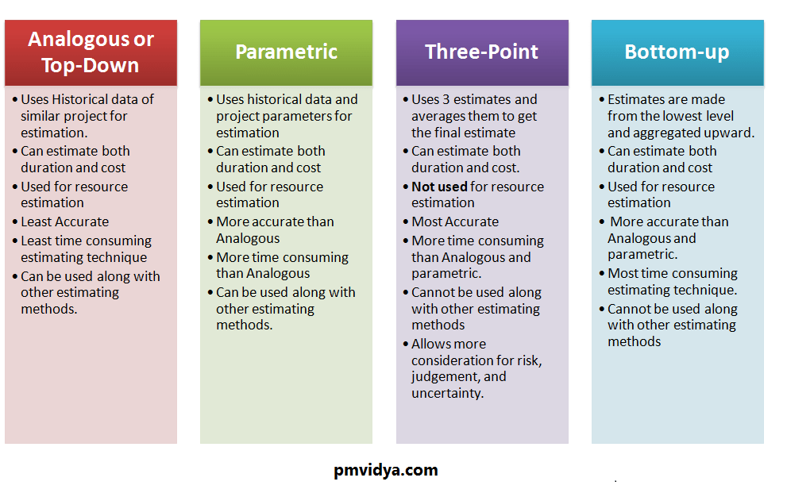

## A6.4. <SKIM>Project failure--12 mistakes to avoid

**Introduction**

Have you ever been part of a failed IT project? If analyst research over the past 5 years is even close to being accurate, the answer is YES. Lets take a look at the definition of a successful IT project. A successful project is any initiative that satisfies all 5 of these criteria:

* •    Completed at or under budget.
* •    Completed on schedule.
* •    Meets sponsor objectives.
* •    Meets defined requirements of features and functions.
* •    Customers score the product as satisfactory or better.

If your projects do not meet all five success criteria, all the time, you need to read further to learn the roadblocks to avoid and the actions to take to make current and future projects successful.

**Numbers Talk**

The Standish Group Chaos Report (2003), a study of over 13,000 projects, shows project success rates have increased over the past 10 years, but still shows that 2 out of 3 projects are not successful. The Chaos report shows only 34% of projects meet all the criteria for a successful project. Challenged projects, those that only met a few project successes criteria measurements, contributed to 51% of the projects. Failed projects, those meeting none of the project success criteria, contributed to 15% of the projects. As with other research reports, it is safe to assume that today's IT project success rate is between 28 to 35%.

The Standish Group Chaos Report (2003) also shows the lost dollar value for US projects is estimated at $38 billion with another $17 billion in cost overruns for a total project waste of $55 billion against $255 billion in project spending.

The bottom line is, 21% of the money your organization spends on IT projects is thrown away. That means, for an organization that budgets $10 million for IT projects this year, they will be receiving no value from $2.1 million of the money spent.

For consulting service organizations who specialize in turn-key projects, the data can be viewed another way. If their organization is financially responsible for the success of $10 million in a project portfolio, they could be performing $10 million of services work while only generating $7.9 million in revenue.

In the article Why Do System Implementations Fail (Sommers, 2003) a survey of 417 IT executives and managers lists 36 items to mitigate during a project to improve project performance.

After years of project successes and roundtable discussions with IT and business executives across the country, I have identified the **“TOP 12”** IT project mistakes that must be avoided.

**1. Project Is Not Part Of The Strategic Plan**

A strategic plan identifies your company's business goals and the solutions needed to support those business goals. If a project does not line up with one of the items on the strategic plan, you should not do the project.

Many organizations are in “re-active” mode. Their focus is on the hottest fire of the day. These organizations usually look at a strategic plan once a year or sometimes never create one. Within these organizations, project failure is more prominent than project success. What is the key? Projects aligned with business goals on the strategic plan will “add value” to the business and your customers.

A large manufacturing organization implemented an expensive application monitoring solution that was implemented on-time and 13% over budget. The justification for the project: Help desk staff would better understand the user application needs and problems when they called in with an issue. The project team considered this a success, plus they had some cool technology to play with.

Unfortunately for the project team, the CFO attended the project de-briefing. The CFO's only question to the team was: “How does this product help us produce more widgets, reduce inventory, or improve customer service?” After a minute of silence and blank faces, the CFO then stated that this project was a failure and just cost us $300,000 plus, returning no value to the business.

This project team learned a lesson the hard way.

**Roadblocks**

* •     Non-strategic projects are first to be cancelled.
* •    Team members and other resources are pulled for high priority “strategic” projects.
* •    Executive and business unit time commitments are limited.
* •    Project budget is reduced.
* •    Executives and business units are slow to respond to critical issues, risks, or project activities.

**Action To Take**

* •    Identify which item on the strategic plan your project supports.
* •    Understand the priority of this strategic plan item.
* •    Understand the “value” your project brings to the business.
* •    Decide whether the risks are to high to continue.

**2. No Executive Sponsorship**

Executive sponsorship of your project is vital for project success. Active sponsor participation has historically ensured a project will be on-time, within budget, and meet the business goals. Take a look at the projects you have been involved in over the past year. When there is an executive sponsor sitting in status meetings, reviewing plans, meeting with team members, etc. the project team stays focused on the project objectives, roadblocks are removed immediately, and morale is up.

Project teams seem to feed off the executives leadership and focus. Projects that are delegated down to line level managers seem to float along, stop when issues arise, and go in fragmented directions. These projects have a higher risk of failure.

**Roadblocks**

* •    Project does not get the right level of support when needed.
* •    Project goes in fragmented directions.
* •    Issue resolutions are slow to arrive, sometimes causing a stoppage of the project.
* •    Project lacks focus.
* •    No leadership.

**Action To Take**

* •    Identify the technical, business, and financial sponsor.
* •    Determine the sponsors participation in the project.
* •    Elicit sponsorship from C-Level executives who will receive the greatest value from the project.

**3. Poor Technology Evaluation**

Many project failures start at the beginning. The evaluation team is knowledgeable on some aspects of the technology but they do not spend enough time researching solutions and they believe all the hype from vendors and industry media.

We have found successful project teams perform an intensive due diligence upfront by using tools like RFI's, RFP's, client visits, demo's using live customer data, etc. Asking the tough detail questions in the beginning can save your return on investment at the end.

**Roadblocks**

* •    Products selected do not work.
* •    Products selected have never been implemented before.
* •    The correct components were not budgeted or purchased until later in the project.
* •    Vendor goes out of business before project completion.

**Action To Take**

* •    Perform an intensive due diligence upfront.
* •    Verify reality vs. vaporware.
* •    See it, tough it, and use it in a comparable environment.

**4. No Customer Involvement**

Successful projects need input from the people who will be affected most by the project. The customers should be consulted on the value they will receive from a product. When implementing an inventory control system, your best feedback will come from the inventory control clerks and supervisors. They better understand the business processes and how to improve efficiencies than anyone else on a project team. These customers can best help with process improvements, features, and functions.

Another key factor on customer involvement is “who” will be included on the team. Successful projects have the best and brightest customers on the team. These individuals make the best decisions in a more timely manner. Also, their time is committed to the project to avoid day to day business priorities that would normally take them away from the project.

**Roadblocks**

* •    Products developed do not meet customer needs.
* •    New business process reduces productivity.
* •    Product design takes longer than expected.
* •    Product is not accepted by the customers.
* •    Products developed do not provide a return on investment or add value to the business.

**Action To Take**

* •    Assign the best and brightest customers to the project.
* •    Commit customer time to the project to avoid day to day priorities.

**5. Scope Creep**

Adding additional scope without testing it against the business case and evaluating the impact on the cost, schedule, and risks is the easiest way to sink a project. Modifying products is risky and the most common form of scope creep. The project best practice is to implement quickly, get the benefit quickly, and modify later. As an example, waiting on software features is better than getting off the vendor upgrade path.

A large retailer implementing a retail management system decided their operations were so unique that they changed 90% of the programs during a two year, $11 million implementation. During the development phase of this project, the vendor released a new and improved version of the software. Once the modified package was implemented, the retailer looked at upgrading to the new release. First, they found that they were not eligible for software upgrades since they modified the code. Second, analysis determined that they would need one full year of programming effort to input the same modifications into the new release. End result, they will be customizing and running this system until it breaks or they can cost justify the purchase of a new system.

**Roadblocks**

* •    Development never ends, product changes frequently.
* •    Modifications to product during initial development drastically increases your risk of failure.
* •    Getting off the vendor upgrade path.
* •    Unexpected increase in cost, effort, and duration.

**Action To Take**

* •    Only modify products if business critical.
* •    Test the change in scope against the business case.
* •    Evaluate impact on cost, schedule, and risks.
* •    Implement scope changes in the next release.
* •    Set up a Change Management Committee.

**6. Invalid Pilots**

Pilot phases of a project can be very enlightening. What a great tool, test the product in a smaller real life environment. Failure occurs when the pilot does not simulate reality.

A mid west distribution company built a brand new lab environment for the new Back Office System project. The pilot was a complete success. Problems started occurring during the rollout of the software to remote locations. Unknowingly, a project lead asked “What is the hardware configuration of the pilot test lab?” What did they find? The lab was built with the latest and greatest server and desktop hardware. The remote facilities were running hardware from five years ago and did not support the new software.

**Roadblocks**

* •    Pilot lab equipment does not mimic reality.
* •    Works in the lab, not on the product floor.
* •    Product can be a complete failure on the first day it is released.

**Action To Take**

* •    Before starting, document an accurate inventory of all hardware, software, and other production environment information.
* •    Validate the pilot tests for all environment configurations.

**7. Inadequate Testing**

Question: What is the second item cut when a project is low on funding or over budget? Answer: Testing of course.

Limiting your testing of a solution will increase the chance of system failure or unknown bugs that can cripple your business. Do not skimp on testing to save time or money. Eliminate features first.

To limit project failure, the testing phase should consist of system test, customer acceptance testing, volume testing, and stress testing to test scalability.

**Roadblocks**

* •    Dramatic increase in product bugs.
* •    Dramatic increase in quality issues.
* •    Increased risk of product failure.
* •    Increased costs during deployment and support.
* •    Low customer satisfaction.

**Action To Take**

* •    Eliminate features before cutting back on testing.
* •    Testing should include system test, customer acceptance test, volume test, and stress testing.

**8. Poor Planning**

Rolling out a product to one location is fairly simple. Now, take the same product and try deploying it to hundreds of locations across the country simultaneously. Multiple location deployments are more of a challenge to do quickly and cost effectively. Larger deployments require more planning due to greater chances of conflicts and timing issues. Proper planning of equipment and resources will make or break the project.

**Roadblocks**

* •    Number of outside locations to deploy products increases project complexity and risk exponentially.
* •    Unknown conflicts and timing issues delay project.
* •    Unexpected staffing needs.
* •    Unexpected equipment and supply needs, increasing cost of project.

**Action To Take**

* •    Perform a detail plan before the start of the project
* •    Review and adjust plan on a daily basis

**9. Rolling Out At The Wrong Time**

Proper timing of a project “Go Live” is an important success factor that is often challenged by missed milestone dates. Business sponsors want solutions implemented before peak times where it will provide the greatest benefit. However, pilots and testing cannot be sacrificed. Pressing your luck on the timing of a rollout can be disastrous.

A small specialty retailer was behind schedule on a warehouse system implementation. The original planned completion date of the project was one month prior to the Christmas rush where the facility pushed through 1/3 of the yearly volume. Scope creep added an additional 2 months to the project, but the new date was not acceptable. Limiting the software testing reduced this overage by 1 month. Therefore, the team was behind schedule by 1 month, but could be implemented days before the Christmas rush.

This new software was so important to the business that they made a decision to “Go Live” the weekend before the heaviest volume would arrive. Due to poor testing, the system could not handle the warehouse volume which slowed productivity and delayed shipments to the stores. A project post mortem review estimated a $13 million loss of sales caused by the poorly timed system roll out.

**Roadblocks**

* •    Missed milestones and a “Go Live” date that cannot move will sacrifice other key project needs (i.e. testing, pilot, etc.).
* •    Peak volume season sounds good to the business but adds unnecessary stress and risk.
* •    Conflicts with other projects and initiatives targeted for the same period of time.

**Action To Take**

* •    Once a “Go Live” date is available, evaluate the business cycle, other project dependencies, alternative dates, etc.
* •    Understand why the business needs a solution by a certain date.
* •    Allocate enough time between “Go Live” and Peak Season to work out any last minute kinks.

**10. Limited Training**

Training is the first thing cut from a project when funding is low or over budget. You get the product released and the sponsors will not spend additional money on training. Without proper training, the new system will not provide the expected return on investment. Additionally, poor or no training will lead to low customer acceptance resulting in a failed project. To receive value, the customer must know how to use the new product.

**Roadblocks**

* •    Low customer acceptance.
* •    Increased costs during deployment and support.
* •    Low morale and decreased productivity.
* •    Lost revenue.

**Action To Take**

* •    Prepare a low cost training alternative.
* •    Involve customers more during the product testing.
* •    Eliminate features before cutting back on training.
* •    Delay the project if possible.

**11. Underestimating Change To The Business**

Change management involves the business process changes necessary to succeed. When implementing software, failure occurs most of the time when the project sponsors do not understand that they must change the business to work with the software or change the software to work like the business.

Managing change is more difficult in organizations with high turnover, lack of education, or high stress environments. To successfully manage change, a project should have 25 to 35% of the budget allocated to change management. This allocation will lower the project risk and provide a cushion toward project success.

Take, for example, the shoe company that implemented a warehouse management system to increase inventory accuracy and throughput. The project was, from the beginning, focused on software features and functions. Little attention was given to current and future operating practices on the warehouse floor, how they could improve and must change. In the end, the implementation resulted in a 1.2 million square foot facility that was very adept at quickly losing product. If process improvements are identified early, as part of the business case effort, they are much more likely to be carried through to implementation.

**Roadblocks**

* •    Project and business processes are not aligned.
* •    Business process changes are not considered until the end of the project.
* •    Drastic process or project changes required at the last minute causing overages and delays.
* •    Results in reduced or negative ROI.

**Action To Take**

* •    Understand the business process impact of the solution at the beginning of the project.
* •    Allocate a 25 to 35% change management budget (time and cost).
* •    Set up a Change Management committee with the business.

**12. Avoiding Risk Analysis**

No one likes discussing project risks. It is human nature to think positive, that nothing will go wrong. Sometimes success or failure is determined by how well prepared a project team is when disaster occurs. If they project team or organization is not prepared, the project may stop unexpectedly until a new plan can be executed.

During a project milestone review session at one financial services company, the project manager was asked “risk type” questions like, “What are the chances that vacations will slow down the project?” and “What affects will a union strike have on the project?”. The project manager answered with one statement, “We don't worry about those things, we are her to code, test and install this application”. As you guessed, no one analyzed the risks so no mitigation plan was in place. In the end, consultants were hired to make up for low staff counts, the project was over budget by 43% and implemented 4 months late.

An insurance company that ran a skeleton staff always ran projects by the seat of their pants. Plan were sketched out on scrap pieces of paper and planning for the unexpected was considered a waste of time. During a hardware and software upgrade that was to be implemented before year end processing, there was no contingency plan if the hardware was late. Due to production problems, the new hardware was delayed for 2 months. Two weeks before the “Go Live”, they were scrambling around looking to rent hardware. Unfortunately, the project was not implemented before year end.

**Roadblocks**

* •    Nobody likes discussing “risks”.
* •    Project teams are not prepared for disaster.
* •    Unrealistic view of the project status.
* •    A .01% risk probability can stop a $100 million project dead.
* •    Unexpected project delays and cost overruns.

**Action To Take**

* •    Day 1, start a risk management log.
* •    Identify risks throughout the project.
* •    Continually revise risk mitigation and contingency plans.

## A6.5. Why do projects really fail?

Project failure has always been a hot topic. Yet the mystery behind what drives projects off track is starting to fade. Organizations have come a long way when it comes to ferreting out the root causes of failure.

Here are some of the top reasons projects fall short—and tips for how you can use that knowledge to stop making the same mistakes over and over again:

**1. Poor alignment**

The right project isn't always the most profitable one, but it does have to align with the organization's vision. If not, a lack of executive backing will most likely doom it. If the project will deliver value to customers and users, though, stakeholder support and ownership should be strong.

**2. Bad planning**

The old adage tells us, “If you fail to plan, you plan to fail.” The planning stage of the project has to be taken seriously. Project managers must identify key risks, dependencies, stakeholders, and communication and quality needs. Consulting team members and subject matter experts will help ensure the team's buy-in and commitment.

**3. Lack of executive support**

The gap between project managers and executives has always been there. All too often, a senior manager is made the project sponsor without enough knowledge of the project—or even a basic knowledge of a project manager's role.

Project managers can find themselves alone when it comes to wrestling with project issues, stakeholder conflicts, and lack of cooperation from resource managers, system users, team members and other support departments.

The sponsor must agree to study the project charter and have a full understanding of each and every section. Once the charter is formally accepted and signed, the sponsor should then send a notice asking all stakeholders to give full support to the project manager. This can lead to great results in organizations that are not projectized. Executive support must be continuously given to empower the project manager during all stages of the project and should be on the agenda of steering committee meetings.

**Join the discussion on PMI.org/Voices**

In her post, **“Developing Swift Trust,”** Lynda Bourne, DPM, PMP, explains, “Swift trust occurs when a diverse group of experts are brought together in a temporary organization such as a virtual team created for an urgent project.” Ahmad Al-Ani, MD, PMP, commented that project managers “should build (rather than have) such a skill, since many projects are short-term ones involving strangers from outside the comfort zone.”

**4. Incomplete requirements**

One issue that haunts IT projects in particular is the high level of uncertainty. To avoid drastic changes during later stages, project managers should follow a robust requirements analysis process and build a consensus among conflicting stakeholders from the start.

**5. Unclear expectations**

Different stakeholders may perceive a project in different ways, and each has his or her own ideas about its duration, cost and quality. Make sure to set expectations and establish that some deviation is inevitable. Without that step, a key stakeholder is likely to wield undue power and could easily get the project canceled. Throughout the project, continue to anticipate and monitor stakeholder attitudes, demands and actions.

**6. Scope creep**

Uncontrolled changes can bust a budget. Project managers must institute a robust change-management process that can handle both minor and major shifts. Beware of “gold plating,” another form of scope creep, where some extravagant additions are included by a project team in an attempt to indulge stakeholders.

A project manager has to promote a culture of change management and protect the boundaries of the project so it remains consistent with its charter. Ideally, all changes should be assessed for their impacts on cost, time, risk and quality.

**7. Lack of resources**

The recession fundamentally altered the way organizations work: Projects come with fewer resources, stricter deadlines, higher expectations and smaller budgets. Working in a weak-matrix environment only compounds matters because resources are shared among more than one project, and the functional manager often defines priorities. To secure resources and gain executive support, project managers should be well-versed in people skills.

**8. Choice of technology**

With new technology comes risk. Selecting the wrong technology, incapable system integrators and inadequate products can all lead to trouble. Vendors are going to oversell their products, and many project managers have been duped. Project managers and their teams must conduct robust due diligence and demand that vendors present relevant case studies and proof the technology does what the company says it will.

**9. Inexperience**

Though they're loath to admit it, project professionals themselves can be the main reason projects fail. Some lack education or experience, while others adopt an improper management style. Few project managers will accept accountability when a project doesn't work out—but it's the first step in learning from their mistakes.

# Week 7 Quality Assurance/Risk

## A7.1. The Difference Between Quality Assurance and Quality Control

It is important for an organisation to agree on what the meanings of **Quality Assurance** (QA) and **Quality Control** (QC). Both form an integral part of the organisation's quality management plan, and the effectiveness of delivery teams relies on the differences being well understood by all stakeholders, including management.  
  
Effective quality systems can contribute enormously to the success of projects, but the counterpoint is that, when poorly understood, the quality systems are likely to be weak and ineffective in ensuring that the delivered system is delivered on time, built by the team within their allocated budget, and satisfies the customer’s requirements.  
  
This article considers the difference between Quality Assurance and Quality Control. The concepts are investigated by looking at guidance from key industry players.

**Introduction**

How many times has it struck you that many practitioners involved in the ICT field lack an understanding of the difference between Quality Assurance and Quality Control? Often you will hear someone talk about ‘QA’, when what they actually mean is ‘QC’.  
  
This ambiguity consistently throws up problems and is a sure way of undermining a project. Projects are negatively affected as it tends to lead to strained conversations and makes reaching consensus difficult.  
  
Although QA and QC are closely related concepts, and are both aspects of quality management, they are fundamentally different in their focus:

* **QC is used to verify the quality of the output;**
* **QA is the process of managing for quality.**

Achieving success in a project requires both QA and QC. If we only apply QA, then we have a set of processes that can be applied to ensure great quality in our delivered solution, but the delivered solution itself is never actually quality-checked.  
Likewise, if we only focus on QC then we are simply conducting tests without any clear vision for making our tests repeatable, for understanding and eliminating problems in testing, and for generally driving improvement into the means we use to deliver our ICT solutions.  
  
In either case, the delivered solution is unlikely to meet the customer expectation or satisfy the business needs that gave rise to the project in the first place.

**Understanding the Difference Between QA and QC**

So, what exactly is the difference between Quality Assurance (QA) and Quality Control (QC)?  
  
A good point of reference for understanding the difference is the **ISO 9000 family of standards**. These standards relate to quality management systems and are designed to help organisations meet the needs of customers and other stakeholders.  
  
In terms of this standard, a quality management system is comprised of quality planning and quality improvement activities, the establishment of a set of quality policies and objectives that will act as guidelines within an organisation, and QA and QC.  
  
In the ISO 9000 standard, clause 3.2.10 defines Quality Control as:  
***“A part of quality management focused on fulfilling quality requirements”***  
  
Clause 3.2.11 defines Quality Assurance as:  
***“A part of quality management focused on providing confidence that quality requirements will be fulfilled”***  
  
These definitions lay a good foundation, but they are too broad and vague to be useful. NASA, one of the most rigorous software engineering firms in the world, provides the following definitions:

Software Quality Control:  
***"The function of software quality that checks that the project follows its standards, processes, and procedures, and that the project produces the required internal and external (deliverable) products"***  
  
Software Quality Assurance:  
***"The function of software quality that assures that the standards, processes, and procedures are appropriate for the project and are correctly implemented"***  
  
Simply put, Quality Assurance focuses on the process of quality, while Quality Control focuses on the quality of output.

**Quality Assurance: a Strategy of Prevention**

QA is focused on planning, documenting and agreeing on a set of guidelines that are necessary to assure quality. QA planning is undertaken at the beginning of a project, and draws on both software specifications and industry or company standards. The typical outcomes of the QA planning activities are quality plans, inspection and test plans, the selection of defect tracking tools and the training of people in the selected methods and processes.  
  
**The purpose of QA is to prevent defects from entering into the solution in the first place.** In other words, QA is a pro-active management practice that is used to assure a stated level of quality for an IT initiative.  
  
Undertaking QA at the beginning of a project is a key tool to mitigate the risks that have been identified during the specification phases. Communication plays a pivotal role in managing project risk, and is crucial for realising effective QA. Part of any risk mitigation strategy is the clear communication of both the risks, and their associated remedies to the team or teams involved in the project.

**Quality Control: a Strategy of Detection**

Quality Control, on the other hand, includes all activities that are designed to determine the level of quality of the delivered ICT solutions. **QC is a reactive means by which quality is gauged and monitored**, and QC includes all operational techniques and activities used to fulfil requirements for quality. These techniques and activities are agreed with customers and/or stakeholders before project work is commenced.  
  
QC involves verification of output conformance to desired quality levels. This means that the ICT solution is checked against customer requirements, with various checks being conducted at planned points in the development lifecycle. Teams will use, amongst other techniques, structured walkthroughs, testing and code inspections to ensure that the solution meets the agreed set of requirements.

**Benefits of Quality Management**

The benefits of a structured approach to quality management cannot be ignored.  
  
Quality Control is used, in conjunction with the quality improvement activity, to **isolate and provide feedback on the causes of quality problems**. By using this approach consistently, across projects, the feedback mechanism works towards identifying root-cause problems, and then developing strategies to eliminating these problems. Using this holistic approach ensures that teams achieve ever higher levels of quality.  
  
As a consequence of formulating and executing a quality management plan the company can expect:

* Greater levels of customer satisfaction, which will very likely result in both repeat business, as well as referral business
* A motivated team that not only understand the policy objectives of the quality management plan, but who also actively participate in executing the plan
* Elimination of waste by eliminating rework arising from either the need to address bugs, or to address gaps in the solution’s ability to meet customer requirements
* Higher levels of confidence in planning, since the tasks arising from unplanned rework will fall away
* Financial rewards for the company, which are a consequence of new projects from existing and referral clients, as well as through the reduction of monies spent on rework tasks.

As the company’s quality management plan matures, **the confidence of all stakeholders will grow.** The company will be seen to be more effective and efficient in delivering an agreed ICT solution to clients.

## A7.2. Difference Between Quality Assurance And Quality Control (QA Vs QC)

**What is Quality?**

Quality is meeting the requirement, expectation, and needs of the customer is free from the defects, lacks and substantial variants. There are standards needs to follow to satisfy the customer requirements.

**What is Assurance?**

Assurance is provided by organization management, it means giving a positive declaration on a product which obtains confidence for the outcome. It gives a security that the product will work without any glitches as per the expectations or requests.

**What is Quality Assurance?**

Quality Assurance is known as QA and focuses on preventing defect. Quality Assurance ensures that the approaches, techniques, methods and processes are designed for the projects are implemented correctly.

Quality assurance activities monitor and verify that the processes used to manage and create the deliverables have been followed and are operative.

Quality Assurance is a proactive process and is Prevention in nature. It recognizes flaws in the process. Quality Assurance has to complete before Quality Control.

**What is Control?**

Control is to test or verify actual results by comparing it with the defined standards.

**What is Quality Control?**

Quality Control is known as QC and focuses on identifying a defect. QC ensures that the approaches, techniques, methods and processes are designed in the project are following correctly. QC activities monitor and verify that the project deliverables meet the defined quality standards.

Quality Control is a reactive process and is detection in nature. It recognizes the defects. Quality Control has to complete after Quality Assurance.

**What is The Difference in QA/QC?**

Many people think QA and QC are the same and interchangeable but this is not true. Both are tightly linked and sometimes it is very difficult to identify the differences. Fact is both are related to each other but they are different in origins. QA and QC both are part of Quality Management however QA is focusing on preventing defect while QC is focusing on identifying the defect.

**QA vs QC**

**Here is the exact difference between Quality Control and Quality Assurance that one needs to know:**

| **Quality Assurance** | **Quality Control** |
| --- | --- |
| It is a process which deliberates on providing assurance that quality request will be achieved. | QC is a process which deliberates on fulfilling the quality request. |
| A QA aim is to prevent the defect. | A QC aim is to identify and improve the defects. |
| QA is the technique of managing quality. | QC is a method to verify quality. |
| QA does not involve executing the program. | QC always involves executing the program. |
| All team members are responsible for QA. | Testing team is responsible for QC. |
| QA Example: Verification | QC Example: Validation. |
| QA means Planning for doing a process. | QC Means Action for executing the planned process. |
| Statistical Technique used on QA is known as Statistical Process Control (SPC.) | Statistical Technique used on QC is known as Statistical Quality Control (SPC.) |
| QA makes sure you are doing the right things. | QC makes sure the results of what you've done are what you expected. |
| QA Defines standards and methodologies to followed in order to meet the customer requirements. | QC ensures that the standards are followed while working on the product. |
| QA is the process to create the deliverables. | QC is the process to verify that deliverables. |
| QA is responsible for full software development life cycle. | QC is responsible for [software testing life cycle.](https://www.softwaretestinghelp.com/what-is-software-testing-life-cycle-stlc/) |

**Does Quality Assurance Remove Need for Quality Control?**

**“If QA (Quality Assurance) is done then why do we need to perform QC (Quality Control)?”**

Well, this thought might come to your mind, from time to time.

If we have followed all the pre-defined processes, policies & standards correctly and completely then why do we need to perform a round of QC?

In my opinion, QC is required after QA is done.

While doing ‘QA’, we define the processes, policies & strategies, establish standards, develop checklists etc. that needs to be used and followed throughout the life cycle of a project.

And while doing QC we follow all those defined processes, standards and policies that we laid down in QA to make sure that the project is maintaining high quality and the final outcome of the project at least meets the customer’s expectations.

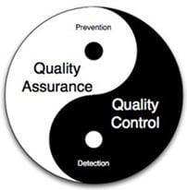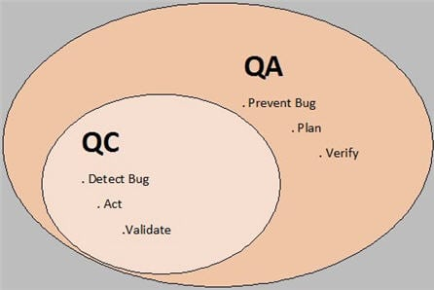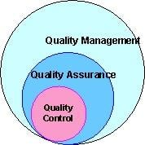

**QC looks at the end of the line while QA looks further down the line.** QC aims at detecting & correcting the issues while QA aims at preventing the issues to occur.

**QA does not assure quality, rather it creates and ensures the processes are being followed to assure quality. QC does not control quality, rather it measures quality.** QC measurement results can be utilized to correct/modify QA processes which can be successfully implemented in new projects as well.

Quality control activities are focused on the deliverable itself. Quality assurance activities are focused on the processes followed to create the deliverable.

**QA and QC are both part of Quality management and these are the powerful techniques which can be used to ensure that the deliverables are of high quality and meet expectations of the customers.**

When we talk about software testing, it falls in the domain of quality control because it focuses on the product or application. We test the quality in order to control it. Furthermore, quality assurance makes sure that we are doing the testing in the right way.

**Example:**Suppose we need to use an Issue tracking system to log the bugs during the testing of a web application.  
QA would include defining the standard for adding a bug and what all details should be there in a bug like a summary of the issue, where it is observed, steps to reproduce the bugs, screenshots etc. This is a process to create a deliverable called ‘bug–report’.

When a bug is actually added in issue tracking system based on these standards then that bug report is our deliverable. This activity is a part of the QA process.

Now, suppose some time at a later stage of the project, we realize that adding ‘probable root cause’ to the bug based on tester’s analysis would provide some more insight to the Dev team, then we will update our pre-defined process and finally, it will be reflected in our bug reports as well.

Adding this extra information in the bug report to support faster & better resolution of the issue is a part of the QC Process. So, this is how QC gives its inputs to QA to further improve the QA and final deliverables.

**Real-life scenario Examples for QA/QC**

**QA Example:**

Suppose our team has to work on completely new technology for an upcoming project. Our team members are new to technology. So, for that, we need to create a plan for getting the team members trained in the new technology.

Based on our knowledge, we need to collect pre-requisites like DOU (Document of Understanding), design document, technical requirement document, functional requirement document, etc. and share these with the team.

This would be helpful while working on the new technology and even would be useful for any newcomer in the team. This collection & distribution of documentation and then kicking off the training program is a part of the QA process.

**QC Example:**

Once the training is completed, how can we make sure that the training was successfully done for all the team members?

For this purpose, we will have to collect statistics e.g. the number of marks the trainees got in each subject and the minimum number of marks expected after completing the training. Also, we can make sure that everybody has taken training in full by verifying the attendance record of the candidates.

If the marks scored by candidates are up to the expectations of the trainer/evaluators, then we can say that the training is successful otherwise we will have to improve our process in order to deliver high-quality training.

Another way to improve the training process would be collecting feedback from the trainees at the end of the training program. Their feedback will tell us what was good about the training and what are the areas where we can improve the quality of training. So, such activities are a part of the QA process.

**Conclusion**

**Key Points:**

* In QA, processes are planned to evade the defects
* QC agreements with the discovery of the defects and modifying them while making the product
* QA detects weakness
* QC detects defects
* QA is process oriented
* QC is product oriented
* QA is a failure prevention system
* QC is a failure detection system.

QA & QC both are different from each other and required as part of quality management. They should not be misunderstood as interchangeable terms. QA is process focused while QC is end-product focused.

Quality control is inspecting something (a product or a service) to ensure that it is working fine. If the product or service is not working fine, then the issue needs to be fixed or eliminated in order to meet conformance standards. So, it aims at detecting and correcting issues.

Quality assurance, on the other hand, aims at preventing the issues from occurring in the future by improving the process.

To summarize, we can say that Quality assurance does not eliminate the need for Quality control as QC lies at the very core of Quality management.

## A7.3. What is Auditing?

Auditing is defined as the on-site verification activity, such as inspection or examination, of a [process](https://asq.org/quality-progress/articles/standards-outlook-process-auditing-and-techniques?id=e1c802e8bac247c89d38744e787c0b58) or [quality system](https://asq.org/quality-resources/iso-19011), to ensure compliance to requirements. An audit can apply to an entire organization or might be specific to a function, process, or production step. Some audits have special administrative purposes, such as auditing documents, risk, or performance, or following up on completed corrective actions.

* The three different types of auditing
* What are first-party, second-party, and third-party audits?
* What are the four phases of an audit cycle?
* Auditing resources
* Become a certified auditor

**The Three Different Types of Audits**

[ISO 19011:2018](https://asq.org/quality-resources/iso-19011) defines an audit as a "systematic, independent and documented process for obtaining audit evidence [records, statements of fact or other information which are relevant and verifiable] and evaluating it objectively to determine the extent to which the audit criteria [a set of policies, procedures or requirements] are fulfilled." There are three main types of audits:

* [**Process audit**](https://asq.org/quality-progress/articles/standards-outlook-process-auditing-and-techniques?id=e1c802e8bac247c89d38744e787c0b58)**:**This type of audit verifies that processes are working within established limits. It evaluates an operation or method against predetermined instructions or standards to measure conformance to these standards and the effectiveness of the instructions. A process audit may:
  + Check conformance to defined requirements such as time, accuracy, temperature, pressure, composition, responsiveness, amperage, and component mixture.
  + Examine the resources (equipment, materials, people) applied to transform the inputs into outputs, the environment, the methods (procedures, instructions) followed, and the measures collected to determine process performance.
  + Check the adequacy and effectiveness of the process controls established by procedures, work instructions, [flowcharts](https://asq.org/quality-resources/flowchart), and training and process specifications.
* **Product audit:** This type of audit is an examination of a particular product or service, such as hardware, processed material, or software, to evaluate whether it conforms to requirements (i.e., specifications, performance standards, and customer requirements).
* **System audit:** An audit conducted on a management system. It can be described as a documented activity performed to verify, by examination and evaluation of objective evidence, that applicable elements of the system are appropriate and effective and have been developed, documented, and implemented in accordance and in conjunction with specified requirements.
  + A ***quality management system audit*** evaluates an existing [quality management program](https://asq.org/quality-resources/quality-management-system) to determine its conformance to company policies, contract commitments, and regulatory requirements.
  + Similarly, an ***environmental system audit*** examines an [environmental management system](https://asq.org/quality-resources/environmental-management-system), a ***food safety system audit*** examines a food safety management system, and ***safety system audits*** examine the safety management system.

**Audit Considerations**

Other methods, such as a desk or document review audit, may be employed independently or in support of the three general types of audits.

Some audits are named according to their purpose or scope. The scope of a department or function audit is a particular department or function. The purpose of a management audit relates to management interests, such as assessment of area performance or efficiency.

An audit may also be classified as internal or external, depending on the interrelationships among participants. Internal audits are performed by employees of your organization. External audits are performed by an outside agent. Internal audits are often referred to as first-party audits, while external audits can be either second-party or third-party.

**Auditing on ASQTV**

**What are First-Party, Second-Party, and Third-Party Audits?**

* A **first-party audit** is performed within an organization to measure its strengths and weaknesses against its own procedures or methods and/or against external standards adopted by (voluntary) or imposed on (mandatory) the organization. A first-party audit is an internal audit conducted by auditors who are employed by the organization being audited but who have no vested interest in the audit results of the area being audited.
* A **second-party audit** is an external audit performed on a supplier by a customer or by a contracted organization on behalf of a customer. A contract is in place, and the goods or services are being, or will be, delivered. Second-party audits are subject to the rules of contract law, as they are providing contractual direction from the customer to the supplier. Second-party audits tend to be more formal than first-party audits because audit results could influence the customer’s purchasing decisions.
* A **third-party audit** is performed by an audit organization independent of the customer-supplier relationship and is free of any conflict of interest. Independence of the audit organization is a key component of a third-party audit. Third-party audits may result in certification, registration, recognition, an award, license approval, a citation, a fine, or a penalty issued by the third-party organization or an interested party.

**Industry Certification Through Auditing**

Companies in certain high-risk categories—such as toys, pressure vessels, elevators, gas appliances, and electrical and medical devices—wanting to do business in Europe must comply with [Conformité Europeënne Mark (CE Mark)](https://asq.org/quality-resources/ce-marking) requirements. One way for organizations to comply is to have their management system certified by a third-party audit organization to management system requirement criteria (such as [ISO 9001](https://asq.org/quality-resources/iso-9001)).

Customers may suggest or require that their suppliers conform to ISO 9001, [ISO 14001](https://asq.org/quality-resources/iso-14001), or [safety criteria](https://asq.org/quality-resources/safety), and federal regulations and requirements may also apply. A third-party audit normally results in the issuance of a certificate stating that the auditee organization management system complies with the requirements of a pertinent standard or regulation.

Third-party audits for system certification should be performed by organizations that have been evaluated and accredited by an established accreditation board, such as the [ANSI-ASQ National Accreditation Board (ANAB)](http://anab.org/).

**Performance Audits vs. Compliance and Conformance Audits**

Value-added assessments, management audits, added value auditing, and [continual improvement assessment](https://asq.org/quality-resources/continuous-improvement) are terms used to describe an audit purpose beyond compliance and conformance. The purpose of these audits relates to organization performance. Audits that determine compliance and conformance are not focused on good or poor performance, yet. Performance is an important concern for most organizations.

A key difference between compliance audits, conformance audits, and improvement audits is the collection of evidence related to organization performance versus evidence to verify conformance or compliance to a standard or procedure. An organization may conform to its procedures for taking orders, but if every order is subsequently changed two or three times, management may have cause for concern and want to rectify the inefficiency.

**Follow-Up Audits**

A product, process, or system audit may have findings that require correction and corrective action. Since most corrective actions cannot be performed at the time of the audit, the audit program manager may require a follow-up audit to verify that corrections were made and corrective actions were taken. Due to the high cost of a single-purpose follow-up audit, it is normally combined with the next scheduled audit of the area. However, this decision should be based on the importance and risk of the finding.

An organization may also conduct follow-up audits to verify preventive actions were taken as a result of performance issues that may be reported as opportunities for improvement. Other times organizations may forward identified performance issues to management for follow-up.

**What are the four Phases of an Audit cycle?**

1. **Audit planning and preparation:** Audit preparation consists of planning everything that is done in advance by interested parties, such as the auditor, the lead auditor, the client, and the audit program manager, to ensure that the audit complies with the client’s objective. This stage of an audit begins with the decision to conduct the audit and ends when the audit itself begins.
2. **Audit execution:** The execution phase of an audit is often called the *fieldwork*. It is the data-gathering portion of the audit and covers the time period from arrival at the audit location up to the exit meeting. It consists of multiple activities including on-site audit management, meeting with the auditee, understanding the process and system controls and verifying that these controls work, communicating among team members, and communicating with the auditee.
3. **Audit reporting:** The purpose of the audit report is to communicate the results of the investigation. The report should provide correct and clear data that will be effective as a management aid in addressing important organizational issues. The audit process may end when the report is issued by the lead auditor or after follow-up actions are completed.
4. **Audit follow-up and closure:** According to ISO 19011, clause 6.6, "The audit is completed when all the planned audit activities have been carried out, or otherwise agreed with the audit client." Clause 6.7 of ISO 19011 continues by stating that verification of follow-up actions may be part of a subsequent audit.

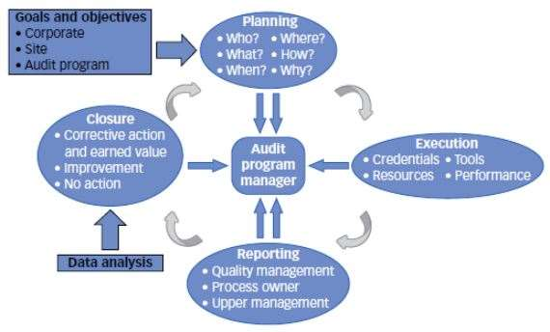

**The Four Phases of an Audit Cycle**

**Note:** Requests for correcting nonconformities or findings within audits are very common.

* **Corrective action** is action taken to eliminate the causes of an existing nonconformity, defect, or other undesirable situation in order to prevent recurrence (reactive). Corrective action is about eliminating the causes of problems and not just following a series of problem-solving steps.
* **Preventive action** is action taken to eliminate the causes of a potential nonconformity, defect, or other undesirable situation in order to prevent occurrence (proactive).

## A7.4. IT risk management -1

**What is IT risk?**

Information technology or IT risk is basically any threat to your business data, critical systems and business processes. It is the risk associated with the use, ownership, operation, involvement, influence and adoption of IT within an organisation. IT risks have the potential to damage business value and often come from poor management of processes and events.

**Categories of IT risks**

IT risk spans a range of business-critical areas, such as:

* security - eg compromised business data due to unauthorised access or use
* availability - eg inability to access your IT systems needed for business operations
* performance - eg reduced productivity due to slow or delayed access to IT systems
* compliance - eg failure to follow laws and regulations (eg data protection)

IT risks vary in range and nature. It's important to be aware of all the [different types of IT risk](https://www.nibusinessinfo.co.uk/content/different-types-it-risk) potentially affecting your business.

**Potential impact of IT failure on business**

For businesses that rely on technology, events or incidents that compromise IT can cause many problems. For example, a security breach can lead to:

* identity fraud and theft
* financial fraud or theft
* damage to reputation
* damage to brand
* damage to your business' physical assets

Failure of IT systems due to downtime or outages can result in other damaging and diverse consequences, such as:

* lost sales and customers
* reduced staff or business productivity
* reduced customer loyalty and satisfaction
* a damaged relationship with partners and suppliers

If IT failure affects your ability to comply with laws and regulations, then it could also lead to:

* breach of legal duties
* breach of client confidentiality
* penalties, fines and litigation
* reputational damage

If technology is enabling your connection to customers, suppliers, partners and business information, managing IT risks in your business should always be a core concern.

In its guidance, the National Cyber Security Centre (NCSC) provides a clear explanation of [why IT risk management matters](https://www.ncsc.gov.uk/collection/risk-management-collection/essential-topics/fundamentals)

.

IT risks should be carefully assessed and measured. This is where an [IT risk assessment](https://www.nibusinessinfo.co.uk/content/it-risk-assessment-methodology) comes in - a process of identifying security risks and evaluating the threat they pose. Once risks are identified and assessed, you will manage them through a comprehensive [IT risk management process](https://www.nibusinessinfo.co.uk/content/it-risk-management-process).

## A7.5. IT risk management -2

**Different types of IT risk**

Your IT systems and the information that you hold on them face a wide range of risks. If your business relies on technology for key operations and activities, you need to be aware of the range and nature of those threats.

**Types of risks in IT systems**

Threats to your IT systems can be external, internal, deliberate and unintentional. Most IT risks affect one or more of the following:

* business or project goals
* service continuity
* bottom-line results
* business reputation
* security
* infrastructure

**Examples of IT risks**

Looking at the nature of risks, it is possible to differentiate between:

* Physical threats - resulting from physical access or damage to IT resources such as the servers. These could include theft, damage from fire or flood, or unauthorised access to confidential data by an employee or outsider.
* Electronic threats - aiming to compromise your business information - eg a hacker could get access to your website, your IT system could become infected by a computer virus, or you could fall victim to a fraudulent email or website. These are often of a criminal nature.
* Technical failures - such as software bugs, a computer crash or the complete failure of a computer component. A technical failure can be catastrophic if, for example, you cannot retrieve data on a failed hard drive and no backup copy is available.
* Infrastructure failures - such as the loss of your internet connection can interrupt your business - eg you could miss an important purchase order.
* Human error - is a major threat - eg someone might accidentally delete important data, or fail to follow security procedures properly.

**How to manage IT risks?**

Managing various types of IT risks begins with identifying exactly:

* the type of threats affecting your business
* the assets that may be at risks
* the ways of securing your IT systems

Find out how to carry out an [IT risk assessment](https://www.nibusinessinfo.co.uk/content/it-risk-assessment-methodology) and learn more about the [IT risk management process](https://www.nibusinessinfo.co.uk/content/it-risk-management-process).

## A7.6. IT risk management -3

**IT risk management process**

In business, IT risk management entails a process of identifying, monitoring and managing potential information security or technology risks with the goal of mitigating or minimising their negative impact.

Examples of potential IT risks include security breaches, data loss or theft, cyber attacks, system failures and natural disasters. Anything that could affect the confidentiality, integrity and availability of your systems and assets could be considered an IT risk.

**Steps in the IT risk management process**

To manage IT risks effectively, follow these six steps in your risk management process:

**1. Identify risks**

Determine the nature of risks and how they relate to your business. Take a look at the [different types of IT risk](https://www.nibusinessinfo.co.uk/content/different-types-it-risk).

**2. Assess risks**

Determine how serious each risk is to your business and prioritise them. Carry out an [IT risk assessment](https://www.nibusinessinfo.co.uk/content/it-risk-assessment-methodology).

**3. Mitigate risks**

Put in place preventive measures to reduce the likelihood of the risk occurring and limit its impact. Find solutions in our [IT risk management checklist](https://www.nibusinessinfo.co.uk/content/it-risk-management-checklist).

**4. Develop an incident response**

Set out plans for managing a problem and recovering your operations. Devise and test your [IT incident response and recovery](https://www.nibusinessinfo.co.uk/content/it-incident-response-and-recovery) strategy.

**5. Develop contingency plans**

Ensure that your business can continue to run after an incident or a crisis. Read about [IT risk and business continuity](https://www.nibusinessinfo.co.uk/content/it-risk-and-business-continuity).

**6. Review processes and procedures**

Continue to assess threats and manage new risks. Read more about the [strategies to manage business risk](https://www.nibusinessinfo.co.uk/content/strategies-help-you-manage-business-risk).

**IT risk controls**

As part of your risk management, try to reduce the likelihood of risks affecting your business in the first place. Put in place measures to protect your systems and data from all known threats.

For example, you should:

* Review the information you hold and share. Make sure that you [comply with data protection legislation](https://www.nibusinessinfo.co.uk/content/data-protection-principles-under-uk-gdpr), and think about what needs to be on public or shared systems. Where possible, remove sensitive information.
* Install and maintain security controls, such as firewalls, anti-virus software and processes that help prevent intrusion and [protect your business online](https://www.nibusinessinfo.co.uk/content/protect-your-business-online).
* Implement security policies and procedures such as internet and email usage policies, and train staff.
* Use a third-party IT provider if you lack in-house skills. Often, they can provide their own security expertise. See how to [choose an IT supplier for your business](https://www.nibusinessinfo.co.uk/content/choose-it-supplier-your-business).

If you can't remove or reduce risks to an acceptable level, you may be able to take action to lessen the impact of potential incidents.

**Mitigate IT risks**

To mitigate IT risks, you should consider:

* setting procedures for detecting problems (eg a virus infecting your system), possibly with the help of [cyber security breach detection](https://www.nibusinessinfo.co.uk/content/cyber-security-breach-detection) tools
* getting [cyber insurance](https://www.nibusinessinfo.co.uk/content/cyber-insurance) against the costs of security breaches

# Week 8 Testing Management

## A8.1. How much Testing is Enough?

A familiar question every software developer and team grapples with is, “How much testing is enough to qualify a software release?” A lot depends on the type of software, its purpose, and its target audience. One would expect a far more rigorous approach to testing commercial search engine than a simple smartphone flashlight application. Yet no matter what the application, the question of how much testing is sufficient can be hard to answer in definitive terms. A better approach is to provide considerations or rules of thumb that can be used to define a qualification process and testing strategy best suited for the case at hand. The following tips provide a helpful rubric:

* Document your process or strategy.
* Have a solid base of unit tests.
* Don’t skimp on integration testing.
* Perform end-to-end testing for Critical User Journeys.
* Understand and implement the other tiers of testing.
* Understand your coverage of code and functionality.
* Use feedback from the field to improve your process.

**Document your process or strategy**

If you are already testing your product, document the entire process. This is essential for being able to both repeat the test for a later release and to analyze it for further improvement. If this is your first release, it’s a good idea to have a written test plan or strategy. In fact, having a written test plan or strategy is something that should accompany any product design.

**Have a solid base of unit tests**

A great place to start is writing unit tests that accompany the code. Unit tests test the code as it is written at the functional unit level. Dependencies on external services are either mocked or faked.

A *mock* has the same interface as the production dependency, but only checks that the object is used according to set expectations and/or returns test-controlled values, rather than having a full implementation of its normal functionality.

A *fake*, on the other hand, is a shallow implementation of the dependency but should ideally have no dependencies of it’s own. Fakes provide a wider range of functionality than mocks and should be maintained by the team providing the production version of the dependency. That way, as the dependency evolves so does the fake and the unit-test writer can be confident that the fake mirrors the functionality of the production dependency.

At many companies, including Google, there are best practices of requiring any code change to have corresponding unit test cases that pass. As the code base expands, having a body of such tests that is executed before code is submitted is an important part of catching bugs before they creep into the code base. This saves time later both in writing integration tests, debugging, and verifying fixes to existing code.

**Don’t skimp on integration testing**

As the codebase grows and reaches a point where numbers of functional units are available to test as a group, it’s time to have a solid base of integration tests. An integration test takes a small group of units, often only two units, and tests their behavior as a whole, verifying that they coherently work together.

Often developers think that integration tests can be deprioritized or even skipped in favor of full end-to-end tests. After all, the latter really tests the product as the user would exercise it. Yet, having a comprehensive set of integration tests is just as important as having a solid unit-test base (see the earlier Google Blog article, [Fixing a test hourglass](https://testing.googleblog.com/2020/11/fixing-test-hourglass.html)).

The reason lies in the fact that integration tests have less dependencies than full end-to-end tests. As a result, integration tests, with smaller environments to bring up, will be faster and more reliable than the full end-to-end tests with their full set of dependencies (see the earlier Google Blog article, [Test Flakiness - One of the Main Challenges of Automated Testing](https://testing.googleblog.com/2020/12/test-flakiness-one-of-main-challenges.html)).

**Perform end-to-end testing for Critical User Journeys**

The discussion thus far covers testing the product at its component level, first as individual components (unit-testing), then as groups of components and dependencies (integration testing). Now it’s time to test the product end to end as a user would use it. This is quite important because it’s not just independent features that should be tested but entire workflows incorporating a variety of features. At Google these workflows - the combination of a critical goal and the journey of tasks a user undertakes to achieve that goal - are called Critical User Journeys (CUJs). Understanding CUJs, documenting them, and then verifying them using end-to-end testing (hopefully in an automated fashion) completes the [Testing Pyramid](https://docs.google.com/presentation/d/15gNk21rjer3xo-b1ZqyQVGebOp_aPvHU3YH7YnOMxtE/edit#slide=id.g437663ce1_53_98).

**Understand and implement the other tiers of testing**

Unit, integration, and end-to-end testing address the functional level of your product. It is important to understand the other tiers of testing, including:

* Performance testing - Measuring the latency or throughput of your application or service.
* Load and scalability testing - Testing your application or service under higher and higher load.
* Fault-tolerance testing - Testing your application’s behavior as different dependencies either fail or go down entirely.
* Security testing - Testing for known vulnerabilities in your service or application.
* Accessibility testing - Making sure the product is accessible and usable for everyone, including people with a wide range of disabilities.
* Localization testing - Making sure the product can be used in a particular language or region.
* Globalization testing - Making sure the product can be used by people all over the world.
* Privacy testing - Assessing and mitigating privacy risks in the product.
* Usability testing - Testing for user friendliness.

Again, it is important to have these testing processes occur as early as possible in your review cycle. Smaller performance tests can detect regressions earlier and save debugging time during the end-to-end tests.

**Understand your coverage of code and functionality**

So far, the question of how much testing is enough, from a qualitative perspective, has been examined. Different types of tests were reviewed and the argument made that smaller and earlier is better than larger or later. Now the problem will be examined from a quantitative perspective, taking code coverage techniques into account.

Wikipedia has a great article on [code coverage](https://en.wikipedia.org/wiki/Code_coverage) that outlines and discusses different types of coverage, including statement, edge, branch, and condition coverage. There are several open source tools available for measuring coverage for most of the popular programming languages such as Java, C++, Go and Python. A partial list is included in the table below:

| **Language** | **Tool** |
| --- | --- |
| Java | JaCoCo |
| Java | JCov |
| Java | OpenClover |
| Python | Coverage.py |
| C++ | Bullseye |
| Go | Built in coverage support (go -cover) |

Table 1 - Open source coverage tools for different languages

Most of these tools provide a summary in percentage terms. For example, 80% code coverage means *about* 80% of the code is covered and *about* 20% of the code is uncovered. At the same time, It is important to understand that, just because you have coverage for a particular area of code, this code can still have bugs.

Another concept in coverage is called changelist coverage. Changelist coverage measures the coverage in changed or added lines. It is useful for teams that have accumulated technical debt and have low coverage in their entire codebase. These teams can institute a policy where an increase in their incremental coverage will lead to overall improvement.

So far the coverage discussion has centered around coverage of the code by tests (functions, lines, etc.). Another type of coverage is feature coverage or behavior coverage. For feature coverage, the emphasis is on identifying the committed features in a particular release and creating tests for their implementation. For behavior coverage, the emphasis is on identifying the CUJs and creating the appropriate tests to track them. Again, understanding your “uncovered” features and behaviors can be a useful metric in your understanding of the risks.

**Use feedback from the field to improve your process**

A very important part of understanding and improving your qualification process is the feedback received from the field once the software has been released. Having a process that tracks outages and bugs and other issues, in the form of action items to improve qualification, is critical for minimizing the risks of regressions in subsequent releases. Moreover, the action items should be such that they (1) emphasize filling the testing gap as early as possible in the qualification process and (2) address strategic issues such as the lack of testing of a particular type such as load or fault tolerance testing. And again, this is why it is important to document your qualification process so that you can reevaluate it in light of the data you obtain from the field.

**Summary**

Creating a comprehensive qualification process and testing strategy to answer the question “How much testing is enough?” can be a complex task. Hopefully the tips given here can help you with this. In summary:

* Document your process or strategy.
* Have a solid base of unit tests.
* Don’t skimp on integration testing.
* Perform end-to-end testing for Critical User Journeys.
* Understand and implement the other tiers of testing.
* Understand your coverage of code and functionality.
* Use feedback from the field to improve your process.

## A8.2. The different types of Software Testing

There are many different types of testing that you can use to make sure that changes to your code are working as expected. Not all testing is equal, though, and we will see here how the main testing practices differ from each other.

**Manual vs. automated testing**

At a high level, we need to make the distinction between manual and automated tests. Manual testing is done in person, by clicking through the application or interacting with the software and APIs with the appropriate tooling. This is very expensive as it requires someone to set up an environment and execute the tests themselves, and it can be prone to human error as the tester might make typos or omit steps in the test script.

Automated tests, on the other hand, are performed by a machine that executes a test script that has been written in advance. These tests can vary a lot in complexity, from checking a single method in a class to making sure that performing a sequence of complex actions in the UI leads to the same results. It's much more robust and reliable than manual tests – but the quality of your automated tests depends on how well your test scripts have been written. If you're just getting started with testing, you can read our continuous integration tutorial to help you with your first test suite. Looking for more testing tools? Check out these [DevOps testing tutorials](https://www.atlassian.com/devops/testing-tutorials).

Automated testing is a key component of [continuous integration](https://www.atlassian.com/continuous-delivery/continuous-integration/how-to-get-to-continuous-integration) and [continuous delivery](https://www.atlassian.com/continuous-delivery/principles/pipeline) and it's a great way to scale your QA process as you add new features to your application. But there's still value in doing some manual testing with what is called exploratory testing as we will see in this guide.

**The different types of tests**

**Unit tests**

Unit tests are very low level, close to the source of your application. They consist in testing individual methods and functions of the classes, components or modules used by your software. Unit tests are in general quite cheap to automate and can be run very quickly by a continuous integration server.

**Integration tests**

Integration tests verify that different modules or services used by your application work well together. For example, it can be testing the interaction with the database or making sure that microservices work together as expected. These types of tests are more expensive to run as they require multiple parts of the application to be up and running.

**Functional tests**

Functional tests focus on the business requirements of an application. They only verify the output of an action and do not check the intermediate states of the system when performing that action.

There is sometimes a confusion between integration tests and functional tests as they both require multiple components to interact with each other. The difference is that an integration test may simply verify that you can query the database while a functional test would expect to get a specific value from the database as defined by the product requirements.

**End-to-end tests**

End-to-end testing replicates a user behavior with the software in a complete application environment. It verifies that various user flows work as expected and can be as simple as loading a web page or logging in or much more complex scenarios verifying email notifications, online payments, etc...

End-to-end tests are very useful, but they're expensive to perform and can be hard to maintain when they're automated. It is recommended to have a few key end-to-end tests and rely more on lower level types of testing (unit and integration tests) to be able to quickly identify breaking changes.

**Acceptance testing**

Acceptance tests are formal tests executed to verify if a system satisfies its business requirements. They require the entire application to be up and running and focus on replicating user behaviors. But they can also go further and measure the performance of the system and reject changes if certain goals are not met.

**Performance testing**

Performance tests check the behaviors of the system when it is under significant load. These tests are non-functional and can have the various form to understand the reliability, stability, and availability of the platform. For instance, it can be observing response times when executing a high number of requests, or seeing how the system behaves with a significant of data.

Performance tests are by their nature quite costly to implement and run, but they can help you understand if new changes are going to degrade your system.

**Smoke testing**

Smoke tests are basic tests that check basic functionality of the application. They are meant to be quick to execute, and their goal is to give you the assurance that the major features of your system are working as expected.

Smoke tests can be useful right after a new build is made to decide whether or not you can run more expensive tests, or right after a deployment to make sure that they application is running properly in the newly deployed environment.

**How to automate your tests**

An individual can execute all the tests mentioned above, but it will be very expensive and counter-productive to do so. As humans, we have limited capacity to perform a large number of actions in a repeatable and reliable way. But a machine can easily do that rapidly and will test that login/password combination works for the 100th time without complaining.

To automate your tests, you will first need to write them programmatically using a testing framework that suits your application. [PHPUnit](https://phpunit.de/), [Mocha](https://mochajs.org/), [RSpec](http://rspec.info/) are examples of testing frameworks that you can use for PHP, Javascript, and Ruby respectively. There are [many options](https://en.wikipedia.org/wiki/List_of_unit_testing_frameworks) out there for each language so you might have to do some research and ask developer communities to find out what would be the best framework for you.

When your tests can be executed via script from your terminal, you can have them be automatically executed by a continuous integration server like Bamboo or use a cloud service like Bitbucket Pipelines. These tools will monitor your repositories and execute your test suite whenever new changes are pushed to the main repository.

**Exploratory testing**

The more features and improvements go into your code, the more you'll need to test to make sure that all your system works properly. And then for each bug you fix, it would be wise to check that they don't get back in newer releases. Automation is key to make this possible and writing tests sooner or later will become part of your development workflow.

So the question is whether it is still worth doing manual testing? The short answer is yes, and it should be focused on what is called exploratory testing where the goal is to uncover non-obvious errors.

An exploratory testing session should not exceed two hours and need to have a clear scope to help testers focus on a specific area of the software. Once all testers have been briefed, is up to them to try various actions to check how the system behaves. This type of testing is expensive by nature but is

**A note about testing**

To finish this guide, it's important to talk about the goal of testing. While it's important to test that users can use your application (I can log in, I can save an object) it is equally important to test that your system doesn't break when bad data or unexpected actions are performed. You need to anticipate what would happen when a user makes a typo, tries to save an incomplete form or uses the wrong API. You need to check if someone can easily compromise data, get access to a resource they're not supposed to. A good testing suite should try to break your app and help understand its limit.

And finally, tests are code too! So don't forget them during code review as they might be the final gate to production.

## A8.3. QA Roles and Responsibilities: Who Do You Need on Your Software Testing Team?

If you ask a ransom product owner about QA roles and responsibilities in software testing, they will most likely say that a [QA team](https://u-tor.com/our-team) is a bunch of testers. They sit quietly all day and look for software bugs. Some product owners might mention a Team Lead – a person who manages the QA engineers, and maybe even an Analyst without being certain about what this person does.

It’s time for a huge revelation: a QA team is usually even more diverse. It consists of profs who perform different tasks and have various responsibilities. There may be several QA engineers, Test Analysts, Test Architects, Test Managers, QA Team Leads, and other roles, depending on the complexity of the project.

Now, let’s try to figure out what contribution each of these roles makes.

**Key QA Roles and Responsibilities**

| **Role** | **Responsibilities** |
| --- | --- |
| **QA Engineer** | Tests software to detect bugs and errors. Checks whether a product complies with the requirements. A detective who knows where the bugs can hide, even where no one expects them to. Tests the system using attention, deduction, and sometimes special software. |
| **Test Analyst** | Guru of project documentation. The first one to decide what to test and how. Knows exactly what the product should do. Systemizes the information to ease the QA engineer’s life. |
| **Test Architect** | Looks for ultimate solutions that will meet the client’s demands and align with the team’s resources. Has a complete vision of the software system. Knows every little feature and how it interacts with other features. |
| **Test Manager** | Takes full responsibility for the project’s success (or fail). Prepares test strategy, defines the scope of work for other members, controls test execution. |
| **QA Team Lead** | The Supervisor. May take part in any process mentioned above, but usually just checks the status and manages the team. Conducts interviews. Hires and mentors new members. Deals mostly with managerial tasks rather than tech tasks. |

<https://u-tor.com/topic/qa-roles-and-responsibilities>

## A8.4. Types of Software Testing

Completing a software project is not sufficient, we also need to test it. But exactly why should we care about testing a software application?

Software testing is about checking if the software works properly and if it meets the written requirements specifications.

The basic goals of software tests are to eliminate bugs and to enhance various aspects of the software, such as performance, user experience, security, and so on. A great deal of testing can amazingly improve the overall quality of the software, which will lead to great customer satisfaction.

But is software testing essential? What if we don’t do this?

Nowadays, software applications are used everywhere -- hospital, traffic, shops, business organizations, etc. So not testing the software at all is dangerous. It’s dangerous in the sense that it can cause severe harm, such as security breach, loss of money, and even deaths in some cases. Delivering or launching an application without testing it very well will cause many small or big problems for the users.

**Types of Software Testing**

Software testing is generally classified into two main broad categories: functional testing and non-functional testing. There is also another general type of testing called maintenance testing.

**1. Functional Testing**

Functional testing involves the testing of the functional aspects of a software application. When you’re performing functional tests, you have to test each and every functionality. You need to see whether you’re getting the desired results or not.

There are several types of functional testing, such as:

* Unit testing
* Integration testing
* End-to-end testing
* Smoke testing
* Sanity testing
* Regression testing
* Acceptance testing
* White box testing
* Black box testing
* Interface testing

Functional tests are performed both manually and using automation tools. For this kind of testing, manual testing is easy, but you should use tools when necessary.

Some tools that you can use for functional testing are [Micro Focus UFT](https://www.microfocus.com/en-us/products/unified-functional-automated-testing/overview) (previously known as QTP, and UFT stands for Unified Functional Testing), [Selenium](https://www.seleniumhq.org/), [JUnit](https://junit.org/junit5/), [soapUI](https://www.soapui.org/), [Watir](http://watir.com/), etc.

**2. Non-functional Testing**

Non-functional testing is the testing of non-functional aspects of an application, such as performance, reliability, usability, security, and so on. Non-functional tests are performed after the functional tests.

With non-functional testing, you can improve your software’s quality to a great extent. Functional tests also improve the quality, but with non-functional tests, you have the opportunity to make your software even better. Non-functional testing allows you to polish the software. This kind of testing is not about whether the software works or not. Rather, it’s about how well the software runs, and many other things.

Non-functional tests are not generally run manually. In fact, it’s difficult to perform this kind of tests manually. So these tests are usually executed using tools.

There are several types of non-functional testing, such as:

* Performance testing
* Security testing
* Load testing
* Failover testing
* Compatibility testing
* Usability testing
* Scalability testing
* Volume testing
* Stress testing
* Maintainability testing
* Compliance testing
* Efficiency testing
* Reliability testing
* Endurance testing
* Disaster recovery testing
* Localization testing
* Internationalization testing

Note that explaining all the types of software testing is beyond the scope of this article.

<https://hackr.io/blog/types-of-software-testing>

## A8.5. Seven Principles of Testing

According to International Software Testing Qualification Board there are seven principles that should be considered when developing the testing strategy for a software project/product.

**1) Testing shows presence of defects**

By testing you can show presence of defects in a product but you can never prove that the product under test is defect free. The testing strategy should focus on clustering the defects in order to reduce the residual risk of the software to a minimum but, even if no defects are found, it is not a proof of correctness.

**2) Exhaustive testing is impossible**

Testing all possible scenarios (all combinations of preconditions and inputs) is not feasible. Techniques like risk analysis should be used to prioritize and focus the testing efforts.

**3) Early testing**

The testing activities should be started as early as possible during the software or system development life cycle. The cost to fix a bug increases exponentially if the bug is found in a later phase of the development life cycle. The testing activity shall be focused on defined objectives.

**4) Defect clustering**

The density of modules should be used to decide where to focus the testing effort. Usually a small number of modules contains most of the defects. That is why, in order to have an efficient test strategy, this areas of the software should be explored in more details by the testing strategy.

**5) Pesticide paradox**

The test cases should be reviewed and updated on regular basis. New tests should be developed to exercise new parts of the software or system. If this is not done and the same tests are repeated again and again eventually no new bugs will be found, but this does not mean that the system is defect free. Testing should focus on continuous improvement during the complete development life cycle.

**6) Testing is context dependent**

Different kind of systems are tested in a different way. A safety critical system like an automotive or aircraft ECU will be tested more extensively than a presentation website of a company.

**7) Absence – of – errors fallacy**

In short words: if a systems does not fulfill the user needs and expectations then having a bug free system does not help. Functional testing and a deep understanding of the customer expectations is a must during the development life cycle.

# Week 9 Security Management

## A9.1. Cyber Security: How You Can Protect Your Company’s Assets with a Few Simple Steps

**How Are Systems Attacked?**

Even a few years ago, a computer security event usually involved unauthorized access to a facility or a laptop unintentionally left in a taxi. Now threats come from the outside:

* **Vulnerabilities:** Weaknesses that exist in the design of software, its implementation, or the installation of equipment. These weaknesses become exploits in the hands of attackers who leverage vulnerabilities for malign purposes. Although one or several individuals may benefit from cyber attacks, probing for vulnerabilities itself is usually automated.
* **Backdoors:** A way into a system or program that circumvents the authorization process. Backdoors may be included intentionally for maintenance.
* **Denial of Service Attacks:** This type of attack renders computers or networks inaccessible to users. Forms of attack include repeatedly mangling an individual’s password so they are locked out of a system or overloading a system so it cannot respond. A distributed denial of service attack comes from multiple IP addresses, making it more complicated for a firewall to shut out malign calls and allow in legitimate users.
* **Direct-access Attacks:** Attackers may gain unauthorized access to a laptop to add malware, but attacks can also spread through other devices. Camcorders and storage devices, for example, directly access computer memory for high-speed transfers, which make them vectors for worms, keyloggers, and other malware.
* **Eavesdropping:** The surreptitious conversation monitoring, whether by listening in on a room, tapping into a landline or cell phone, or intercepting an email.
* **Spoofing:** The act of pretending to be something or someone you are not in order to gain access to sensitive information. You can spoof people or equipment, such as spoofing email addresses to distribute spam or spoofing caller IDs on VoIP networks.
* **Tampering:** The act of modifying devices, such as installing surveillance capability on a router or installing a rootkit, with software that permits access to parts of a computer that are usually inaccessible.
* **Privilege Escalation:** A user with some privileges can give themselves heightened privileges, including potentially superuser access to the entire system.
* **Phishing:** This is an attempt to acquire sensitive information by pretending to represent a legitimate organization or person, often someone of authority. Culprits send instant messages and emails to a swath of victims in the hope that some will bite.
* **Ransomware:** A method that locks data systems or individual devices. Ransomware may be installed through a phishing scam.
* **Clickjacking:** Through hijacking webpage links or user clicks, clickjacking redirects a user to a page that spoofs a legitimate page, often to collect sensitive information.
* **Social Engineering:** A sophisticated elevation of phishing wherein attackers use web pages, email, and even phone calls to pose as authority figures or friendly agents to acquire sensitive personal or company data. Social engineering often involves research on an individual through social media so that they can leverage the victim’s lifestyle, work, and interests. Examples can include an email under the name of a CFO asking for HR records, or a message requesting money from a “grandchild.” Other examples include emailing invoices under the guise of a legitimate vendor in order to secure payment into the accounts of thieves.
* **Botnet:** A network of private computers, including portable devices that are surreptitiously controlled as a group to propagate spam or break passwords.

**Tips to Promote Cyber Security**

Take comfort in the fact that most successful attacks leverage known vulnerabilities that you can easily eliminate with patches, up-to-date infrastructure (such as firewalls and other equipment), and good configuration management. Beyond good IT practices, however, organizations also must foster an information security culture. Employees can easily think of cyber security as the purview of management and the IT department. In fact, management and IT need to lead their team members in taking responsibility for cyber hygiene.

As individuals, we have to protect ourselves. “Assume your information has been stolen, and now you’ve just got to have your guard up,” advises Gates. Part of that includes regularly monitoring your credit report.

He also stresses the importance of implementing 2FA, or two-factor identification, for every online account that offers it. With two-factor identification, you access a web application or even a device, with not only a username and password, but also with a third separate piece of information (usually a code sent to an email account or phone), which you enter to gain access. This added layer of protection helps in cases of stolen usernames; thieves still cannot get into your account. “2FA makes a lot of sense for every single consumer,” says Gates.

You can prevent many intrusions, breaches, and the spread of malware simply by guarding how you handle email and act on nefarious requests. Below are some situations you might encounter and tips on how to handle them.

* A terse email appears from the address of someone you recognize, your cousin or your boss, with a generic link such as, “Look at this video.” Don’t look at this video, delete the email.
* Someone who says they’re a recruiter informs you via email that they have the perfect opening for you. Then they ask to meet on Google hangouts, and their email address is a Hotmail account. They ask for sensitive information, like your social security number, through email, and inform you that $200 will start the hiring process for you. Run away!
* The site administrator at your bank sends you a message requesting that you send them your password. No you don’t!
* Your CFO just asked for information on everyone in your company’s payroll. There are safer ways to share sensitive information within your company. Remember, if something seems questionable, pick-up the phone to verify the request. The CFO probably has other ways of accessing that data.
* You receive a random email request from your bank, the IRS, your company administering your retirement plan, the Social Security Administration, or any other institution, offering you a link to their “website” and asking for personal information. Before responding, type the web address of the institution into your browser to verify that the source is legitimate before clicking on the link. These institutions typically send actual mail for these requests.
* If you work in the accounts payable department and receive an email from a known vendor directing you to [pay them on their new site](https://edmontonjournal.com/news/local-news/macewan-university-not-the-only-online-scam-victim), think twice and verify with the vendor before you transfer.

**Practical Cyber Security Tips You Can Implement Now**  
Although the risks of unsecured devices and networks are daunting, implementing strong security practices doesn’t have to be.

* **Install Patches:** Software updates aren’t pushed out just to share cool new features. Patches close vulnerabilities. “Over the years, I’ve seen company after company and person after person not taking advantage of updates,” says Herman. “That makes a difference. Updates shut down a lot of bugs.” That holds true for updating system software on cell phones, too. Herman advises, “We should leverage the free tools they provide us to close threats down ourselves.”
* **Practice Password Discipline:** Password security is no longer derived from complexity, but from length. If you need to remember many long passwords, use a locker tool.
* **Leverage Traditional and New Antivirus Software:** Schedule deep scans and when in doubt, use quick scans.
* **Educate the Team:** “There’s a huge human element to risk associated with cyber security,” Herman says. Through education comes a heightened vigilance. Use experts to help your employees become “cyber defense warriors.”
* **Consider Managed Services:** Rather than maintaining your own servers, including patches and hardware, consider cloud-based work platforms, storage options, file-sharing, and cyber threat protection. Managed well, cloud-based protection systems offer around-the-cloud monitoring for your network infrastructure, and also regularly investigate new threats and implement solutions.
* **Keep Cyber Security Resources at Hand:** Herman suggests having a resource on speed dial so that you can reach out the moment you suspect a breach.
* **Promote a Culture of Forgiveness:** Companies must cultivate an environment that encourages honesty with regards to cyber security problems. “If you click on a wrong link, be open and honest about it before it causes damage for the whole team,” advises Herman. And, don’t be afraid to shut down that device the moment you suspect something might be wrong.

**Practical Aspects of Cyber Security**  
In addition to developing and distributing a cyber security policy, there are plenty of things you can do to start protecting your digital work assets:

* Protect physical access
* Create an information security culture
* Protect your network and equipment from injections and intrusions
* Work by the following principles: Security by design, unit testing, principle of least privilege, defense in depth, audit trails, and full disclosure
* An intact system can be described by its confidentiality, integrity, and availability. Security architecture describes how defense and countermeasures are situated to ensure system solidity. Some of these efforts that also play a role in network security include the following:
  + Firewalls
  + Intrusion detection (machine learning for persistent threats)
  + System access controls (reduces vulnerabilities, also 2FA, backups)
  + Cryptography
  + Detection response
  + Vulnerability management
    - Access control
    - Hardware protection: Dongles, drive locks, disable USB ports, AES, thumbprint and other biometric, BlueTooth near field detection
  + Access-control list versus capability based security

## A9.2. Data Security 101: Understanding the Crisis of Data Breaches, and Best Practices to Keep Your Organization's Data Secure

**What Is Data Security Protecting Against?**

The threats that data security protects again are constantly changing and evolving. But there remain some consistent threats, which include the following:

* **Security Hackers**: People who work to exploit vulnerabilities in a computer system, sometimes for information gathering, protest or theft.
* **Malware**: A shortened name for “malicious software,” this is software built to gain unauthorized access or cause damage to a computer or computer system.
* **Computer Viruses**: One form of malware, computer viruses are maliciously written codes that alter how a computer operates and can damage the computer and data stored on it. The code is written so the virus can spread from one computer and computer system to another.

**What Is Data Security Management?**

*Data security management* is the effective oversight and management of an organization's data to ensure the data is not accessed or corrupted by unauthorized users. A data security management plan includes planning, implementation of the plan, and verification and updating of the plan’s components.

Additionally, the following are basics of data security that are often included in any data security management plan:

* **Backups**: Continual backups of data ensure the ability to recover lost data.
* **Data Masking**: A process in which some data is obscured so sensitive information is not exposed. Data masking might be necessary when technicians need to work with the data to develop applications or conduct text cycles.
* **Data Erasure**: A method in which data on a hard disk or other digital media is overwritten or wiped clean when the equipment is sold or discarded.
* **Encryption**: The process by which data is scrambled and encoded to make it unintelligible. Only another entity with the encryption key can decode the data. Encryption is an important method for ensuring data security, especially for data that moves across computer networks.
* **Authentication**: The process of determining whether a computer system user is who he or she claims to be. Usernames and passwords are a common authentication method.
* **One-time Password**: A password that works for only one network session or transaction. One-time passwords enhance digital security because intruders who could gain access through the discovery and reuse of a traditional password can't gain that access.
* **Electronic Security Tokens**: Physical devices that serve as an electronic "key" to allow a user to gain access to data or to a physical place. Digital information is stored on the devices. The user may need the device along with a separate password to access the resource.
* **Two-factor Authentication**: A requirement of two methods to authenticate an authorized user. For example, two-factor authentication might require a password from the user, along with information only they would know, or a password along with an electronic security token.
* **Transparent Data Encryption (TDE)**: A method that encrypts the actual files of a database, rather than the data. An authorized user has normal access to the data, and may not be aware of the use of TDE. The method ensures that an intruder who gets access to all of the data can't read it or use it when it's placed on a different server.
* **Cloud Access Security Broker**: Software that works between users of a cloud service and the cloud applications. The software monitors activity and ensures the user's security policies are followed.
* **Active Directory Rights Management Services**: Use of this Microsoft Windows security tool (formerly called Windows Rights Management Services, before Windows Server 2008) helps organizations set and manage the kind of access users have to an email message, Microsoft office documents, and other information on the Windows server.
* **Big Data Security**: Big data refers to the extremely large amounts of data (in all forms) that can be gathered, analyzed, and mined for information. Hadoop is an open source software platform that you can use to store and process extremely large sets of data.
* **Internet of Things (IoT) Data Security**: Safeguards that are part of, or added to, devices that are part of the Internet of Things. The IoT are the billions of everyday devices that are embedded within computing devices, from refrigerators to oil-drilling equipment. Those computers enable them to send and receive data that help them operate.
* **Payments Security, Mobile App Security, Web Browser Security, Email Security**: Each of these modes of computing and data transfer have special security features that work to prevent unauthorized access.

## A9.3. The 15 Most Common Types of Cyber Attacks

Cybercrime increases drastically every year, as attackers improve in efficiency and sophistication. Cyber attacks happen for a number of different reasons and in a number of different ways. However, a common thread is that cybercriminals will look to exploit vulnerabilities in an organization’s security policies, practices or technology.

**What is a Cyber Attack?**

A cyberattack is where an attacker tries to gain unauthorized access to an IT system for the purpose of theft, extortion, disruption or other nefarious reasons.

Of course, a large number of security incidents are caused by insiders – whether through negligence or malice. However, for the sake of simplicity, let us assume that a cyber-attack is carried out by someone who is not, or was not, a member of your organization.

**15 Common Types of Cyber Attacks**

While there are many different ways that an attacker can infiltrate an IT system, most cyber-attacks rely on pretty similar techniques. Below are some of the most common types of cyber-attacks.

**1. Malware**

Malware is a type of application that can perform a variety of malicious tasks. Some strains of malware are designed to create persistent access to a network, some are designed to spy on the user in order to obtain credentials or other valuable data, while some are simply designed to cause disruption.

Some forms of malware are designed to extort the victim in some way. Perhaps the most notable form of malware is Ransomware – a program designed to encrypt the victim’s files and then ask them to pay a ransom in order to get the decryption key.

**2. Phishing**

A Phishing attack is where the attacker tries to trick an unsuspecting victim into handing over valuable information, such as passwords, credit card details, intellectual property, and so on.

[Phishing attacks](https://www.lepide.com/blog/10-ways-to-prevent-phishing-attacks/) often arrive in the form of an email pretending to be from a legitimate organization, such as your bank, the tax department, or some other trusted entity.

Phishing is probably the most common form of cyber-attack, largely because it is easy to carry-out, and surprisingly effective.

**3. Man-in-the-middle attack (MITM)**

A man-in-the-middle attack (MITM) is where an attacker intercepts the communication between two parties in an attempt to spy on the victims, steal personal information or credentials, or perhaps alter the conversation in some way.

MITM attacks are less common these days as most email and chat systems use end-to-end encryption which prevents third parties from tampering with the data that is transmitted across the network, regardless of whether the network is secure or not.

**4. Distributed Denial-of-Service (DDoS) attack**

A DDoS attack is where an attacker essentially floods a target server with traffic in an attempt to disrupt, and perhaps even bring down the target. However, unlike traditional denial-of-service attacks, which most sophisticated firewalls can detect and respond to, a DDoS attack is able to leverage multiple compromised devices to bombard the target with traffic.

**5. SQL injection**

SQL injection is a type of attack which is specific to SQL databases. SQL databases uses SQL statements to query the data, and these statements are typically executed via a HTML form on a webpage. If the database permissions have not been set properly, the attacker may be able to exploit the HTML form to execute queries that will create, read, modify or delete the data stored in the database.

**6. Zero-day exploit**

A zero-day exploit is where cyber-criminals learn of a vulnerability that has been discovered in certain widely-used software applications and operating systems, and then target organizations who are using that software in order to exploit the vulnerability before a fix becomes available.

**7. DNS Tunnelling**

DNS tunnelling is a sophisticated attack vector that is designed to provide attackers with persistent access to a given target. Since many organizations fail to monitor DNS traffic for malicious activity, attackers are able to insert or “tunnel” malware into DNS queries (DNS requests sent from the client to the server). The malware is used to create a persistent communication channel that most firewalls are unable to detect.

**8. Business Email Compromise (BEC)**

A BEC attack is where the attacker targets specific individuals, usually an employee who has the ability to authorize financial transactions, in order to trick them into transferring money into an account controlled by the attacker.

BEC attacks usually involve planning and research in order to be effective. For example, any information about the target organization’s executives, employees, customers, business partners and potential business partners, will help the attacker convince the employee into handing over the funds.

BEC attacks are one of the most financially damaging forms of cyber-attack.

**9. Cryptojacking**

Cryptojacking is where cyber criminals compromise a user’s computer or device and use it to mine cryptocurrencies, such as Bitcoin. Cryptojacking is not as well-known as other attack vectors, however, it shouldn’t be underestimated.

Organizations don’t have great visibility when it comes to this type of attack, which means that a hacker could be using valuable network resources to mine a cryptocurrency without the organization having any knowledge of it.

Of course, leaching resources from a company network is far less problematic than stealing valuable data.

**10. Drive-by Attack**

A ‘drive-by-download’ attack is where an unsuspecting victim visits a website which in turn infects their device with malware. The website in question could be one that is directly controlled by the attacker, or one that has been compromised.

In some cases, the malware is served in content such as banners and advertisements. These days exploit kits are available which allow novice hackers to easily setup malicious websites or distribute malicious content through other means.

**11. Cross-site scripting (XSS) attacks**

Cross-site scripting attacks are quite similar to SQL injection attacks, although instead of extracting data from a database, they are typically used to infect other users who visit the site. A simple example would be the comments section on a webpage.

If the user input isn’t filtered before the comment is published, an attacker can publish a malicious script that is hidden in the page. When a user visits this page, the script will execute and either infect their device, or be used to steal cookies or perhaps even be used to extract the user’s credentials.

Alternatively, they may just redirect the user to a malicious website.

**12. Password Attack**

A password attack, as you may have already guessed, is a type of cyber-attack where an attacker tries to guess, or “crack” a user’s password. There are many different techniques for cracking a user’s password, although an explanation of these different techniques is beyond the scope of this article.

However, some examples include the Brute-Force attack, Dictionary attack, Rainbow Table attack, Credential Stuffing, Password Spraying and the Keylogger attack. And of course, attackers will often try to use Phishing techniques to obtain a user’s password.

**13. Eavesdropping attack**

Sometimes referred to as “snooping” or “sniffing”, an eavesdropping attack is where the attacker looks for unsecured network communications to intercept and access data that is being sent across the network. This is one of the reasons why employees are asked to use a VPN when accessing the company network from an unsecured public Wi-Fi hotspot.

**14. AI-Powered Attacks**

The use of Artificial Intelligence to launch sophisticated cyber-attacks is a daunting prospect, as we don’t yet know what such attacks will be capable of. The most notable AI-powered attack we’ve seen to-date involved the use of AI-powered botnets which used slave machines to perform a huge DDoS attack.

However, we’re likely to see much more sophisticated attack vectors to come.

AI-powered software is able to learn what kinds of approaches work best and adapt their attack methods accordingly. They can use intelligence feeds to quickly identify software vulnerabilities, as well as scan systems themselves for potential vulnerabilities. AI-generated text, audio and video will be used to impersonate company executives, which can be used to launch very convincing Phishing attacks. Unlike humans, AI-powered attacks can work around the clock. They are fast, efficient, affordable and adaptable.

**15. IoT-Based Attacks**

As it currently stands, IoT devices are generally less secure than most modern operating systems, and hackers are keen to exploit their vulnerabilities. As with AI, the internet-of-things is still a relatively new concept, and so we are yet to see what methods cyber-criminals will use to exploit IoT devices, and to what ends.

Perhaps hackers will target medical devices, security systems, smart thermometers, or perhaps they will seek to compromise IoT devices in order to launch large-scale DDoS attacks. I guess we will find out in the years to come.

## A9.4. Security Incidents: Types of Attacks and Triage Options

**Different Types of Security Incidents Merit  
Different Response Strategies**

So what are you protecting against? The best way to determine the appropriate incident response in any given situation is to understand what types of attacks are likely to be used against your organization. For example, NIST has provided the following list of the different attack vectors:

**External/Removable Media:**

An attack executed from removable media (e.g., flash drive, CD) or a peripheral device.

**Email:**

An attack executed via an email message or attachment (e.g. malware infection).

Preparation

**Attrition:**

An attack that employs brute force methods to compromise, degrade, or destroy systems, networks, or services.

Eradication

**Improper Usage:**

Any incident resulting from violation of an organization’s acceptable usage policies by an authorized user, excluding the above categories.

**Web:**

An attack executed from a website or a web-based application (e.g. drive-by download).

**Loss or Theft of Equipment:**

The loss or theft of a computing device or media used by the organization, such as a laptop or smartphone.

Preparation

**Other:**

An attack that does not fit into any of the other categories.

**Categorize Information Security Incident Types by Getting Inside the Mind of the Attacker**

One of the biggest fallacies with traditional information security is the underlying assumption that you know which path an attacker will take through your network. For example, attackers rarely come through your front door, or in this context, your gateway firewall. But each attack does generally work through a certain pattern, or what Lockheed Martin has called the “cyber kill chain.”

The “cyber kill chain” is a sequence of stages required for an attacker to successfully infiltrate a network and exfiltrate data from it. Each stage demonstrates a specific goal along the attacker’s path. Designing your monitoring and response plan around the cyber kill chain model is an effective method because it focuses on how actual attacks happen.

**<1>Stage**

**<2>Attacker’s Goal**

1) Reconnaissance & Probing

* Find target
* Develop plan of attack based on opportunities for exploit

2) Delivery & Attack

* Place delivery mechanism online
* Use social engineering to induce target to access malware or other exploit

3) Exploitation & Installation

* Exploit vulnerabilities on target systems to acquire access
* Elevate user privileges and install persistence payload

4) System Compromise

* Ex-filtrate high-value data as quietly and quickly as possible
* Use compromised system to gain additional access, “steal” computing resources, and/or use in an attack against someone else

**Which Security Events Do I Really Need to Worry About?**

Which security events develop into the type of information security incident that requires my attention now? And… what do I do about it? To help categorize each incident type, align each one against the cyber kill chain to determine appropriate priority and incident response strategy. You can use this table as a start.

**Incident Types & Recommended Actions**

| **Incident Type** | **Kill Chain Stage(s)** | **Priority Level** | **Recommended Action** |
| --- | --- | --- | --- |
| Port Scanning Activity* (pre-incident) | Reconnaissance & Probing | Low | Ignore most of these events UNLESS the source IP has a known bad reputation , and there are multiple events from this same IP in a small timeframe. |
| Malware Infection | Delivery & Attack | Low-Medium | Remediate any malware infections as quickly as possible before they progress. Scan the rest of your network for indicators of compromise associated with this outbreak (e.g. MD5 hashes). |
| Distributed Denial Of Service | Exploitation & Installation | High | Configure web servers to protect against HTTP and SYN flood requests. Coordinate with your ISP during an attack to block the source IPs. |
| Distributed Denial Of Service Diversion | Exploitation & Installation | High | Sometimes a DDoS is used to divert attention away from another more serious attack attempt. Increase monitoring & investigate all related activity, and work closely with your ISP or service provider. |
| Unauthorized Access | Exploitation & Installation | Medium | Detect, monitor and investigate unauthorized access attempts – with priority on those that are mission-critical and/or contain sensitive data. |
| Insider Breach | System Compromise | High | Identify the privileged user accounts for all domains, servers, apps, and critical devices. Ensure that monitoring is enabled for all systems, and for all system events, and also make sure it’s feeding your log monitoring infrastructure (your USM or SIEM tools). |
| Unauthorized Privilege Escalation | Exploitation & Installation | High | Configure your critical systems to record all privileged escalation events and set alarms for unauthorized privilege escalation attempts. |
| Destructive Attack | System Compromise | High | Backup all critical data and systems. Test, document, and update system recovery procedures. During a system compromise - capture evidence carefully, and document all recovery steps as well as all evidentiary data collected. |
| Advanced Persistent Threat Or Multistage Attack | All Stages | High | Any one of the singular events that are listed here could actually be a part of the worst type of security incident imaginable… the dreaded APT. The important thing is to view each event through a larger context, one that incorporates the latest threat intelligence (see below for more on the need for threat intelligence). |
| False Alarms | All Stages | Low | Much of the incident responder’s job is spent eliminating irrelevant information and removing false positives. You’ll be constantly fine-tuning the radio of security monitoring to get to just the right signal. |
| Other | All Stages | High | Incident response is a discipline of continual improvement. As you see more and more events turn into incidents, you’ll discover new ways to categorize those incidents, as well as new ways to prevent them from ever happening in the first place. |

* A NOTE ABOUT PORT SCANNING:

Even if you’re sure that an attacker is getting no useful information back from their scanning, if they seem to be doing a detailed and comprehensive scan of your external systems, it is reasonable to interpret this as intent to follow-up the recon with attack attempts later on. If the scanning originates from a legitimate organization’s networks, then contacting their security team (if they have one) or network management personnel is usually the best approach.

As a last resort, if no contact details are apparent, try the contact details listed in the WHOIS information for the domain. The email address abuse@domain is often a contact email for this kind of communication, but may not be available for smaller or younger organizations. BTW, blocking the source address may be counterproductive, and merely cause the attacker to use a different source address.

** A NOTE ABOUT FALSE ALARMS:

We’ve expressed the need to “concentrate on what you know” many times in this guide – much of the work that security monitoring discovers is mundane yet vital.

1. **Controls Failure:** Firewall ports that shouldn’t be open to the world, categories of websites that should be blocked at the proxy, hosts that were compromised because they didn’t have endpoint security installed. Incident Response work is best thought of as “quality assurance” for the rest of your security efforts.
2. **Noise Reduction:** If security analysis is about finding the ‘needle in a haystack,’ one of the best ways to make the job easier is to make a smaller haystack. Remove unnecessary traffic, unwanted services, outdated client software, and easily-patched vulnerabilities.
3. **Policy Violation:** Ideally, you hope to be spending more of your time locating the things happening that put your network at risk, not cleaning up the results of that risk being exploited by a hostile party.

## A9.5. Cyber Security Threats and Attacks: All You Need to Know

**Types of Cybersecurity Threats**

While the types of cyber threats continue to grow, there are some of the most common and prevalent cyberthreats that present-day organizations need to know about. The top 10 cyber security threats are as follows:

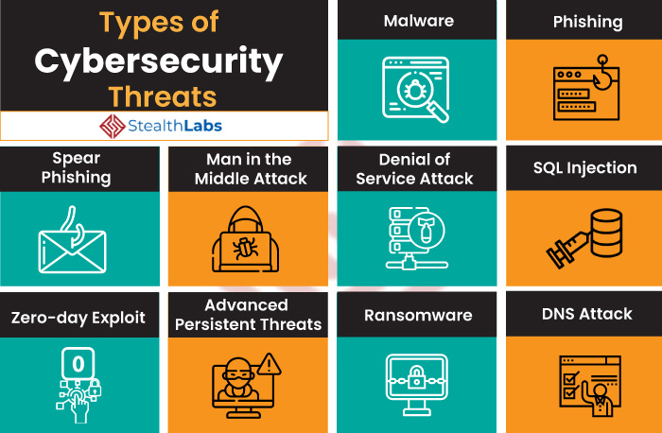

**1) Malware**

Malware attacks are the most common cyber security threats. Malware is defined as malicious software, including spyware, ransomware, viruses, and worms, which gets installed into the system when the user clicks a dangerous link or email. Once inside the system, malware can block access to critical components of the network, damage the system, and gather confidential information, among others.

<According to Accenture, the average cost of a malware attack is USD 2.6 million.>

**2) Phishing**

Cybercriminals send malicious emails that seem to come from legitimate resources. The user is then tricked into clicking the malicious link in the email, leading to malware installation or disclosure of sensitive information like credit card details and login credentials.

<Phishing attack accounts for over 80% of reported cyber incidents.>

**3) Spear Phishing**

Spear phishing is a more sophisticated form of a phishing attack in which cybercriminals target only privileged users such as system administrators and C-suite executives.

<More than 71% of targeted attacks involve the use of spear phishing.>

**4) Man in the Middle Attack**

Man in the Middle (MitM) attack occurs when cyber criminals place themselves between a two-party communication. Once the attacker interprets the communication, they may filter and steal sensitive data and return different responses to the user.

<According to [Netcraft](https://news.netcraft.com/archives/2016/03/17/95-of-https-servers-vulnerable-to-trivial-mitm-attacks.html#:~:text=The%20remaining%2095%25%20are%20therefore,in%2Dthe%2Dmiddle%20attacks.), 95% of HTTPS servers are vulnerable to MitM.>

**5) Denial of Service Attack**

Denial of Service attacks aims at flooding systems, networks, or servers with massive traffic, thereby making the system unable to fulfill legitimate requests. Attacks can also use several infected devices to launch an attack on the target system. This is known as a Distributed Denial of Service (DDoS) attack.

<The year 2019 saw a staggering 8.4 million DDoS attacks.>

**6) SQL Injection**

A Structured Query Language (SQL) injection attack occurs when cybercriminals attempt to access the database by uploading malicious SQL scripts. Once successful, the malicious actor can view, change, or delete data stored in the SQL database.

<SQL injection accounts for nearly 65.1% of all web application attacks.>

**7) Zero-day Exploit**

A zero-day attack occurs when software or hardware vulnerability is announced, and the cybercriminals exploit the vulnerability before a patch or solution is implemented.

<It is predicted that zero-day attacks will rise to one per day by 2021.>

**8) Advanced Persistent Threats (APT)**

An advanced persistent threat occurs when a malicious actor gains unauthorized access to a system or network and remains undetected for an extended time.

<45% of organizations feel that they are likely to be the target of an APT.>

**9) Ransomware**

Ransomware is a type of malware attack in which the attacker locks or encrypts the victim’s data and threatens to publish or block access to data unless a ransom is paid. Learning more about [ransomware threats](https://www.stealthlabs.com/blog/how-can-companies-be-more-resilient-in-the-face-of-ransomware-threats/) can help companies prevent and cope with them better.

<Ransomware attacks are estimated to cost global organizations USD 20 billion by 2021.>

**10) DNS Attack**

A [DNS attack](https://www.stealthlabs.com/news/cybersecurity-dns-attacks-cost-usd-924000-on-average/) is a cyberattack in which cybercriminals exploit vulnerabilities in the Domain Name System (DNS). The attackers leverage the DNS vulnerabilities to divert site visitors to malicious pages (DNS Hijacking) and remove data from compromised systems (DNS Tunneling).

<The average cost of a DNS attack stood at USD 924,000 in 2020.>

**Cyber Threat Actors**

In order to respond effectively to a cyberattack, it’s imperative to know the threat actors and understand their tactics, techniques, and procedures.

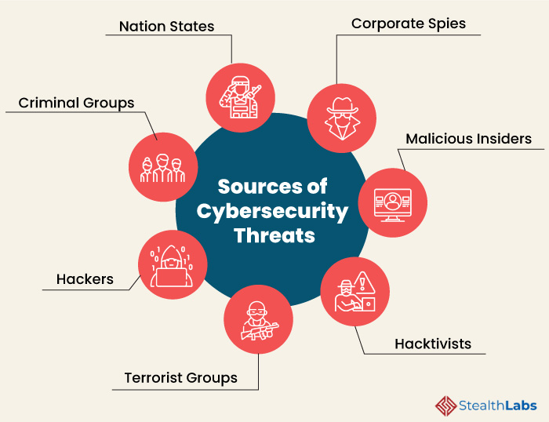

**Here are some of the common sources of cyber threats:**

**1) Nation States**

Cyber attacks by a nation can inflict detrimental impact by disrupting communications, military activities, and everyday life.

**2) Criminal Groups**

Criminal groups aim to infiltrate systems or networks for financial gain. These groups use phishing, spam, spyware, and malware to conduct identity theft, online fraud, and system extortion.

**3) Hackers**

Hackers explore various cyber techniques to breach defenses and exploit vulnerabilities in a computer system or network. They are motivated by personal gain, revenge, stalking, financial gain, and political activism. Hackers develop new types of threats for the thrill of challenge or bragging rights in the hacker community.

**4) Terrorist Groups**

Terrorists conduct cyber attacks to destroy, infiltrate, or exploit critical infrastructure to threaten national security, compromise military equipment, disrupt the economy, and cause mass casualties.

**5) Hacktivists**

Hacktivists carry out cyberattacks in support of political causes rather than for financial gain. They target industries, organizations, or individuals who don’t align with their political ideas and agenda.

**6) Malicious Insiders**

97% of surveyed IT leaders expressed concerns about [insider threats in cyber security](https://www.stealthlabs.com/blog/infographic-20-alarming-insider-threats-statistics/). Insiders can include employees, third-party vendors, contractors, or other business associates who have legitimate access to enterprise assets but misuse that accesses to steal or destroy information for financial or personal gain.

**7) Corporate Spies**

Corporate spies conduct industrial or business espionage to either make a profit or disrupt a competitor’s business by attacking critical infrastructure, stealing trade secrets, and gaining access.

**Cybersecurity Best Practices to Protect from Cyber Threats**

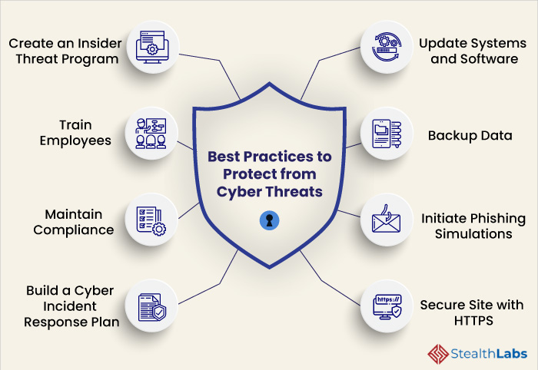

**1) Create an Insider Threat Program**

Creating an insider threat program is imperative for organizations to prevent employees from misusing their access privileges to steal or destroy corporate data. The IT security team should not delay and gain the approval of top management to deploy policies across departments.

**2) Train employees**

Employees are the first line of defense against cyber threats for every organization. Thus, organizations must conduct comprehensive cybersecurity awareness programs to train employees in recognizing and responding to cyber threats. This dramatically improves an organization’s security posture and cyber resilience.

**3) Maintain Compliance**

Irrespective of the level of cybersecurity an organization implements, it must always maintain compliance with data regulations that apply to its industry and geographical location. The organization must stay informed about the evolving compliance regulations to leverage its benefits.

**4) Build a Cyber Incident Response Plan**

In the present digital era, no organization is exempt from cyberattacks. Thus, organizations of all sizes must build an [effective Cyber Security Incident Response Plan (CSIRP)](https://www.stealthlabs.com/solutions/cyber-security-incident-response-services/) to navigate cyber adversaries. It enables businesses to prepare for the inevitable, respond to emerging threats, and recover quickly from an attack.

**5) Regularly Update Systems and Software**

As cyber threats are evolving rapidly, your optimized security network can become outdated within no time, putting your organization at the risk of cyberattack. Therefore, regularly update the security network and the associated systems and software.

**6) Backup Data**

Backing up data regularly helps reduce the risk of data breaches. Back up your website, applications, databases, emails, attachments, files, calendars, and more on an ongoing and consistent basis.

**7) Initiate Phishing Simulations**

Organizations must conduct phishing simulations to educate employees on how to avoid clicking malicious links or downloading attachments. It helps employees understand the far-reaching effects of a phishing attack on an organization.

**8) Secure Site with HTTPS**

Organizations must encrypt and secure their website with an SSL (Secure Sockets Layer) certificate. HTTPS protects the integrity and confidentiality of data between the user and the website.

## A9.6. Top 5 Most Common Incident Response Scenarios

Whether it is phishing, malicious network scanning, or ransomware, cyber incidents can be overwhelming experiences. If your organization has been fortunate enough to avoid being greatly affected by any of these scenarios, that might not always be the case. When it comes to Incident Response, it is important to understand how attackers operate and to be as informed as possible of potential incidents that can affect your organization. Being able to detect an incident and recognize a threat as one of these common attack types might be the difference in how successful your organization is in containing and eradicating a cyber attack before your organization becomes one of the many victims of cybercrime.

**1. Phishing**

Phishing is the #1 most common Incident Response scenario and is most likely the initial compromise for ALL of the following scenarios. Now is the time, more than ever, to be focusing on training employees to be vigilant of malicious emails by educating your people regularly and testing them with company-wide phishing campaigns.

**Protect:**

* Security Awareness Training & testing employees. Training will serve as a good learning opportunity for your employees. Your employees need to understand how to identify Social Engineering techniques and phishing emails, as well as the most common phishing scenarios used by attackers. Take their education a step further by testing employee’s Social Engineering and phishing awareness through a Social Engineering Assessment.
* DomainKeys Identified Mail (DKIM), Sender Policy Framework (SPF) and Domain-based Message Authentication, Reporting & Conformance (DMARC). DMARC is an email authentication, policy and reporting protocol. DKIM is an email authentication method that identifies forged sender addresses in emails. SPF is also an email authentication method; however, it detects the forging of sender addresses during the email delivery. Implementing DKIM, SPF, and DMARC (all of which are free!) will help prevent phishing emails from becoming an incident response situation.
* Email Sandboxing. Sandboxing methods, such as Mimecast, add an extra layer of protection against malicious emails. Emails containing links or attachments can be tested before they reach a mail server.
* Multi-Factor Authentication (MFA). MFA is an authentication method in which a user is granted access to an application or system only after successfully presenting two or more pieces of evidence (or factors – often a test code) to an authentication mechanism. MFA will ensure an attacker cannot gain unauthorized access to any accounts that are in the network, even if the user provides those credentials through a phishing attack.

**Detect:**

* Unexpected emails from known or unknown individuals. If the person or conversation seems out-of-the-blue, be vigilant and confirm the email is legitimate.
* Emails that contain links and/or attachments. Links and attachments can act as a “back door” to your network. Remember, the hacker cannot get in unless you give them an opening. Also, be on the lookout for spelling errors or unusual domains in emails you receive.
* If any email is trying to persuade or rush you into doing an action, resist the urge. Phishing emails often prompt extreme feelings to push the user in the direction the malicious actor wants.

**Respond:**

* Quarantine the malicious email from all accounts on the system. Be sure no one can access the email from anywhere on your network until it is reviewed by an administrator.
* If your organization uses a SIEM, check to see if there are any custom threat intelligence rules to add.
* Watch network alerts for Indicators for Compromise- you can refer to SBS’ previous article on [Indicators of Compromise (IoC)](https://sbscyber.com/resources/indicators-of-compromise) for more information.

**2. Malware**

Malware is a big umbrella for malicious software. Malware is mainly used to gain unauthorized system or network access to steal (exfiltrate) intelligence, data, or information.

**Protect:**

* Application Whitelisting. Whitelisting specific applications ensures a device will only allow pre-approved applications to be installed onto a device, therefore preventing malicious applications from being downloaded and installed onto your devices.
* AV scans and Endpoint protection. Use a solution that has second-generation detection capabilities (behavioral analysis vs. detection by definition) that includes scripting control.
* Multi-Factor Authentication (MFA). Same as in the Phishing scenario; MFA will ensure an attacker cannot gain unauthorized access to any accounts that are in the network.

**Detect:**

* Slow computer & Blue Screen of Death (BSOD). If your device seems to be running much slower or you receive an unexpected BSOD, these are common symptoms of malware on your device. Be sure to report such issues to your IT and IS staff.
* Dwindling storage space. If you find that your device is suddenly (and unexpectedly) running out of storage, there may be malware hiding in your system.
* Pop-ups or unwanted applications. Keep track of the applications installed on your device and pay attention if you get any confusing pop-ups. If you find any applications that you did not install on your system yourself, it could be malware camouflaging itself.

**Respond:**

* Key Risk Indicators. Refer to the article mentioned above on [Indicators of Compromise (IoC)](https://sbscyber.com/resources/indicators-of-compromise) for more information on KRI.
* Contain and eradicate. Disconnect the computer from the network, but don’t power the device off. Work through the system and eradicate any malicious files or applications.

**3. Ransomware**

Technically, ransomware is included under the malware umbrella we discussed above. However, due to its destructive nature, ransomware is deserving of its own category. Modern ransomware has taken a turn for the worse, and attackers are now dropping ransomware after being in a network for a while once they have gained the information and data. Ransomware covers an attacker’s tracks on their way out and distracts users while data is being exfiltrated.

**Protect:**

* AV scans and Endpoint protect. Once again, use a solution that has second-generation detection capabilities include scripting control.
* Multi-Factor Authentication (MFA). MFA ensures a user would be notified if a malicious advisory tried to log into an account.
* Be wary of email attachments. Ransomware can be masked in emails to look like safe attachments.

**Detect:**

* Unusual pop-ups on the device and encrypted files. Being the most obvious sign of detection, ransomware will more than likely notify the user on the device and encrypt all files your device can see and access on your network.
* Firewall logs. Logs will show all activity of data being received and sent from outside of the network. Make sure your firewall logs are properly configured before an attack occurs, which will help with investigating where external traffic is coming and going, as well as when the attack occurred.
* Define Key Risk Indicators, such as high disk usage on servers or workstations, and user account logins at strange times to help with the detection of a ransomware incident.

**Respond:**

* Detect a network intrusion before ransomware encrypts files. As mentioned above, modern ransomware is caused by attackers that are already in the network.
* Monitor Key Risk Indicators and Indicators of Compromise vigilantly. It is important to know what normal looks like on your network. “Know your normal” will be reiterated throughout this article to reinstate how important it is. Anything outside your “normal” levels should raise red flags.
* Containment is a top priority to any
* Incident Response scenario. Creating an environment where nothing gets out of the network that is not approved, and nothing runs on a workstation or server that isn’t approved is key to eradiation.

**4. Internet-Facing Vulnerabilities**

Every device that’s connected to the internet can be scanned for vulnerabilities from outside sources. Hackers do not specifically look for one victim of their scans; they set up scripts and scan every port and device they can. Whatever devices are identified over the internet and can be exploited may become an attacker’s next victim.

**Protect:**

* AV Scans and Endpoint protect. Once again, use a solution that has second-generation detection capabilities include scripting control.
* Only whitelist the scripts your web apps use and block everything else.
* Implement a DMZ for anything you host locally that requires someone from the internet to access (like a website or an online banking platform). A DMZ is a separate, firewalled zone that protects the rest of your network from being accessed by internet traffic from the application or system you host.

**Detect:**

* Audit your webservers, routers, and firewalls with penetration tests and vulnerability assessments regularly. Vulnerability Assessments will identify any known external vulnerabilities, and Penetration Tests will determine if those vulnerabilities are exploitable, allowing an attacker to access your network from the outside.
* Use a web application firewall (WAF). A WAF helps monitor and block HTTP traffic to and from web applications. A WAF makes it possible to filter the content of certain web applications & protect the device from any malicious content. Know your organization’s Key Risk Indicators (KRI), as mentioned previously.

**Respond:**

* Know your organization’s Indicators of Compromise (IOCs), as mentioned previously.
* Contain and eradicate. If advisories gain access to your network due to known vulnerabilities, the organization is at risk. Be sure to disconnect compromised devices or network segments from the rest of your corporate network, as doing so will ensure no lateral network movement can be performed by the attacker. From there, eradicate those compromised devices or network segments, and be sure they are clear of any malware that is present.

**5. Business Email Account Takeover**

In case this incident is not familiar to you, Business Email Account Takeover occurs when a malicious user gains access to a legitimate user’s email account. For example, once an attacker gains access to the credentials from a phishing email that was sent out to employees, the attacker will then have access to that user’s email.

**Protect:**

* Multi-Factor Authentication (MFA). See previous descriptions of MFA.
* Only enable external (outside your network) email access for the specific countries in which your employees work.

**Detect:**

* User Behavior Analytics (UEBA) in the SIEM. Look for user logins at strange times or strange user activity. Another good idea is to set alerts employees accessing their email accounts at strange times. Remember to ask yourself the same question - what does normal look like on your network?
* Email logging. Look out for strange county code logins to cloud-based email accounts. Remember, Office 365 and G-suite do not log strange country code logins & cloud-based email accounts by default. Be sure your organization’s email platform is licensed properly.

**Response:**

* Contain. Shut down the email account so that no users can access it.
* Change passwords of all accounts and block email access from countries where employees won’t be logging in.
* Examine what is in your email that got compromised. Keep in mind that you may need to file a breach report for PII that is exposed.

# Week 10 Communication

## A10.1. What Is Effective Written Communication?

The purpose of written communication is to capture your reader’s attention and get your point across clearly. Ultimately, when you communicate in writing, you are helping the reader understand your perspective on a topic. There are certain qualities all effective written communication shares, and if you add these elements to your writing, your work will be more powerful.

**Importance of Effective Written Communication**

In some ways, effective written communication is even more important than spoken communication. Unless it is being recorded, regular speech does not last. However, written communication is a record, and people may refer back to it later. This means that in addition to creating a connection with your audience, you need to consider the lasting impact of what you write. Think about how it will be perceived by your audience initially, as well as the impact it will leave.

**The Five Cs of Effective Written Communication**

Good written communication depends on the audience, the topic, your purpose in communicating, and other factors. However, all effective written communication has some characteristics in common:

* **Connection** - Good written communication forms a connection between the reader and the writer.
* **Clarity** - Effective written communication is clear and easy to understand.
* **Cause** - The cause or reason for writing needs to be clear to both the writer and the reader, including any specific actions you need from your audience.
* **Conciseness** - Good written communication sticks to the point and doesn’t meander around or include lots of extraneous information.
* **Correctness** - To be effective, the written communication should use the correct tone, inoffensive language, and appropriate grammar.

**How to Make Your Writing Communicate Effectively**

Effective writing allows the reader to thoroughly understand everything you are saying. This is not always easy to do. Here are a few tips that will help you:

**1. Know Your Goal and State It Clearly**

Do you want the reader to do something for you, or are you merely passing along information? Do you want a response from the reader, or do you want him to take action? Effective written communication has a clear purpose, and that purpose is communicated to the reader. Explain in clear terms what you want the reader to do.

**2. Use the Correct Tone for Your Purpose**

Tone can help your writing be more effective. Certain forms of communication, like [memorandums](https://grammar.yourdictionary.com/grammar-rules-and-tips/tips-for-writing-memorandums.html) and [proposals](https://grammar.yourdictionary.com/writing/how-to-write-a-proposal.html), need a formal tone. Writing to someone you know well would need a more informal tone. The kind of tone depends on the audience and purpose of the writing.

**3. Keep Language Simple**

Do not overuse clichés, jargon, and expressions or try to impress with big words. This can make the reader work harder, and you want to make it easy to understand what you’re saying.

**4. Stay on Topic and Keep It Concise**

Effective written communication stays on topic. Avoid information that is not relevant. Clarity is key. Less is more when it comes to length. Keep sentences and paragraphs short and concise, since long, complicated sentences will slow the reader down. Leave out words that do not contribute to the main focus of the communication.

**5. Use Active Voice**

Using an [active voice](https://grammar.yourdictionary.com/style-and-usage/active-voice-adds-impact-to-your-writing.html) will strengthen your writing. It’s easier to understand sentences that are written in the active voice. An active example is "I caught the ball," and a passive example is "The ball was caught by me." Active voice will engage the reader and keep his or her attention.

**6. Have Someone Proofread Your Writing**

Good [grammar](https://grammar.yourdictionary.com/grammar-rules-and-tips/) and [punctuation](https://grammar.yourdictionary.com/punctuation/) are very important. It is a good idea to have someone else proofread your writing before you send it. If you cannot do that, then try reading it out loud.

**Practice Different Types of Written Communication**

There are many types of written communication, including emails, memos, business letters, blogs and websites, [press releases](https://grammar.yourdictionary.com/grammar/writing/how-to-write-a-press-release.html) and more. Practice writing a variety of documents to improve your written communication skills. Like anything else, becoming a great writer takes practice.

## A10.2. Essential Skills for Written Communication

**What is written communication?**

In the age of information, there is simply too much to remember. A simple solution is to write it all down.

**Written communication definition**

Written communication is making use of the written word to deliver information. Anytime a person writes a message that will be sent along for someone else to read and interpret, they are using written communication.

A tale as old as Egyptian hieroglyphs, written communication has evolved in a lot of different directions. No matter where we go, we are surrounded by words. Notes from roommates saying the dishwasher is clean, expiration dates printed on food, and street signs telling us we made another wrong turn all give us worthwhile information that might ultimately alter our actions.

**3 types of written communication**

There are many different written communication channels in business. But no matter the channel, the content of the message sent is either transactional, instructional or informational.

**Transactional written communication**

Simply put, a transactional message is sent to get results. It can be a quick clarification, a [request for a meeting](https://mailshake.com/blog/meeting-request-email/), or asking for a favor. The whole point is to get a response from the person the message was sent to, or from the person with the best information.

Because the sender ultimately becomes the receiver when delivering transactional messages, they have the power to choose the channel that best fits their informational needs.

When sending a transactional message, it’s best to use an online form of written communication. The point of asking a question is to get a response, and preferably ASAP. Sending a written message on paper when a response is needed will leave you waiting without the information you need. Online written communication tools, such as instant messengers, are perfect for asking a brief question and getting the most timely response possible.

**Informational written communication**

Informational written communication includes the sender delivering a message for the receiver’s benefit. Since this is less dependent on the receiver, there is no response needed. If the receiver has questions or concerns, that would bring the conversation back to transactional communication.

Informational messages can be sent to an individual or a group with the help of online and offline channels. A written memo posted in different locations around the office can address an entire group while also serving as a reminder of the information. An email, on the other hand, will likely pair the message with a notification or alert for the receiver, making it hard to miss.

Whichever channel you pick to send an informational message, make sure it will reach the audience before they must apply the information.

**Instructional written communication**

Instructional written communication gives receivers directions for a specific task. If the receiver is required to take action, it is important to make these messages detailed and easy to understand. Certain people may not know as much as others on the topic at hand, so including the basics is always necessary. The goal is to educate the audience about something they need to know and might have to apply later on.

When distributing instructional information, the format is more important than the method. Typically, instructions involve a step-by-step process. Using bullet points or numbering phrases can visually break down the directions and make the process easier to understand.

**Written communication skills**

Now that we know the types of written communication, let's sharpen up that content.

When writing, you’ll need more than a pen and paper. These skills will make sure your writing is in tip-top shape.

**Planning and preparation**

While all types of written communication allow time to gather thoughts before sending a message, the use of that time varies.

Shooting a quick text to a friend simply requires typing the message and sending it, perhaps without a second thought. If the message is going to someone you have a more formal relationship with, you might want to have at least an idea of what you want to cover.

Writing emails, letters or memos is a different story. Ideas are written, then erased, then reworded, then erased again. This is mostly because the messages we send in emails, letters and memos tend to be more thoughtful and serious.

When deciding how much time to put into writing a message, consider the seriousness of the topic. Using written communication can seem impersonal at times, so take the extra time to make up for that.

**Word choice**

Similar to [verbal communication](https://learn.g2.com/verbal-communication), the words we choose when writing affects the way the message is received.

The audience receiving the message should determine the words chosen. Sending an email full of lingo unique to your office will be confusing to a new employee. In situations where you are addressing a whole team, it is particularly important to explain jargon and industry terms for those with less experience.

One of the biggest misconceptions people generally have about writing is that the use of fancy words makes you seem more intelligent and well informed. But here’s the scoop: the true sign of knowledge on any topic is the ability to explain it in as few simple words as possible.

Keep it short, sweet, and informational.

**Formatting**

Formatting refers to the look and design of your written message. The size of the words, spacing, and paragraph layout can impact the reader’s experience. The wrong format can intimidate the reader, and dissuade their interest and comprehension of the message.

Put yourself in the shoes of the reader and think about how you would want that information to look and be delivered. Consider using lists, bullet points and breaking up paragraphs.

**Editing**

Editing written communication is crucial. It can be a pain, but the risk of a misspelled word or an embarrassing typo making you look unprofessional is not worth skipping it.

It is easy to recover from a mistake in a text or instant message. You can simply send another one correcting yourself. On the other more formal hand, written letters and emails should be reviewed more closely. An email correcting a mistake is hard to write, and once a written letter is sent, it’s not coming back.

Have someone else read over your work. A fresh set of eyes will always catch more grammar and spelling mistakes than just your own. Also, read it aloud. It’s easier to notice mistakes when sentences are vocalized.

**Jot it down**

Written communication is a simple, reliable and effective tool. The workplace has countless opportunities to communicate, and there are definitely times when writing is your best bet.

## A10.3. Practical guide to effective written communication

**Why We Communicate**

You as a project manager spend a large portion of your time communicating to ensure the success of your project. You require the cooperation of others to make the decisions and complete the tasks. You must communicate so others clearly understand their role in the project and complete their areas of responsibility in a timely fashion. Your objective is to get action from others.

The *PMBOK® Guide* discusses many areas, which require communication. This paper deals with the day-to-day, often informal, communications so crucial in project management. We communicate to inform or solicit input as part of the decision-making process. We communicate to build a consensus among the project team or to resolve conflict. In the end, we communicate to assign tasks and responsibilities.

No matter what the reasons are for communication, it should be for a purpose. We expect our communication to result in effecting the way our project progresses. Most of the time, this requires action on the recipient's part. Bottom line, we are tying to sell the recipients to perform a desired action.

**When Written Communication Is Appropriate**

Informal verbal communication has its place to build personal relationships and to be able to better read the other person's body language. It allows a less threatening environment to work out troublesome issues. Where would modern project management be without the insight gained during side discussions next to the water cooler or coffee pot? Even a phone conversation is more personal than a memo or email.

**Exhibit 1. Errors in Communication Can Easily Lead to Major Embarrassment or Worse**

This paper by no means advocates eliminating these crucial means of verbal communications and personal interaction. However, I strongly advocate using written communications to supplement not only formal but also informal discussions. A brief, one paragraph email can summarize and emphasize an agreement reached in the hallway.

Written communication is crucial to document all aspects of an ongoing project. It is part of the permanent record and will read the same six months later as when it was written. It enables the project team to review decisions later on and can bring new team members up to speed quickly and objectively. The project manager must document any critical project issues in writing to establish the permanent record.

You can forward written communication without altering its meaning. If the matter calls for escalation, you can forward the message without accidentally altering or distorting the meaning and misrepresenting the facts as they were presented to you.

**Exhibit 2. Written Communication Provides a More Permanent Record and Can Avoid Misunderstandings**

How often do we wish we could take back words we said? You have an opportunity to review what you write before you sent it. You can massage your message to make sure it is just perfect. You can even try the message out on a coworker. Moreover, it provides you with a record in cases were you warned of potential problems and the responsible parties did not take the appropriate action.

This paper addresses only the short written communications typically expressed as letters, memos and, more often, email. It does address more formal documents like legal contracts, dissertations, theses, technical documentation, presentations, novel, etc.

**Who Is the Target Audience?**

**Define the Audience**

Most of the time, our audience is obvious. These are peers, subordinates, supervisors, project team member, project owners, or stakeholders.

However, our message can have an unexpected audience. The receiver can forward the message to their boss, all the way to the company CEO. Our message can be subpoenaed in a lawsuit. Just remember the supposedly internal emails that hurt Microsoft during the antitrust trial. How would you feel if your last email were published in a newspaper? What if the client sees the message you intended for internal distribution only? Has a client ever shown you a document, which was clearly not intended for their eyes?

If you think this sounds paranoid, think again. The “leak” often is not even intentional. How easy is it to accidentally send a message to the wrong email recipient? Have you ever stapled a memo to the wrong paperwork?

The best protection against any of these problems is to always write in a professional manner. Avoid derogatory language and keep your and your company's image in mind. Then, you do not ever have to be embarrassed by one of your messages showing up in an unexpected place.

**Understand the Audience**

To start out with, forget everything your high school English teacher told you. In order to be successful, you need action based on the message. That is all that counts. So, forget about suspense and building up to the ultimate climax. Put yourself in your reader's shoes and write short and to the point. Understand what types of constraints are on his or her daily activities. You need to present the information to fit the reader's style.

Many people work in piles in one way or another. For example, I work off my email inbox. Items stay in my inbox until I finish with them. Then, I move them to a more permanent location. Therefore, if you send me one email, which has two separate issues, it causes me a problem with the way I work. It is easy for me to accidentally ignore the second issue in your email after I completed the first item and filed the email away.

**Address the Reader's Issues**

If we do not achieve our objective, we wasted our time communicating. Therefore, it is in your best interest (career, financial, personal, etc.) that the reader reads and acts upon the message appropriately.

That means that you write for the benefit of the reader, not your benefit. Show the readers what is at stake for them by writing in terms of the reader's interests, requirements and issues and by keeping the reader's concerns in mind.

**How to Get the Message Across**

**Talk Directly to the Reader**

It is important to speak directly to the reader. Preferably, the memo or email should start with the word “you.” This immediately sets the tone that this may be of importance to the reader.

If the reader only reads one sentence, what should this sentence be? It has to contain a summary of the message as well as the action you want the reader to take. This should be the first sentence.

Yes, that is contradictory to what you learned in school. Think of it this way. You cannot force anybody to read your message. Once they get bored, they will stop and discard your writing. You loose! You have about two seconds, which is about the maximum time the reader will take to decide whether to read or ignore your message. So, make sure the reader gets the meat of your issue within these two seconds.

Once you got his or her attention, you have about 30 seconds to get the rest of your message across. That is the length of a typical commercial. That is it. Odds are, the reader will be interrupted before the 30 seconds are up. It is your job to ensure the reader gets all the info needed. That means do not waste your time and effort on tangents or background. Once you got your message across, the reader can always get back to you to ask for more. However, the first message must be sufficiently self-contained so the reader can make, at least, a preliminary decision on whether to pursue your issue or not.

It is important to ensure the message is relevant to the recipient. Do not send the message to dozens of people because you are not sure who should get it. You will acquire the reputation of wasting time. That will distract from the important messages that you need to get through. It can be so annoying when you respond to a message sent to a long list of recipients by selecting “Reply to All” just to acknowledge the receipt of the message. If everyone on the distribution list does that, they immediately create hundreds of messages, which are meaningless, but still require the recipients to sort through.

It is crucial that not only your message is clear, but that you spell out what action you expect the reader to take. Do not make them guess. Odds are, they guess wrong. If you want the reader to approve your approach, make sure to say so. Avoid “FYI” messages. That is not an action. If the message is important, then you want the recipient to read the message and act on the contents. If it is not of importance, then do not send it.

Make sure to clearly delineate between fact and opinion. You want to provide your reader the facts to base a decision on. It may be your opinion that this is a good decision. Again, do not make the reader guess what is fact. Even worse, do not disguise your opinion as fact. That will hurt your credibility in the end.

**Take Your Time to Write**

If you do not have time to write it right, do not bother wasting your time. The more important the message, the shorter and concise you want the message. There are no bonus points for the longest memo or email. Quality is not proportional to length. You win if the reader understands your message. If the reader for any reason misses the point, you loose. It is truly that simple.

Therefore, make sure you construct your message carefully. Trim off any unnecessary fluff, tangents, and words that are not directly required to bring your point home. Be short and concise.

It is OK to spend a day on a two-paragraph email. Write it and then let it sit for a few hours. Read it again and evaluate how you can improve it. Show it to a coworker and watch their impression reading it.

Never send the message in anger. Once sent, the permanency you desire is hard to undo. You may want to let it sit overnight and read it again in the morning, just to make sure that you got it perfect. If it is that important, it can wait that additional time.

Once you are done, make sure to create a meaningful subject line. It has to say enough to ensure the recipient will, at least, open the rest of the message. Some email clients, like Microsoft Outlook, have a three-line message preview. Make sure that this all-important first sentence fits into this preview area.

**Consider How the Reader Sees You**

What kind of impression do you want to give when you write? As project managers, we want to be perceived to be in control. This means we want to make sure we take ownership and clearly assign responsibilities. We especially do not want to appear as passing the buck. Along the same line, we want to show we are proactive instead of reacting to the whims of the situation or environment.

It is important that we show that we are organized. This goes hand in hand with being in control. It is hard to project the proper image if our writing is disorganized and hard to follow. We need to show that we are knowledgeable of the issues and are not just paraphrasing (especially incorrectly) what others tell us.

Our writing style will say at least as much about how the reader perceives us as the words. The writing style becomes the equivalent of the body language in verbal communication. Sloppy writing will project the image that we do not care. Incoherent writing can indicate that we do not understand the bottom line. Bad grammar and misspelled words show it is not important enough to get it right.

**What is the Best Format for Optimal Results?**

**Use a Proper Structure**

As mentioned before, we are not writing a novel. You can find the best examples on how to structure a message by reading a high-quality newspaper. The main point is in the headline and the first paragraph. As you continue reading, you obtain more detail. You can stop reading any time and still have gotten the gist of the article. Another example is direct mail pieces. The authors of these messages have made a science out of how to get your attention and keep it.

That means you start with the most important aspect of the message. Background and detail go in the back. You do not build up to the most important part, but order your thoughts by decreasing importance. It is OK to keep the message interesting, just leave out the suspense.

Write with plenty of white space. If there are three points, put them in bullets. Highlight the action you want the reader to take. The reader is often drawn to bold words. However, if you have too much text in bold, it looses its benefits. Make sure the bold text is self-contained so that the reader does not have to hunt to find the text to complete the highlighted portion.

Keep the format light and consistent (not too many type faces, font sizes, etc). DO NOT WRITE IN ALL UPPER CASE. It is considered obnoxious and the equivalent of yelling. By the way, most people will read a postscript, although that is not a common part of an email message.

**Use Good English**

Make sure to show that the message is important to you by taking the time to write with proper spelling and grammar. With the modern tools (see below), there is no excuse for poor English. Why should the reader be interested in your issue when you send the message that it is not important enough to you to spend the time on the details?

In general, it is beneficial to write short sentences. Under no circumstances do you want to force the reader to have to reread text because it is too convoluted. It is a good idea to write at most at a 10th grade level. This is not to insult the intelligence of the reader, but to make it easier on them to comprehend the message.

Avoid jargon or fancy words. They may force the reader to have to stop and think about their meaning or, even worse, miss the point. Remember that the message may end up with people who are not necessarily as experienced with the technology or subject matter as you are. True experts prove their grasp of the subject matter by their ability to express even complicated issues so nonprofessionals can understand them.

One key suggestion for effective writing is to avoid passive voice and, even worse, the use of “one” or “someone.” This may be all right for academic dissertations. A sentence like “One needs to write documentation” or “The documentation needs to be written” does not convey ownership. Make sure that you assign required actions directly to the appropriate person.

**Exhibit 3. The Spelling and Grammar Checkers Provide Continuous Feedback**

**Exhibit 4. Readability Statistics Show How Difficult it May Be to Read Your Message**

**Where Are the Right Tools?**

**Microsoft Word**

Microsoft Word has some features, which can greatly help you with your writing skills. Most users consider these an annoyance and turn the features off. Keeping the features on provide you instant feedback on your writing skills and, over time, will help you improve them.

The greatest assistance is the spelling and grammar checker. A red line under a word tells you that the spelling is incorrect. Left-click on the word and the pop-up menu presents you with a number of choices to correct the word. Even more powerful is the green line, which indicates grammar errors. This can be maddening at the beginning. Often, no matter how hard you try, you cannot get the green line to disappear. At times, the only solution is to rewrite a whole paragraph. That is good. As a result, your message will be clearer and more concise.

**Exhibit 5. Outline Mode Helps Organize the Document and Enforce Consistent Format**

Once you wrote your message, perform a spell and grammar check and request readability statistics. You may have to enable this in the options dialog box first. The results can be eye opening. Use the Microsoft Word online help to obtain a detailed explanation regarding how the program calculates the statistics. After you rephrased some of the text, run the statistics again to find out whether the changes improved readability or made it worse. You can even highlight a sentence or a few paragraphs and find out the statistics for a subset of your document.

It will require quite a bit of effort to improve the readability of your document. It is time worthwhile and the features of Microsoft Word can greatly help you along the way.

For improving consistency in formatting, the outline feature of Microsoft Word can provide plenty of help. It provides a means to organize your thoughts and easily rearrange whole sections. It is easy to ensure consistency of headings. Then, you can apply consistent formatting to the whole document, including numbering.

**Microsoft Outlook**

Microsoft Outlook allows the use of Microsoft Word as email editor. This means that you can have all the writing assistance from Microsoft Word available to ensure high-quality emails as well.

Remember that some of your recipients may not be using the same software to view the email as you are. That means that you may loose formatting, such as fonts, bullets, bold or font size. Your chances of maintaining the format improve if you instruct Microsoft Outlook to send messages in HTML format. That is the same format used by the World Wide Web.

Microsoft Outlook allows you to request read receipts. This allows you to check who read the message without having to bother the recipients. An option even correlates the receipts with the original message and removes the receipts from your inbox. You can open the sent message and view who read the message and when from the “tracking” tab.

**Conclusion**

Understanding how people read in today's fast pace environment enables us to tailor the message to the reader and, thus, greatly improve the quality and effectiveness of our message. Make sure you show you are in control and make it easy for the reader to process and respond to your message. Using modern tools for written communication, such as email, can greatly enhance the effectiveness of the project manager.

<https://www.pmi.org/learning/library/practical-guide-effective-written-communication-7828>

Koehler, T. P. (2001). Practical guide to effective written communication. Paper presented at Project Management Institute Annual Seminars & Symposium, Nashville, TN. Newtown Square, PA: Project Management Institute.

## A10.4. Seven C’s of Effective Communication

There are **7 C’s of effective communication** which are applicable to both written as well as oral communication. These are as follows:

1. **Completeness -** The communication must be complete. It should convey all facts required by the audience. The sender of the message must take into consideration the receiver’s mind set and convey the message accordingly. A complete communication has following features:
   * Complete communication develops and enhances reputation of an organization.
   * Moreover, they are cost saving as no crucial information is missing and no additional cost is incurred in conveying extra message if the communication is complete.
   * A complete communication always gives additional information wherever required. It leaves no questions in the mind of receiver.
   * Complete communication helps in better decision-making by the audience/readers/receivers of message as they get all desired and crucial information.
   * It persuades the audience.
2. **Conciseness -** Conciseness means wordiness, i.e, communicating what you want to convey in least possible words without forgoing the other C’s of communication. Conciseness is a necessity for effective communication. Concise communication has following features:
   * It is both time-saving as well as cost-saving.
   * It underlines and highlights the main message as it avoids using excessive and needless words.
   * Concise communication provides short and essential message in limited words to the audience.
   * Concise message is more appealing and comprehensible to the audience.
   * Concise message is non-repetitive in nature.
3. **Consideration -** Consideration implies “stepping into the shoes of others”. Effective communication must take the audience into consideration, i.e, the audience’s view points, background, mind-set, education level, etc. Make an attempt to envisage your audience, their requirements, emotions as well as problems. Ensure that the self-respect of the audience is maintained and their emotions are not at harm. Modify your words in message to suit the audience’s needs while making your message complete. Features of considerate communication are as follows:
   * Emphasize on “you” approach.
   * Empathize with the audience and exhibit interest in the audience. This will stimulate a positive reaction from the audience.
   * Show optimism towards your audience. Emphasize on “what is possible” rather than “what is impossible”. Lay stress on positive words such as jovial, committed, thanks, warm, healthy, help, etc.
4. **Clarity -** Clarity implies emphasizing on a specific message or goal at a time, rather than trying to achieve too much at once. Clarity in communication has following features:
   * It makes understanding easier.
   * Complete clarity of thoughts and ideas enhances the meaning of message.
   * Clear message makes use of exact, appropriate and concrete words.
5. **Concreteness -** Concrete communication implies being particular and clear rather than fuzzy and general. Concreteness strengthens the confidence. Concrete message has following features:
   * It is supported with specific facts and figures.
   * It makes use of words that are clear and that build the reputation.
   * Concrete messages are not misinterpreted.
6. **Courtesy -** Courtesy in message implies the message should show the sender’s expression as well as should respect the receiver. The sender of the message should be sincerely polite, judicious, reflective and enthusiastic. Courteous message has following features:
   * Courtesy implies taking into consideration both viewpoints as well as feelings of the receiver of the message.
   * Courteous message is positive and focused at the audience.
   * It makes use of terms showing respect for the receiver of message.
   * It is not at all biased.
7. **Correctness -** Correctness in communication implies that there are no grammatical errors in communication. Correct communication has following features:
   * The message is exact, correct and well-timed.
   * If the communication is correct, it boosts up the confidence level.
   * Correct message has greater impact on the audience/readers.
   * It checks for the precision and accurateness of facts and figures used in the message.
   * It makes use of appropriate and correct language in the message.

Awareness of these 7 C’s of communication makes you an effective communicator.

# Week 11 Ethics & Regulation

## A11.1. Different types of Ethical Theories

**SLIDE 1 – INTRODUCTORY SLIDE**

Ethical theories provide part of the decision-making foundation for ***Decision Making When Ethics Are In Play*** because these theories represent the viewpoints from which individuals seek guidance as they make decisions. Each theory emphasizes different points – a different decision-making style or a decision rule—such as predicting the outcome and following one’s duties to others in order to reach what the individual considers an ethically correct decision. In order to understand ethical decision making, it is important for students to realize that not everyone makes decisions in the same way, using the same information, employing the same decision rules. In order to further understand ethical theory, there must be some understand- ing of a common set of goals that decision makers seek to achieve in order to be successful.

Four of these goals include beneficence, least harm, respect for autonomy, and justice.

**SLIDE 2 - ETHICAL PRINCIPLES**

**Beneficence**

The principle of beneficence guides the decision maker to do ***what is right and good***. This priority to “do good” makes an ethical perspective and possible solution to an ethical dilemma acceptable. This principle is also related to the principle of utility, which states that we should attempt to generate the largest ratio of good over evil possible in the world. This principle stipulates that ethical theories should strive to achieve the great-

est amount of good because people benefit from the most good. This principle is mainly associated with the utilitarian ethical theory discussed later in this set of notes.

**Least Harm**

Similar to beneficence, least harm deals with situations in which no choice appears benefi- cial. In such cases, decision makers seek to choose to do the least harm possible and to do harm to the fewest people. Students might argue that people have a greater responsibility to “do no harm” than to take steps to benefit others. For example, a student has a larger responsibility to simply walk past a teacher in the hallway rather than to make derogatory remarks about that teacher as he/she walks past even though the student had failed that teacher’s class.

**Respect for Autonomy**

This principle states that decision making should focus on allowing people to be autono- mous—to be able to make decisions that apply to their lives. Thus, people should have control over their lives as much as possible because they are the only people who com- pletely understand their chosen type of lifestyle. ***Ask students if they agree. Are there limits to autonomy?*** Each individual deserves respect because only he/she has had those exact life experiences and understands his emotions, motivations, and physical capabilities in such an intimate manner. In essence, this ethical principle is an extension of the ethi- cal principle of beneficence because a person who is independent usually prefers to have control over his life experiences in order to obtain the lifestyle that he/she enjoys.

**Justice**

The justice ethical principle states that decision makers should focus on actions that are fair to those involved. This means that ethical decisions should be consistent with the ethical theory unless extenuating circumstances that can be justified exist in the case. This also means that cases with extenuating circumstances must contain a significant and vital difference from similar cases that justify the inconsist nt decision. ***Ask students if they describe what extenuating circumstances might be***.

**SLIDE 3 – FORMS OF ETHICAL THEORIES**

For individuals, the ethical theory they employ for decision making guidance emphasizes aspects of an ethical dilemma important to them and leads them to the most ethically correct resolution according to the guidelines within the ethical theory itself. Four broad categories of ethical theory include deontology, utilitarianism, rights, and virtues.

**Deontology**

The deontological class of ethical theories states that people should adhere to their obliga- tions and duties when engaged in ***decision making when ethics are in play***. This means that a person will follow his or her obligations to another individual or society because upholding one’s duty is what is considered ethically correct. For instance, a deontologist will always keep his promises to a friend and will follow the law. A person who adheres to deontological theory will produce very consistent decisions since they will be based on the individual’s set duties.

Deontology contains many positive attributes, but it also contains flaws. One flaw is that there is no rationale or logical basis for deciding an individual’s duties. For instance, a busi- nessperson may decide that it is his/her duty to always be on time to meetings. Although this appears to be something good, we do not know why the person chose to make this his duty. ***Ask students what reasons they might provide for this behavior***. Sometimes, a person’s duties are in conflict. For instance, if the business person who must be on time to meetings is running late, how is he/she supposed to drive? Is speeding breaking his/her duty to society to uphold the law, or is the businessperson supposed to arrive at the meeting late, not fulfilling the duty to be on time? ***Ask students how they would rectify the conflicting obligations to arrive at an a clear ethically-correct resolution. Also ask students to bring into play the consideration of the welfare of others as a result of the business person’s decision***.

**Utilitarianism**

Utilitarian ethical theories are based on one’s ability to predict the consequences of an action. To a utilitarian, the choice that yields the greatest benefit to the most people is the one that is ethically correct. There are two types of utilitarianism, ***act utilitarianism*** and ***rule utilitarianism***. Act utilitarianism subscribes precisely to the definition of utilitar- ianism—a person performs the acts that benefit the most people, regardless of personal feelings or the societal constraints such as laws. Rule utilitarianism takes into account the law and is concerned with fairness. A rule utilitarian seeks to benefit the most people but through the fairest and most just means available. Therefore, added benefits of rule utili- tarianism are that it values justice and includes beneficence at the same time.

Both act and rule utilitarianism have disadvantages. Although people can use their life experiences to attempt to predict outcomes, no one can be certain that his/her predictions will be accurate. Uncertainty can lead to unexpected results making the utilitarian deci- sion maker appear unethical as time passes, as the choice made did not benefit the most people as predicted.

Another assumption that a utilitarian decision maker must make concerns his/her ability to compare the various types of consequences against each other on a similar scale. But, comparing material gains, such as money, against intangible gains, such as happiness, is very difficult since their qualities differ to such a large extent.

An act utilitarian decision maker is concerned with achieving the maximum good. Thus, one individual’s rights may be infringed upon in order to benefit a greater number of people. In other words, act utilitarianism is not always concerned with justice, benefi- cence or autonomy for an individual if oppressing the individual leads to the solution that benefits a majority of people.

Still another source of challenge with act utilitarian decision makers occurs when an individual faces one set of variable conditions and then suddenly experiences changes in those conditions. The change in conditions may lead to a change in the original deci- sion—being be nice to someone one moment and then dislike them the next moment because the situation has changed, and liking the person is no longer beneficial to the most people.

In rule utilitarianism, there is the possibility of conflicting rules. Recall the example of the business person running late for a meeting. Suppose the business person happens to be the CEO, who may believe that it is ethically correct to arrive at important meet- ings on time as the members of the company will benefit from this decision. The CEO may encounter conflicting ideas about what is ethically correct if he/she is running late. Yet, the CEO believes that he/she should follow the law because this benefits society.

Simultaneously, he/she believes that it is ethically correct to be on time for his meeting because it is a meeting that also benefits the society. There appears to be no ethically cor- rect answer for this scenario.

**Rights**

In ethical theories based on rights, the rights established by a society are protected and given the highest priority. Rights are considered to be ethically correct and valid since a large population endorses them. Individuals may also bestow rights upon others if they have the ability and resources to do so. For example, a person may say that her friend may borrow her laptop for the afternoon. The friend who was given the ability to borrow the laptop now has a right to the laptop in the afternoon.

A major complication of this theory on a larger scale is that one must decipher what the characteristics of a right are in a society. The society has to determine what rights it wants to uphold and give to its citizens. In order for a society to determine what rights it wants to enact, it must decide what the society’s goals and ethical priorities are. Therefore, in order for the rights theory to be useful, it must be used in conjunction with another ethical theory that will consistently explain the goals of the society. For example in America people have the right to choose their religion because this right is upheld in the Constitution. One of the goals of the Founding Fathers’ of America was to uphold this right to freedom of religion.

**Virtue**

The virtue ethical theory judges a person by his/her character rather than by an action that may deviate from his/her normal behavior. It takes the person’s morals, reputation, and motivation into account when rating an unusual and irregular behavior that is con- sidered unethical. For instance, if a person plagiarized a passage that was later detected by a peer, the peer who knows the person well will understand the person’s character and will judge the friend accordingly. If the plagiarizer normally follows the rules and has good standing amongst his colleagues, the peer who encounters the plagiarized passage may be able to judge his friend more leniently. Perhaps the researcher had a late night and simply forgot to credit his or her source appropriately. Conversely, a person who has a reputation for academic misconduct is more likely to be judged harshly for plagiarizing because of his/her consistent past of unethical behavior.

One weakness of virtue ethical theory is that it does not take into consideration a person’s change in moral character. For example, a scientist who may have made mistakes in the past may honestly have the same late night story as the scientist in good standing. Neither of these scientists intentionally plagiarized, but the act was still committed. On the other hand, a researcher may have a sudden change from moral to immoral character may go

unnoticed until a significant amount of evidence mounts up against him/her.

**SLIDES 4-6 - SELECTED PRINCIPLES OF ETHICAL CONDUCT**

When individuals find themselves in a decision-making situation when ethics are in play, there are a variety of ethical theories (decision rules) which provide decision-making guidance as individuals strive to make ethically correct answers. Each ethical theory attempts to adhere to the ethical principles that lead to success when trying to reach the best decision. Most individuals adopt a preferred decision-making style (e.g. do unto others ... ), but might adjust it depending on decision circumstances. As decision mak- ers, they soon discover that others have adopted different decision rules. Thus, a team of decision makers must first understand the decision-making styles and decision rules of all members of the team.

**SLIDES 7 – 9 - A TAXONOMY OF ETHICAL TYPES**

There are three different approaches to examining how ethical theories (differing decision- making styles and decision rules) impact decision making. The first group, entitled, “Selected Principles of Ethical Conduct,” present different ethical theories or decision making styles. The second group, entitled “A Taxonomy of Ethical Types” also provides

a look at different decision-making styles, presenting some of the positives and negatives associated with each. The third group, entitled “Models of Personal and Organizational Development,” also deals with decision-making styles but presents them in a hierarchy from simple to more sophisticated.

**SLIDES 10-12 - MODELS OF PERSONAL AND ORGANIZATIONAL DEVELOPMENT**

From *Cognitive Moral Development* (as espoused by Lawrence Kohlberg in *The Philosophy of Moral Development: Moral Stages and the Idea of Justice*, 1981, HarperCollins Publishers***)***

Cognitive Moral Development asserts that ethics education is possible. Just as people develop mentally, physically, and emotionally, they develop a moral cognizance. Using critical thinking and decision-making tactics such as the Socratic method, people can solve their ethical dilemmas. Kohlberg taught that there were six stages of ethical think- ing, each stage being of greater maturity than the previous one. By delineating these levels, we are allowed to know and test our own thinking and decision making. This helps individuals know themselves better and challenges them to move on to a higher level of thinking.

**To examine how different ethical theories (decision-making styles and decision rules enter into team decision making, the following questions are presented.**

1. ***Ask students to play the role*** of a hospital administrator who has been asked to set up an Ethics Task Force in the hospital. The task force will deal with ethical dilemmas that may confront hospital staff and advise in establishing ethical guidelines for the treatment of patients. (a) What kind of persons would you look for to fill this position? What values would you want them to hold? What types of ethical sensitivity would you be looking for? (b) What basic ethical principles would you advise the task force to follow?
2. Now tell students they are charged with the same task described in Question #1, but this time for a ***market research firm*** instead of a hospital. What would the differences be? If there are any differences, what conclusions would you draw about the way we define the moral ballpark?
3. An undergraduate student published *A Students’ Guide to Good Grades 10*. This book was written to help students learn how to cheat. ***You can ask students many questions about this***: What ethical issues do you see associated with publishing such a book? Should the campus bookstore carry it? Why or why not? Should the campus newspaper carry advertisements for the book? Similarly, should the campus newspaper carry advertisements for companies that will write students’ research papers for them? Again, what are the relevant ethical considerations here? Are these issues in the ethical ballpark? Why or why not? What is the ethical issue that you are most undecided about? Describe the pros and cons relating to this issue. How do you go about arriving at a decision when it is unavoidable?

## A11.2. Ethics in the workplace - making them work

**Ethics and Making a Business Successful**

A successful business depends on the trust of various parties—employees, managers, executives, customers, suppliers, and even competitors. Six ethical terms form the foundation of trust upon which ethical business practice is built:

* Ethics
* Values
* Morals
* Integrity
* Character
* Laws

**Ethics**

Ethics refers to a set of rules that describes acceptable conduct in society. Ethics serve as a guide to moral daily living and helps us judge whether our behavior can be justified.

Ethics refers to society’s sense of the right way of living our daily lives. It does this by establishing rules, principles, and values on which we can base our conduct. The concepts most directly associated with ethics are truth, honesty, fairness, and equity.

While ethics is a societal concern, it is of critical importance to the professions that serve society. Because professionals such as physicians, attorneys, engineers, and property and facility managers provide services that affect our welfare, they develop professional codes of ethics that establish professional standards for behavior.

Examples of the types of standards found in professional codes of ethics include:

* An attorney or physician maintaining client-patient confidentiality
* An accountant not using client information for personal gain

**Values**

Values are defined as the acts, customs, and institutions that a group of people regard in a favorable way. Statements of value typically contain words of approval, disapproval, and obligation. Some of these words might be good, bad, should, and should not. However, value judgments do not have to contain specific value words. “That is a lie” does not contain a particular word of disapproval, but the implication that a lie is wrong is understood.

Values are what really matter to us most—what we care about. For instance, family devotion, respect for the environment, and working hard for a day’s pay are three values that can evoke a response in many people.

**Morals**

Morals are a set of rules or mode of conduct on which society is based. Certain moral elements are universal, such as the laws forbidding homicide and the basic duties of doing good and furthering the well-being of others. With morals serving as the underpinning of society, there are four points we should remember, says philosopher Robert C. Solomon.

* *Moral rules are important*: In general, moral rules are rules that help society function in a civilized way.
* *Morality consists of universal rules*: They apply to everyone, everywhere, and are recognized by everyone as being necessary.
* *Morals are objective*: They do not consider personal preferences. Right is right and wrong is wrong.
* *Morality affects other people*: Morality involves considering the well-being of others as reflected by the Golden Rule: Do unto others as you would have them do unto you.

**Integrity**

To have integrity is to be honest and sincere. Integrity is defined as adhering to a moral code in daily decision making. When people and businesses possess integrity, it means they can be trusted. On the other hand, companies that lack this quality and mislead customers with inferior products or false advertising will suffer the consequences.

**Character**

Ethics is not just how we think and act. It is also about character. Character drives what we do when no one is looking. Each person has the ability to build, change, or even destroy his or her own character. We can build our character through the way we live—by thinking good thoughts and performing good acts. Similarly, bad thoughts and behavior can destroy our character.

A person with character has high morals and will act morally in all situations by choice, not force. A person with character will honor his or her commitments. Character pertains to organizations, as well. A company with high character is worthy of trust and respect, acts honestly, and stands by its promises.

**Laws**

The law is a series of rules and regulations designed to express the needs of the people. Laws protect people from the most blatant and despicable affront to morality, such as murder, rape, and theft.

Laws frequently provide us with a sense of right and wrong and guide our behavior, but not always. While murder is against the law, the law does not always stop someone from killing another out of hatred, anger, or in defense of a personal philosophy.

Laws are instituted as notions of justice and tend to be specific, yet diverse within different societies. Laws have always had a strong connection to morality, ethics, and values. But, not all laws are ethical.

Laws have legalized slavery, segregation, sexism, and apartheid. Although these laws might have reflected society’s values at the time they were enacted, they could not nor will they ever justify immoral behavior. Likewise in business, it is not unlawful to lie to a coworker or on a job application, but both are ethically wrong.

These six concepts—ethics, values, morals, integrity, character, and laws—form the foundation of trust upon which ethical business practice is built.

## A11.3. Personal Ethics: What They Are and Why They're Important

**Personal ethics in the workplace**

Personal ethics refers to a person's beliefs about what's right and wrong and guides individuals in the decisions they make both in and out of the workplace. Your unique ethics will determine how you handle certain situations at work as well as how you grow and develop within your career. Here we explore what personal ethics are, why they are important, the difference between personal and professional ethics, and common examples of personal ethical principles.

**Personal ethics defined**

Personal ethics are ethical principles that a person uses when making decisions and behaving in both personal and professional settings. These ethics influence various aspects of a person’s life and help individuals develop their work ethic, personal and professional goals, and values. Individuals use their ethics to determine between right and wrong and influence how someone behaves in challenging situations. Each person’s code of ethics varies, but many people share common ethics such as honesty and respect.

**Why are personal ethics important?**

A person’s personal ethical principles are important for several reasons, including that they:

* **Allow leaders to more effectively lead their teams:** When a leader regularly follows a predictable and respectable code of ethics, their team is more likely to follow their lead and feel confident in the contributions they make to the organization as a whole.
* **Instill a sense of trust and support in leaders:** Leaders and other professionals who regularly behave in the same way no matter the situation are more likely to be trusted and supported by colleagues and employees. Individuals who follow a sound ethical code are easier to believe in and are more likely to establish credibility among others.
* **Give individuals a solid basis of which to determine the most appropriate action in any given situation:** When a person has solid personal ethics, they are better able to make decisions and take action in situations that may otherwise seem challenging.
* **Improve the decision-making process:** A professional’s ability to make decisions is based on their personal and professional ethics and what they believe to be good or bad. Having strong ethics makes the decision-making process easier and more streamlined.
* **Set a standard of behavior:** In the workplace and in life, ethics help establish an appropriate standard of behavior for individuals. This behavior is called ethical behavior and refers to a person’s ability to make sound decisions based on their ethical nature.
* **Support motivation:** Individuals with strong ethics are often easily self-motivated and willing to go the extra mile to accomplish a task or goal on time and in the correct manner.

**Differences between personal and professional ethics**

There are a few key differences between personal and [professional ethics](https://www.glassdoor.com/blog/speak-up-about-ethical-issues-at-work-without-risking-your-job/). The primary difference is that a personal set of ethics refers to an individual’s beliefs and values in any area of life, while professional ethics refers to a person’s values within the workplace.

An example of a personal code of ethics is as follows: A person chooses to return a wallet that they found on the ground to lost and found rather than keep it for themselves due to their personal ethic of honesty. In the workplace, an example of professional ethics would be the same person returns a wallet to their coworker due to a code of conduct rule of no stealing.

Some people differentiate personal and professional ethics by viewing a personal ethical system as a personal moral code or a person’s conscience, while professional ethics are viewed as a set code of conduct that must be adhered to in the workplace.

**Examples of personal ethics**

The following are examples of a few of the most common personal ethics shared by many professionals:

**Honesty**

Many people view honesty as an important ethic. This ethic transfers from an individual’s personal life into their professional life and ensures they are truthful in all scenarios.

**Loyalty**

Loyalty is another common personal ethic that many professionals share. People who have a personal ethic of loyalty demonstrate trustworthiness and fidelity in all of their dealings and can be trusted by others to maintain their loyal behavior no matter the situation.

**Integrity**

Integrity refers to a person’s commitment to upholding their moral principles in any situation and is an important component of trustworthy and sound relationships both in and out of the workplace. People with integrity are reliable, responsible, and hold themselves accountable for their actions.

**Respect**

People with sound personal ethics demonstrate respect for those around them both [at work](https://www.glassdoor.com/blog/mission-culture-survey/) and in their personal lives. They respect others’ autonomy, rights, and interests, and do not discriminate based on someone’s religion, sex, or race.

**Selflessness**

People who are selfless put others first and do not act in selfish or self-serving ways. They consider the needs and situations of others and prioritize these needs before their own.

**Responsibility**

Someone with a strong moral code is willing to take responsibility for their actions and make changes or amends when necessary.

**How to identify your personal ethics**

The following are steps you can take to identify your unique personal ethical beliefs so you can improve upon them and demonstrate them in your daily life:

1. **Get clear on your priorities.** Knowing what means the most to you can help you determine your personal set of ethics. For example, if you regularly put others first, you likely have a personal ethic of selflessness. Make a list of your personal priorities in life and see if you can connect each priority with a unique ethic.
2. **Write down your goals.** Having a concrete idea of your personal and professional goals will help you establish your unique ethics. For example, if your goal is to maintain honesty and integrity in everything you do, these are likely two of your personal ethics.
3. **Consider your practices and beliefs.** What you believe in and the things you practice will shed light on your unique ethics. For example, if you believe that one should be willing to take responsibility for their actions no matter the situation, you likely have responsibility as a personal ethic.

## A11.4. Differences and Similarities in Personal and Professional Ethics

The differences and similarities between personal and professional ethics can be tricky to pin down. Some people define personal ethics as conscience and professional ethics as a standardized code: by these definitions, a person can be torn between conflicting ethical beliefs. Others define ethics, in general, as moral guidelines and say that personal ethics and professional ethics are just different ways to apply a single moral code. By that definition, they are much less likely to conflict.

**Personal Ethics: Conscience**

Some people use the term "personal ethics" to describe their own moral code – the values and standards by which they operate in their daily lives. These can include honesty, accountability, loyalty and treating others fairly or kindly. A woman who visits her boyfriend at work and notices that he is spending company time playing computer games might feel that she is ethically bound to keep this secret out of loyalty to him. She also may feel that she is ethically bound to talk to him about his behavior in private if she believes that his actions are wrong.

Some other personal ethics examples can include:

* Always speaking the truth.
* Respect for elders.
* Never hurting anyone intentionally.
* Always treating others with kindness.

**Professional Ethics: Code**

If personal ethics are the dictates of an individual's conscience, then professional ethics are the individual's commitment to follow a particular code of behavior that is defined by his profession. If the woman is not the man's girlfriend but rather his co-worker, then her professional ethics might dictate that she bring his misuse of company time to the boss's attention to maximize benefits to the company. Her personal ethics may still be against jeopardizing his position, but her professional ethics may require her to take action. Personal and professional ethics, by these definitions, can conflict.

Professional ethics can include:

* Punctuality at work.
* Meeting deadlines.
* Not gossiping about colleagues.
* Maintaining company confidentiality and privacy.

**Personal Ethics: Private**

Another definition for "personal ethics" is an individual's code of behavior toward the people around him and the efforts he makes to be the best person he can be in his private life. A man may have specific ideas about how much it is acceptable to drink when he is out with his friends. He may make this decision based on his knowledge of his own behavior when he drinks, his knowledge of his friends' level of comfort with his drinking and how his drinking may impact his productivity the next day. These are all considerations of personal ethics.

**Professional Ethics: Public Work Life**

In that case, professional ethics are an individual's efforts to be the best person possible in his work life. It may be personally ethical for the man to have two drinks with his friends, but it may not be professionally ethical for him to have the same two drinks before coming to work. He would not be violating any personal codes about drinking; however, any level of intoxication would be inappropriate in a professional context.

His value system has not changed, but, because of the context, the way he implements it has changed. While his personal ethics are more general, his professional ethics are his applications of that moral code in a specific area of his life.

## A11.5. Code of Ethics

**ITPA Code of Ethics**

**Fair Treatment**

I will treat everyone fairly. I will not discriminate against anyone on grounds such as age, disability, gender, sexual orientation, religion, race or national origin.

**Privacy**

I will access private information on computer systems only when it is necessary in the course of my duties. I will maintain the confidentiality of any information to which I may have access. I acknowledge statutory laws governing data privacy such as the Australian Privacy Principles.

**Communication**

I will keep users informed about computing matters that may affect them -- such as conditions of acceptable use, sharing of common resources, maintenance of security, occurrence of system monitoring and any relevant legal obligations.

**System Integrity**

I will strive to ensure the integrity of the systems for which I have responsibility, using all appropriate means -- such as regularly maintaining software and hardware; analysing levels of system performance and activity; and, as far as possible, preventing unauthorised use or access.

**Co-operation**

I will co-operate with and support my fellow computing professionals. I acknowledge the community responsibility that is fundamental to the integrity of local, national, and international network resources.

**Honesty**

I will be honest about my competence and will seek help when necessary. When my professional advice is sought, I will be impartial. I will avoid conflicts of interest; if they do arise I will declare them.

**Education**

I will continue to update and enhance my technical knowledge and management skills by training, study, and the sharing of information and experiences with my fellow professionals.

**Social Responsibility**

I will continue to enlarge my understanding of the social and legal issues that arise in computing environments, and I will communicate that understanding to others when appropriate. I will strive to ensure that policies and laws about computer systems are consistent with my ethical principles.

**Workplace Quality**

I will strive to achieve and maintain a safe, healthy, productive workplace for all users.

# Week 12 Decision Making

## A12.1. Decision Making Process

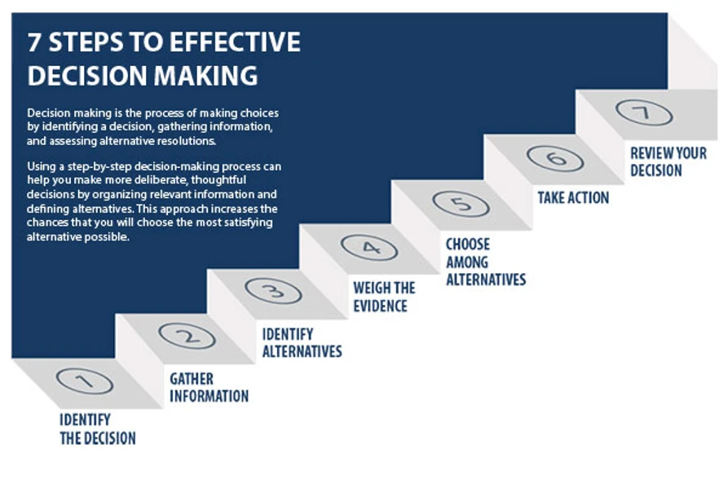

Decision making is the process of making choices by identifying a decision, gathering information, and assessing alternative resolutions.

Using a step-by-step decision-making process can help you make more deliberate, thoughtful decisions by organizing relevant information and defining alternatives. This approach increases the chances that you will choose the most satisfying alternative possible.

**Step 1: Identify the decision**

You realize that you need to make a decision. Try to clearly define the nature of the decision you must make. This first step is very important.

**Step 2: Gather relevant information**

Collect some pertinent information before you make your decision: what information is needed, the best sources of information, and how to get it. This step involves both internal and external “work.” Some information is internal: you’ll seek it through a process of self-assessment. Other information is external: you’ll find it online, in books, from other people, and from other sources.

**Step 3: Identify the alternatives**

As you collect information, you will probably identify several possible paths of action, or alternatives. You can also use your imagination and additional information to construct new alternatives. In this step, you will list all possible and desirable alternatives.

**Step 4: Weigh the evidence**

Draw on your information and emotions to imagine what it would be like if you carried out each of the alternatives to the end. Evaluate whether the need identified in Step 1 would be met or resolved through the use of each alternative. As you go through this difficult internal process, you’ll begin to favor certain alternatives: those that seem to have a higher potential for reaching your goal. Finally, place the alternatives in a priority order, based upon your own value system.

**Step 5: Choose among alternatives**

Once you have weighed all the evidence, you are ready to select the alternative that seems to be best one for you. You may even choose a combination of alternatives. Your choice in Step 5 may very likely be the same or similar to the alternative you placed at the top of your list at the end of Step 4.

**Step 6: Take action**

You’re now ready to take some positive action by beginning to implement the alternative you chose in Step 5.

**Step 7: Review your decision & its consequences**

In this final step, consider the results of your decision and evaluate whether or not it has resolved the need you identified in Step 1. If the decision has *not* met the identified need, you may want to repeat certain steps of the process to make a new decision. For example, you might want to gather more detailed or somewhat different information or explore additional alternatives.

## A12.2. An Overview of Decision-Making Models

Decision making means the process of selecting the best choices among various options. Every person has to make many decisions on a daily basis, and the decisions range from simple ones, such as what to eat or where to go out for fun, to more complicated and important decisions, such as which university to attend or which major to study. These decisions tend to be personal and only affect one individual at a time. For a top-level manager of a big company, decision making is another story because his decision can influence hundreds of other employees' lives, and can even change the course of a company. Each manager employs a different decision-making model to evaluate their choices and reach the final decision. However, regardless of the models managers choose, there exist inherent decision-making traps that if they do not recognize and learn to deal with them, they will suffer from choosing the wrong course of actions which can lead to problematic consequences.

**Decision-Making Models in This Article**

* Rational Decision-Making Model
* Intuitive Decision-Making Model
* Creative Decision-Making Model
* Recognition-Primed Decision Making Model

**Rational Decision-Making Model**

The classic decision-making model is the rational decision-making model which consists of eight steps that decision makers need to take to achieve the optimal decision given their goals and constraints. In order to come up with an appropriate decision, they should establish a list of criteria used to evaluate their choices. By adopting this model, the decision-makers have the opportunities to contemplate on what are the things that matter the most in their situation and select the choices that best reflect their standards. However, the problem of this model is the fact that people do not always know what they want or have enough information about the available alternatives, and usually, people end up just making a "good enough" or a safe-bet decision.

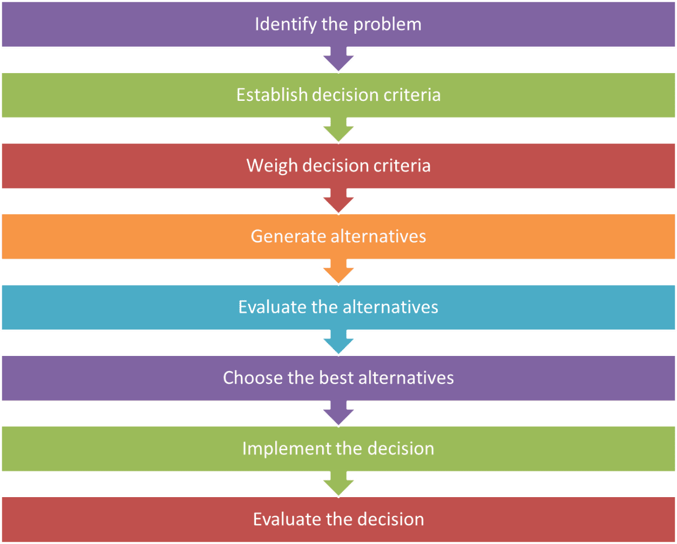

**Intuitive Decision-Making Model**

The second decision-making model which is utilized frequently by experts and experienced managers is the intuitive decision-making model. At first, this model appears to be based solely on gut feelings, but closer examination reveals that it is in fact a very sophisticated process in which the manager applies their intuition in many ways. First, they intuitively detect a potential problem and use their intuition to investigate its patterns. In this case, intuition means their painstaking years of experience, expertise, education background, insider information and other valuable resources unknown to an average employee. Intuition also helps them to integrate pieces of isolated data, facts and figures to a complete picture of the whole problem. If there is more than one possible solution to the problem, the manager will use their intuition as a check point to eliminate anti-intuitive decision and go with their gut feelings. One distinctive feature of this decision making model is that acting is a part of the process of defining and analyzing the problems. Managers usually “know” what to do first before they can explain the justification for their actions, and they use the results from their action to further their understanding about the problems.

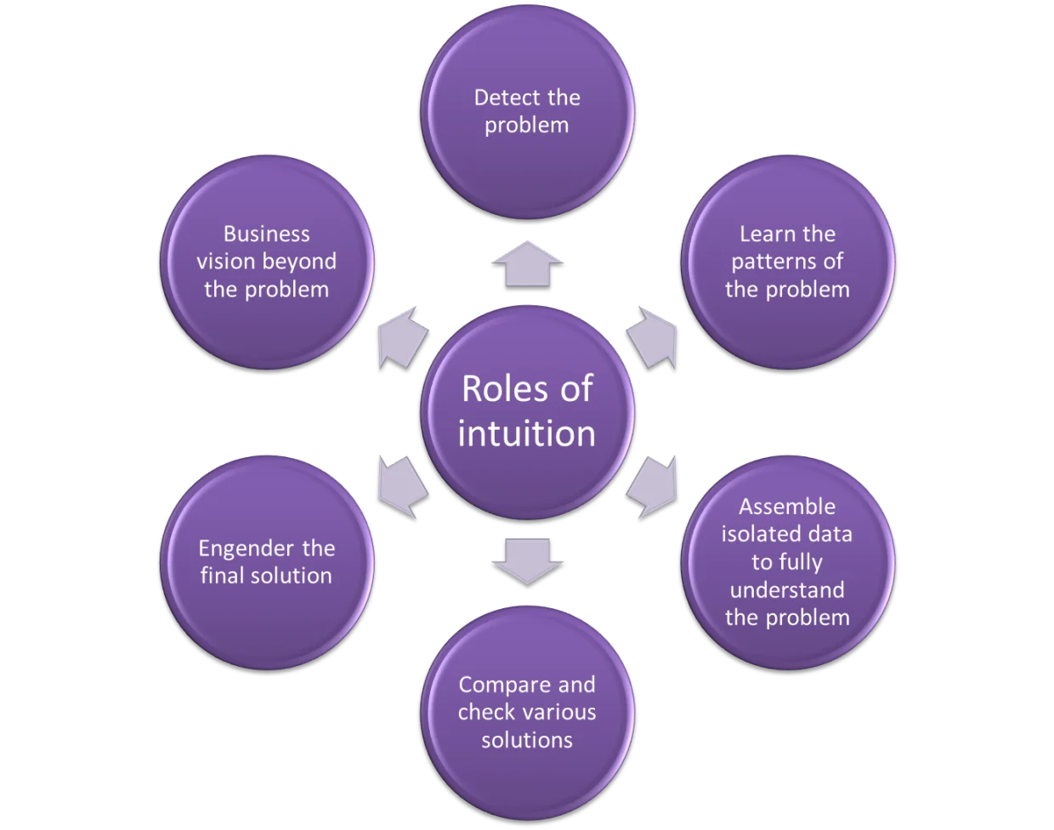

**Creative Decision-Making Model**

Another decision-making model is the creative decision-making model. This model is applied when the decision maker has to come up with an original and unique decision for a situation. In the decision-making process, after gathering information and insights about the problem and generating some initial ideas, the decision maker undergoes a period of incubation, in which he does not actively think about the solutions but let his unconscious mind take over the process. After quite some time, the answer just naturally comes to him in an “eureka” moment, and his next step is just to test and finalize it. The downside of this model is the success of it depends mainly on the decision maker's personal traits such as his creativity and the contextual situation.

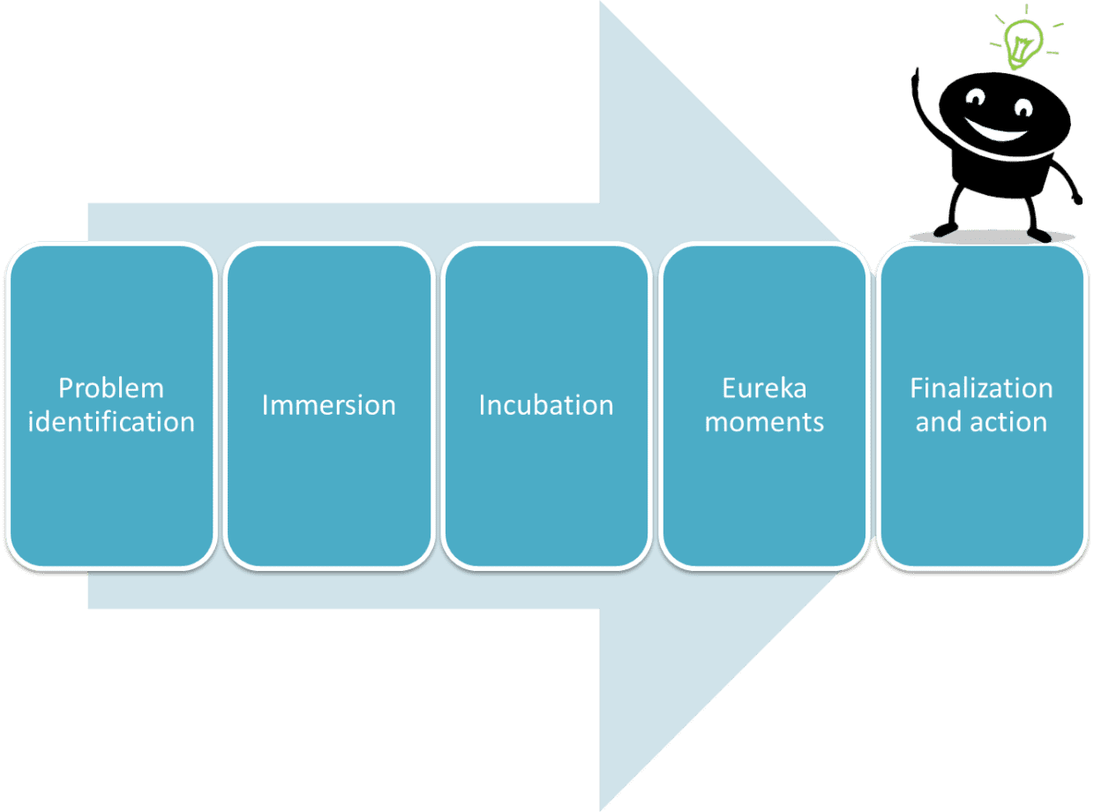

**Recognition-Primed Decision Making Model**

This decision-making model was developed by Gary A. Klein in his book “Recognition-primed decision model”. This model incorporates contextual assessment and metal evaluation to come up with the best reaction to a problem. The characterizing element of this model is that decision makers consider only one option instead of weighing several choices at a time. After recognizing the problem, the manager identifies its characteristics including the goals, problem cues, expectations and typical actions to take, the situation. After that the manager will think through the plan, conducting a mental simulation of the scenario to see if it works and making suitable modifications if necessary. If he thinks the plan is sufficient, he makes it his final decision. An alternative is only assessed if the initial plan does not work out in the manager's opinion. Although this decision-making model can be applied when managers are under time pressure, its success rate correlates with managers’ experiences and expertise.

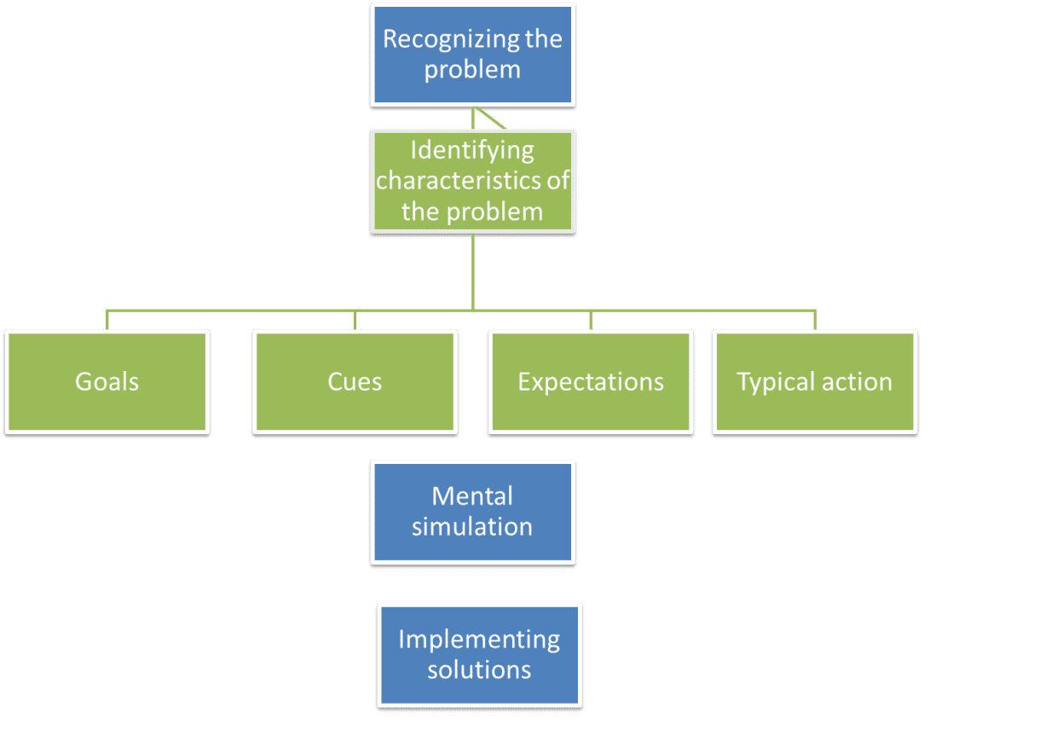

**Common Decision-Making Traps: Confidence Bias**

Obviously, each decision - making model has its own pros and cons. Moreover, there are also decision-making traps that decision makers should be aware of so that they can avoid letting those traps cloud their judgment. First of all, confidence bias is a very common problem, especially among seasoned managers. Clearly, it is very important that the manager should be confident, particularly in a critical time when the company requires pivotal decisions. However, if the manager is overconfident, and is blinded by his past success, he can become careless, oversimplify the situation or miss some key information, and end up making a risky decision or even a costly one for the company. Hence, before making any decisions based on past experiences and personal opinion, decision makers should spend some time to detach themselves from the situation and look at their decision with an objective attitude.

**Common Decision-Making Traps: Hindsight Bias**

Hindsight bias is also likely to obscure decision makers' judgment. After a problem occurs, detecting the person or event at fault that leads to the problem is an important part of finding the right solution. However, if holding a hindsight bias, the manager can blame the problem on the wrong person/ department because he only selectively looks back at certain events in the past instead of getting the whole picture of what really happened. This can cause internal conflict and endless accusations which are detrimental to an organization in the time of crisis. Moreover, by identifying the wrong cause, the manager increases the chances of making a faulty decision.

**Common Decision-Making Traps: Anchoring Bias**

Next, anchoring bias can impede a decision maker. Researchers have shown that people have the tendency to just see what they want to see, and they make decisions only based on those pieces of information. This bias is very dangerous because it might make the situation appear brighter than it actually is, and it conceals other perspectives of the problems from the decision maker. In addition, if the decision maker only focuses on some specific information, he might overlook other possibilities or alternatives to decide on a more effective solution. Framing bias is another related trap when the decision maker is deceived by the way the problem is presented to him. Both of these biases distort the nature of the problems and hinder the decision maker's ability to think out of the box.

**Common Decision-Making Traps: Escalation of Commitment**

Last but not least, escalation of commitment is often considered a fatal trap. Nobody wants to admit that his decision is a mistake, and managers are especially defensive of their decisions. Also, some managers believe that the plan does not work out yet just because they haven't spend enough time and efforts, and they want to commit further to it. However, once there is enough evidence to prove that the current decision is a bad move, continuing to execute it will only lead to more damages to the organization. A wise manager is someone who not only knows how to make good decisions but also recognizes a bad one and has the courage to abandon it and embark on a new track.

**Conclusion**

In order to become a successful decision maker, a person should learn to apply the appropriate decision-making model in each situation, and practice it frequently to master the use of it. More importantly, one should avoid the decision-making traps so that they will not cloud one's judgement. For senior managers whose decisions can impact the lives of hundreds of people, they should invest more time to explore more decision-making tools and techniques to prevent them from falling into those traps and make better decisions.

## A12.3. The different decision making models you need to know – and their pros and cons

The mark of any [good manager](https://careers.gazprom-mt.com/blog/5-ways-managers-improve-wellness-and-reduce-team-stress/) is being able to make the right decision at the right time, even when circumstances aren’t exactly ideal. Regardless of sector and industry, it’s an important element of any management role, one that has the potential to impact employees and the direction a company might take going forward.

Big or small, decisions have the power to alter things at both a micro and a macro level. Whether it’s the snacks served at a meeting or a change in company culture, management has a lot to weigh up when it’s crunch time.

The good news is there are several different decision-making models that managers can employ when needed. Here, we’ll explore some of the most prevalent theories, including their pros and cons, to see which could be the correct approach for your management style.

**What is decision-making in business?**

Decision-making sounds like a relatively simple idea. After all, everyone has to make decisions in their lives. But many managers often disregard just how important the process really is.

Models and styles aside, let’s boil down decision-making to its basic essence. You have goals that need identifying, you need to gather the relevant information to inform that decision, and you’ll have to weigh up any alternatives before reaching the decision.

In a business context, following a formal process of decision-making lets businesses make more informed, considered decisions that set specific actions in motion. Doing so provides a handful of benefits too, reducing second guessing, providing formal processes that can be shared up and down the chain of command, and engaging employees through more effective collaboration.

**Information needs for decision-makers**

So, what goes into making a decision? While not all decisions are created equal, they generally require the same informational ingredients before reaching a resolution. When it comes to reaching a decision, you need to know how to act if you’re to move forward. That means keeping the following in mind:

***Objective****:* To reach a decision, the decision-maker must determine the objective. What problems and issues stand in the way of reaching this objective, and how are you going to overcome these problems?

***Resources****:* What can you use that will help you reach the decision? Whether it’s financial or human capital, knowing which resources are at your disposal can make the decision-making process go a lot smoother.

When it comes to financial resources, make sure you know how much capital is available, how it can be spread across the process, and be aware of any back up reserves you can fall back on – should the decision not go to plan.

***Alternatives****:* A singular approach to reaching the objective might not cut it. Back-ups, contingencies, and alternatives are therefore a crucial part of decision-making. However you carry it out, thorough analysis of each possible decision’s outcome will ensure you have alternative routes to explore if things don’t properly work out.

***Leadership****:* Once you’ve reached a decision, having the confidence to act on your plans is key. As well as your own leadership, you should be aware of the leadership skills of others within the company. Bringing them into the decision-making process could improve your chances of success and make things go a lot more smoothly as a result.

**Time frames for taking action in the decision process**

Decision-making and time don’t always make for the best of bedfellows. It’s no secret that decision-making can take up a good chunk of your day. And when the hours and minutes are against you, it can lead to rushed, hasty choices – especially if you have to make several of them over the course of a single day.

This is decision fatigue in action. The mental cloudiness that can accumulate often means impulsive actions rather than considered, informed decisions. So, while the time frame will differ from decision to decision, there are certainly things we can do to reduce decision fatigue – and reduce the amount of time we spend on making decisions.

* **Make fewer decisions:** The cumulative effect decisions have on us can be exhausting. Try minimising that tiredness by reducing the number of decisions you have to make throughout the day. Streamlining our choices leaves us with more mental energy to place on bigger, more important choices.
* **Delegate decisions to others:** We can reduce the number of decisions to make by delegating them to employees in the same way we can delegate tasks to them. Asking others to take care of decisions not only frees you up, but it allows employees to feel empowered and engaged by their work.
* **Make decisions in the morning:** In the afternoon, that post-lunch feeling can make us feel tired and sluggish. In the evening, risky and hasty decisions are more likely to happen. The morning, however, can lead to accurate, well-thought-out decisions. If you’ve a big decision that needs all your attention, try taking care of it in the AM.
* **Give yourself deadlines:** Over the course of a project, there’s bound to be a few last-minute decisions that don’t get the attention they deserve. To combat this, try creating mini deadlines. Doing so allows you to act earlier than you normally would, replacing impulsive, eleventh-hour decisions with smart, well-informed choices long before the project’s end is in sight.

**The different decision-making models**

**The Rational Model**

Often cited as the classical approach, the rational model of decision-making is the most commonly used method, and typically consists of the following steps:

* Identification of the problem or opportunity
* Gathering and organisation of relevant information
* Analysing the situation
* Developing a range of options
* Evaluating and assigning a value to each option
* Selecting the option you feel is the best
* Acting decisively on that option

***The pros of the rational model***

The rational model allows for an objective approach that’s based on scientifically obtained data to reach informed decisions. This reduces the chance of errors and assumptions. It also helps to minimise the manager’s emotions which might have resulted in poor judgments in the past.

This means that, due to the step-by-step methodology, decision-makers are better equipped to deal with difficult problems in complex environments.

***The cons of the rational model***

The process is sometimes constrained by insufficient information, which creates problems if a manager has to consider, and then evaluate, any alternatives they need to reach a decision.

Time limitations can also be an issue. Since there’s a lot of information needed, the necessary time for observation, collection and analysis is also essential. In a fast-paced business environment where time is crucial, the rational model is somewhat limited.

It’s also an approach that tends to err on the side of caution. By limiting decision-making based on what’s only available, you may not be able to take the risks that can be necessary for success.

***Which companies use the rational model?***

Larger innovation companies in Sweden, such as Volvo and Ericsson, adhere to the rational model, using structured processes to manage their processes, often collaborating with a huge amount of people, all with differing expertise.

**The Intuitive Model**

Compared to the objective judgments of the rational model, the intuitive decision-making model is much less structured and opts for more subjective opinions – though it’s not simply based on gut feelings. Rather, it takes into consideration the following:

* Pattern recognition – seeing patterns in events and information, and using them to figure out a course of action
* Similarity recognition – seeing similarities in previous situations and recognising the cause and effect of a given situation
* Salience – understanding the importance of information and the way it can affect personal judgment

***The pros of the intuitive model***

Compared to the rational model, intuitive decision-making allows for quick decisions to be reached, while a degree of gut feeling means managers can eliminate counter-intuitive ideas when drawing conclusions.

Since it takes into account the person’s emotions, it ensures that positive feelings are used to their advantage, leveraging them as a way to motivate them through the process.

As opposed to the structure of the rational model, which progresses through steps, the intuitive model opts to see everything as a bigger picture. As a result, intuition can help managers to integrate pieces of isolated data, facts and figures into a cohesive vision of what needs to be done.

***The cons of the intuitive model***

The intuitive model leans heavily on a person’s experience and judgment. As a result, emotions and insufficient experience may end up clouding judgment and make for poor, impulsive decisions.

***Which companies use the intuitive model?***

Intuition and its model of thinking can’t really be quantified in any measurable way. Nevertheless, gut instinct has its fair share of proponents, none more so than perhaps Malcolm Gladwell, the author and public speaker who has written at length on the idea.

When we think of leaders who trusted their instincts, we think of people like Henry Ford or Bill Allen, the CEO of Boeing in the 1950s, who bet $16 million in order to achieve civilian air travel as we know it today. We can even see it in the present, with people like Uber CEO Travis Kalanick, a controversial figure who has stuck to his guns despite heavy resistance to charging customers more for the service.

**The Recognition Primed Model**

A combination of the two models above, the primed model of decision-making begins when a manager quickly assesses a situation, compares it to past situations, recognises patterns and creates a mental ‘action script’ which runs through the scenario up until its conclusion.

This then leads to two options:

* The decision-maker finds no flaw in their scenario and sets about their chosen course of action as outlined by the script they devised.
* The decision-maker encounters a problem in their action script. They then start over with a different script, repeating the process until a scenario successfully plays out.

An experienced decision-maker will have more developed recognition patterns, with more past scenarios to draw from to form their action script. Less experienced decision-makers, meanwhile, may look more towards troubleshooting the mental scenarios instead.

***The pros of the recognition primed model***

Since rational and intuitive reasoning is used, it provides a degree of mental simulation from your predictions. From here, you can prevent problems should they arise because they’ve been played out mentally beforehand.

***The cons of the recognition primed model***

Inexperienced managers may opt for this model when one of the other two models would be more appropriate in certain situations, such as for non-critical decisions.

The trial-and-error approach makes it relatively time-consuming. If time is of the essence, a manager may pick the first course of action, which may be unsatisfactory.

***Which companies use the recognition primed model?***

As well as in business, the model is highly effective for leaders affiliated with firefighters, search and rescue units, and other emergency services.

## A12.4. Problem Solving and Decision Making (Solving Problems and Making Decisions)

**Guidelines to Problem Solving and Decision Making (Rational Approach)**

Much of what people do is solve problems and make decisions. Often, they are  
“under the gun”, stressed and very short for time. Consequently, when  
they encounter a new problem or decision they must make, they react with a decision  
that seemed to work before. It’s easy with this approach to get stuck in a circle  
of solving the same problem over and over again. Therefore, it’s often useful  
to get used to an organized approach to problem solving and decision making.  
Not all problems can be solved and decisions made by the following, rather rational  
approach. However, the following basic guidelines will get you started. Don’t  
be intimidated by the length of the list of guidelines. After you’ve practiced  
them a few times, they’ll become second nature to you — enough that you can  
deepen and enrich them to suit your own needs and nature.

(Note that it might be more your nature to view a “problem” as an  
“opportunity”. Therefore, you might substitute “problem”  
for “opportunity” in the following guidelines.)

**1. Define the problem**

This is often where people struggle. They react to what they think the problem  
is. Instead, seek to understand more about why you think there’s a problem.

**Define the problem: (with input from yourself and others). Ask yourself and others, the following questions:**

1. What can you see that causes you to think there’s a problem?
2. Where is it happening?
3. How is it happening?
4. When is it happening?
5. With whom is it happening? (HINT: Don’t jump to “Who is causing the problem?” When we’re stressed, blaming is often one of our first reactions. To be an effective manager, you need to address issues more than people.)
6. Why is it happening?
7. Write down a five-sentence description of the problem in terms of “The following should be happening, but isn’t …” or “The following is happening and should be: …” As much as possible, be specific in your description, including what is happening, where, how, with whom and why. (It may be helpful at this point to use a variety of research methods.

**Defining complex problems:**

If the problem still seems overwhelming, break it down by repeating steps 1-7  
until you have descriptions of several related problems.

**Verifying your understanding of the problems:**

It helps a great deal to verify your problem analysis for conferring with a  
peer or someone else.

**Prioritize the problems:**

If you discover that you are looking at several related problems, then prioritize  
which ones you should address first.

Note the difference between “important” and “urgent” problems.  
Often, what we consider to be important problems to consider are really just  
urgent problems. Important problems deserve more attention. For example, if  
you’re continually answering “urgent” phone calls, then you’ve probably  
got a more “important” problem and that’s to design a system that  
screens and prioritizes your phone calls.

**Understand your role in the problem:**

Your role in the problem can greatly influence how you perceive the role of  
others. For example, if you’re very stressed out, it’ll probably look like others  
are, too, or, you may resort too quickly to blaming and reprimanding others.  
Or, you are feel very guilty about your role in the problem, you may ignore  
the accountabilities of others.

**2. Look at potential causes for the problem**

* It’s amazing how much you don’t know about what you don’t know. Therefore, in this phase, it’s critical to get input from other people who notice the problem and who are effected by it.
* It’s often useful to collect input from other individuals one at a time (at least at first). Otherwise, people tend to be inhibited about offering their impressions of the real causes of problems.
* Write down what your opinions and what you’ve heard from others.
* Regarding what you think might be performance problems associated with an employee, it’s often useful to seek advice from a peer or your supervisor in order to verify your impression of the problem.
* Write down a description of the cause of the problem and in terms of what is happening, where, when, how, with whom and why.

**3. Identify alternatives for approaches to resolve the problem**

At this point, it’s useful to keep others involved (unless you’re facing a  
personal and/or employee performance problem). Brainstorm for solutions to the  
problem. Very simply put, brainstorming is collecting as many ideas as possible,  
then screening them to find the best idea. It’s critical when collecting the  
ideas to not pass any judgment on the ideas — just write them down as you hear  
them. (A wonderful set of skills used to identify the underlying cause of issues  
is Systems Thinking.)

**4. Select an approach to resolve the problem**

* When selecting the best approach, consider:
* Which approach is the most likely to solve the problem for the long term?
* Which approach is the most realistic to accomplish for now? Do you have the resources? Are they affordable? Do you have enough time to implement the approach?
* What is the extent of risk associated with each alternative?

(The nature of this step, in particular, in the problem solving process is  
why problem solving and decision making are highly integrated.)

**5. Plan the implementation of the best alternative (this is your action plan)**

1. Carefully consider “What will the situation look like when the problem is solved?”
2. What steps should be taken to implement the best alternative to solving the problem? What systems or processes should be changed in your organization, for example, a new policy or procedure? Don’t resort to solutions where someone is “just going to try harder”.
3. How will you know if the steps are being followed or not? (these are your indicators of the success of your plan)
4. What resources will you need in terms of people, money and facilities?
5. How much time will you need to implement the solution? Write a schedule that includes the start and stop times, and when you expect to see certain indicators of success.
6. Who will primarily be responsible for ensuring implementation of the plan?
7. Write down the answers to the above questions and consider this as your action plan.
8. Communicate the plan to those who will involved in implementing it and, at least, to your immediate supervisor.

(An important aspect of this step in the problem-solving process is continually  
observation and feedback.)

**6. Monitor implementation of the plan**

Monitor the indicators of success:

1. Are you seeing what you would expect from the indicators?
2. Will the plan be done according to schedule?
3. If the plan is not being followed as expected, then consider: Was the plan realistic? Are there sufficient resources to accomplish the plan on schedule? Should more priority be placed on various aspects of the plan? Should the plan be changed?

**7. Verify if the problem has been resolved or not**

One of the best ways to verify if a problem has been solved or not is to resume  
normal operations in the organization. Still, you should consider:

1. What changes should be made to avoid this type of problem in the future? Consider changes to policies and procedures, training, etc.
2. Lastly, consider “What did you learn from this problem solving?” Consider new knowledge, understanding and/or skills.
3. Consider writing a brief memo that highlights the success of the problem solving effort, and what you learned as a result. Share it with your supervisor, peers and subordinates.

**Rational Versus Organic Approach to Problem Solving**

**Rational**

A person with this preference often prefers using a comprehensive and logical approach similar to the guidelines in the above section. For example, the rational approach, described below, is often used when addressing large, complex matters in strategic planning.

1. Define the problem.
2. Examine all potential causes for the problem.
3. Identify all alternatives to resolve the problem.
4. Carefully select an alternative.
5. Develop an orderly implementation plan to implement that best alternative.
6. Carefully monitor implementation of the plan.
7. Verify if the problem has been resolved or not.

A major advantage of this approach is that it gives a strong sense of order in an otherwise chaotic situation and provides a common frame of reference from which people can communicate in the situation. A major disadvantage of this approach is that it can take a long time to finish. Some people might argue, too, that the world is much too chaotic for the rational approach to be useful.

**Organic**

Some people assert that the dynamics of organizations and people are not nearly so mechanistic as to be improved by solving one problem after another. Often, the quality of an organization or life comes from how one handles being “on the road” itself, rather than the “arriving at the destination.” The quality comes from the ongoing process of trying, rather than from having fixed a lot of problems. For many people it is an approach to organizational  
consulting. The following quote is often used when explaining the organic (or holistic) approach to problem solving.

*“All the greatest and most important problems in life are fundamentally  
insoluble … They can never be solved, but only outgrown. This “outgrowing”  
proves on further investigation to require a new level of consciousness. Some  
higher or wider interest appeared on the horizon and through this broadening  
of outlook, the insoluble lost its urgency. It was not solved logically in its  
own terms, but faded when confronted with a new and stronger life urge.”*  
From Jung, Carl, Psychological Types (Pantheon Books, 1923)

A major advantage of the organic approach is that it is highly adaptable to understanding and explaining the chaotic changes that occur in projects and everyday life. It also suits the nature of people who shun linear and mechanistic approaches to projects. The major disadvantage is that the approach often provides no clear frame of reference around which people can communicate, feel comfortable and measure progress toward solutions to problems.

## A12.5. Important Decision-Making Skills That Employers Value

Different employers look for different things, of course, but decision-making skills are sought by virtually all companies. That's because all employees are faced with decisions in the workplace, big and small, every day.

In general, applicants who can demonstrate an ability to[identify all the options](https://www.thebalancecareers.com/conceptual-skills-list-and-examples-4142004) and compare them in terms of both cost and effectiveness have an advantage over those who can’t.

**What Are Decision-Making Skills?**

Whether it's a question of deciding which candidate to hire, which consultant to use, or what business plan to execute, having the capacity to make the best decision is critical for organizations. [Organizational culture](https://www.thebalancecareers.com/what-is-company-culture-2062000) and [leadership style](https://www.thebalancecareers.com/top-leadership-skills-2063782) together determine the process of decision-making in any company.

Some companies may use a consensus-based approach, while others depend on a manager or management group to make all major decisions for the company.

Many organizations use a mixture of centralized and consensus-based styles. How an individual employee participates in the decision-making process depends on his or her position within the overall structure of the company.

**The Decision-Making Process**

A good way to make the most informed decision is to follow a process that assures you are taking into account all relevant information and considering each of the most probable outcomes. A step-by-step checklist like this is valuable for that purpose:

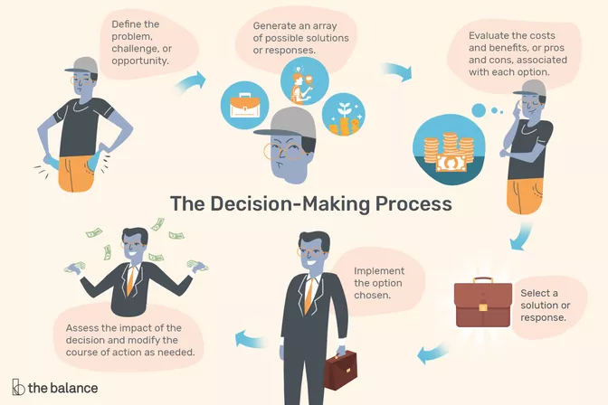

1. Define the problem, challenge, or opportunity.
2. Generate an array of possible solutions or responses.
3. Evaluate the costs and benefits, or pros and cons, associated with each option.
4. Select a solution or response.
5. Implement the option chosen.
6. Assess the impact of the decision and modify the course of action as needed.

You will not always find yourself going through all six steps in an obvious way. You might be responsible for one aspect of the process but not the others, or several steps might be merged, but someone still should be going through each step in one way or another. Skipping steps usually leads to poor outcomes.

Remember to develop strategies to ensure that you have not overlooked important information or misunderstood the situation, and be sure to uncover and correct for any biases you may have.

**Types of Decision-Making Skills**

Even if you do not yet have management experience, you probably have made decisions in a professional setting. Because decision-making is not always a cut-and-dried process, though, you might not have recognized what you were doing.

These examples provide a sense of what activities from your [own work history](https://www.thebalancecareers.com/work-history-definition-with-examples-2060468) you can share with potential employers to demonstrate your decision-making skills. Be sure to keep your sharing as relevant to the [requirements for the position](https://www.thebalancecareers.com/what-are-job-requirements-3928054) as possible.

**Problem-Solving**

Finding the best solution when faced with a problem is of utmost importance, and taking a measured approach will help you get there. Having the ability to [problem-solve](https://www.thebalancecareers.com/problem-solving-skills-with-examples-2063764) thoughtfully and logically while incorporating different perspectives is essential. Leaving your emotions at the door also allows you to look at the problem from every angle. Regardless of your field, you will be faced with many problems. Those of us who don’t let this fact overwhelm us will thrive in our chosen careers.

* [Active Listening](https://www.thebalancecareers.com/active-listening-skills-with-examples-2059684)
* Benchmark Development
* Brainstorming
* Causal Analysis
* [Collaboration](https://www.thebalancecareers.com/collaboration-skills-with-examples-2059686)
* Creative Thinking
* Data Analysis
* Data Gathering
* Discussion
* Fact-Finding
* Forecasting
* Historical Analysis
* Mediation
* Needs Identification
* Prediction
* Prioritizing
* Process Analysis
* Project Implementation
* Project Management
* Project Planning
* Teamwork
* Test Development
* Time Management

**Collaborative**

There are going to be times when you will need the input of others to come to a decision. You will need to recognize when decisions need [collaboration](https://www.thebalancecareers.com/collaboration-skills-with-examples-2059686) and then foster team meetings to come to the best decision. Being able to communicate your goals clearly and welcome feedback are central to a collaborative environment.

* Active Listening
* Authenticity
* Asking for Feedback
* Brainstorming
* Clear Communication
* Compromising
* Embracing Differences
* Honest Feedback
* Knowledge Sharing
* Motivation
* Organized
* Processing Ideas
* Reliable
* Setting Expectations
* Team-Building Activities
* Teamwork
* Team Player

**Emotional Intelligence**

Having high emotional intelligence means that you are aware of and in control of your emotionsand that you can express them in a healthy, measured manner. It is important to not let your emotions take over when coming to an informed decision. When you are working with others to come to a decision central to the decision-making process, it's especially important to control your emotions so you can effectively convey your opinions.

* Active Listening
* Collaboration
* Empathy
* Interpersonal
* Motivation
* Patience
* Self-Awareness
* Self-Regulation
* Social Skills

**Logical Reasoning**

In order to come to an [informed decision](https://www.thebalancecareers.com/logical-thinking-definition-with-examples-2059690), you will need to look at all the facts presented to you. This is where logic comes in. Weighing all the advantages and disadvantages of your actions is at the core of every measured decision. Your emotions will need to take a back seat in order for you to avoid compromising your rational decision-making. For example, if a colleague with whom you have a close working relationship has been accused of harassing another employee, it is imperative that you remove your emotions in order to move forward fairly.

* [Analytical](https://www.thebalancecareers.com/analytical-skills-list-2063729)
* [Conceptual](https://www.thebalancecareers.com/conceptual-skills-list-and-examples-4142004)
* Consulting
* Cost Analysis
* Critical Thinking
* Curiosity
* Data-Driven
* Deductive Reasoning
* Emotional Regulation
* Evidence-Based
* Fact-Based
* Independent Thinking
* Information Gathering
* Managing Emotions
* Planning
* Problem-Solving
* Rational
* Reflective Learning
* Research
* Risk Assessment
* Scientific Analysis
* Self-Awareness
* Self-Control
* Teamwork

**More Decision-Making Skills**

* Conducting Polls
* Consensus Building
* Creativity
* Delegation
* Ethics
* Flexible
* Follow-Through
* Identifying Problems
* Lateral Thinking
* Leadership
* Organization
* Technological Expertise
* Stamina
* Strategy
* [Strong Leadership](https://www.thebalancecareers.com/best-online-leadership-courses-5115917)
* Team Management
* [Time Management](https://www.thebalancecareers.com/time-management-skills-2063776)
* Troubleshooting
* Versatile

**Examples of Workplace Decision-Making Skills**

* Identifying a faulty machine as the source of disruptions in the production process.
* Facilitating a brainstorming session to generate possible names for a new product.
* Polling staff to gauge the impact of extending retail hours.
* Conducting a comparative analysis of proposals from three advertising agencies and selecting the best firm to lead a campaign.
* Soliciting input from staff members on an issue important to the company’s future.
* Surveying customers to evaluate the impact of a change in pricing policy.
* Implementing the shutdown of a designated plant with excess manufacturing capacity.
* Generating a list of options for a new regional sales territory.
* Evaluating the impact of several possible cost-cutting measures.
* Comparing the leadership potential of different team members and choosing a project manager.
* Researching possible legal or logistical problems associated with a new company policy.
* Brainstorming possible themes for a fundraising campaign.
* Analyzing data from focus groups to help select packaging for a new product.
* Comparing the strengths and weaknesses of three potential vendors for processing payroll.

Remember that the critical skill in decision-making is not learning techniques, but knowing how and when to apply the basic principles and constantly reevaluating and improving your methods. If you or the teams you are a part of consistently achieve good results, then you are making decisions well.

## A12.6. 5 decision-making models to try if you’re stuck

Decisions, decisions. By some estimates, we make [35,000 conscious choices](http://science.unctv.org/content/reportersblog/choices) daily.

That number might even be inching upward thanks to the rise of [flatter organizational structures](https://www.forbes.com/sites/williamcraig/2018/02/06/what-businesses-need-in-order-to-develop-a-flat-structure-of-leadership/#584c17f35d29), which decentralize decision-making. Instead of top leaders making every call, [employees at all levels](https://www.inc.com/joel-trammell/3-ways-to-help-your-employees-make-great-decisions.html) have the power to make more decisions, and they are more likely to happen collaboratively.

All of this means good decision-making skills are more important than ever. However, making high-quality decisions, and making them efficiently, isn’t easy. If your team struggles to decide even where to order lunch, you know this firsthand.

But what if you had a toolkit to help you make better and faster decisions? And we're not talking about a Magic 8-Ball and a coin to flip. These tools are called decision-making models. Several models have been identified, but none of them is foolproof. You'll want to draw on different models in different situations.

Besides becoming familiar with decision-making models, you should also get to know the biases that can lead you to make bad decisions. If you've decided you're ready to dive in, let's get started.

**Decision-Making Models**

**Rational decision-making model**

Do you need to make a complex, high-stakes choice? Are you making this decision with other people? Are there strong emotions around the different options? And do you have the time for serious thought and research?

Then you’ll probably want to consider using the [rational decision-making model](https://allmindtools.com/rational-decision-making-model/#Step3_weight_established_criteria). It has six steps:

1. Define the problem
2. Identify the criteria you will use to judge possible solutions
3. Decide how important each criterion is
4. Generate a list of possible alternatives
5. Evaluate those alternatives
6. Determine the best solution

(Some sources identify additional steps, such as [testing your solution](https://blog.hubspot.com/marketing/rational-decision-making) before fully implementing it.)

The rational model counteracts a lot of the factors – like [faulty assumptions](https://www.brighthubpm.com/methods-strategies/121817-is-using-the-rational-decision-making-approach-a-rational-choice/) – that can lead us to bad decisions. It can minimize risk and uncertainty. This model is also one you can use on your own or as part of a team.

However, it's not the best model to use when you're under time constraints or in a fast-changing situation. It's also important to remember that you won't always have all the information you need to use this model. And, even if you do, going through the full process isn't efficient or necessary for some decisions.

**Bounded rationality decision-making model**

And that sets us up to talk about the bounded rationality model. You may have also heard this model called "[satisficing](https://thedecisionlab.com/biases/bounded-rationality/)." Instead of rigorously seeking the best possible decision, you're just looking for a "good enough" decision.

You can use bounded rationality when you don't have enough [time or information](https://medcraveonline.com/MOJCRR/bounded-rationality-in-decisionndashmaking.html) to follow the full rational decision-making model. Sometimes it's better to have a good enough decision sooner vs. a "perfect" decision that's delayed. And it burns a lot less [mental energy](https://us.experteer.com/magazine/as-a-manager-are-you-a-satisficer-or-maximizer/) and other resources.

To help you deal with all the information you have to process and all the decisions you have to make in a day, your brain likes to take shortcuts.

**Vroom-Yetton Decision-Making Model**

There's no one ideal process for making decisions. Instead, the best process to use will change based on your situation.

That's the idea behind the [Vroom-Yetton decision model](https://www.mindtools.com/pages/article/newTED_91.htm) (sometimes known as [Vroom-Yetton-Jago](https://www.designorate.com/vroom-yetton-jagohow-to-decide/)). The first part of this model uses seven yes-or-no questions. Here's an example: "Is team commitment to the decision important?"

Your answers to the questions then guide you toward one of five decision-making processes to use. Options range from making the decision based on what you know now without consulting your team to reaching a group consensus with your team.

The flexibility of the Vroom-Yetton model is one of its strengths. Anyone at any level can use it, and it can work even if you're in an unfamiliar situation. However, it doesn't consider personal factors for the decision-maker, the questions may not be precise enough for some situations and it may not work as well for larger groups.

**Intuitive decision-making model**

You might be surprised to learn that even when you make a decision intuitively or instinctively, you're still following a decision-making model. Intuitive decisions can happen almost instantly. But that doesn't mean they just pop into your head. Your brain is actually doing lightning-fast [pattern recognition](https://www.sciencedaily.com/releases/2012/12/121220144155.htm). It's quickly reviewing everything you've learned from similar past situations to help you make a decision in your current situation.

Researchers have found that an intuitive decision-making model yields good results when you're dealing with areas where you have a lot of expertise or experience. But going with your gut is less effective and efficient when you're in an unfamiliar circumstance, like a new job. This is because you don’t have enough experience to quickly recognize patterns yet.

An interesting side note here: Sometimes a decision that we *think* is rational and logical is actually a lot more intuitive. If you've considered additional options only to go back to your initial choice, you may have been following the [retrospective decision-making model](http://www.yourarticlelibrary.com/decision-making/models-of-decision-making-rational-administrat).

**Recognition-primed decision-making model**

The [recognition-primed model](https://www.decision-making-confidence.com/recognition-primed-decision-making-model.html) has a lot in common with the intuitive model. Here's how it works:

1. The decision-maker recognizes a pattern in available information.
2. They then pick a course of action and run through that "action script" in their mind.
3. If the action script seems like it will work, the decision-maker moves forward. If it *doesn't* seem like it will work, the decision-maker either tweaks the script or ditches it and starts over with a new script.

Like the intuitive model, the recognition-primed model works best in situations where you can draw on deep experience or expertise. In those cases, it's an especially handy model to use when you're under time pressure.

**Common decision-making biases**

Now that you know a variety of decision-making models, deciding should be a snap, right? Well, not quite. To help you deal with all the information you have to process and all the decisions you have to make in a day, your brain likes to take shortcuts. Sometimes those shortcuts are helpful. But sometimes they can lead to really lousy choices.

Be alert for these common mental biases any time you make a decision. Even just knowing that they exist and that you are vulnerable to them can help you make better decisions.

**Confirmation bias**

[Confirmation bias](https://www.verywellmind.com/what-is-a-confirmation-bias-2795024) means paying attention to evidence that confirms your beliefs – and ignoring anything that doesn't. Let's say you're helping choose someone to fill a new position at your organization. The process is down to the two finalists. Based on their resumes, you prefer Candidate B over Candidate A. But you're keeping an open mind.

Or are you? During their interviews, confirmation bias could cause you to pay attention to anything that shows Candidate B is an amazing fit for the role, while ignoring possible red flags. Meanwhile, during Candidate A's interview, you gloss over answers that point to them as the better choice, while seizing on any information that could be a bad sign.

Confirmation bias causes us to seek out information that supports our existing views. But it also encourages us to interpret information in a way that proves we're right. Thanks to confirmation bias, two people with different beliefs could draw [different conclusions](https://www.mindtools.com/pages/article/avoiding-psychological-bias.htm) from the same set of statistics.

To outsmart your confirmation bias, seek out people and information sources that challenge your opinions, even if you're already sure that "all the evidence" supports what you want to do. You might be surprised that things aren't so cut and dried.

**Availability heuristic**

The [availability heuristic](https://kenthendricks.com/availability-heuristic/) leads us to make decisions based on how easily something comes to mind. For example, if your friend just went through a long flight delay with an airline, the availability heuristic could cause you to avoid that airline for your upcoming business trip – even though it actually has a better on-time record than the carrier you ultimately choose. Because you can quickly recall your friend's experience, you overestimate how likely future flight delays are with that airline.

The availability heuristic can really trip us up because our thoughts feel like reality. But you will make better decisions when you can pause, second-guess yourself, and see if there really is information that supports your perceptions.

**Survivorship bias**

The [survivorship bias](https://blog.hubspot.com/sales/survivorship-bias) causes us to make decisions based only on examples of success – all while assuming that we have the full story.

A [common example of the survivorship bias](http://www.richardhughesjones.com/survivorship-bias/) is using other organizations' success stories to decide what your organization should do. Sure, Company A may have succeeded wildly by using a particular strategy, and everyone is singing their praises. But what we hear less about is that Companies B, C and D used the same strategy and now they're out of business.

To avoid survivorship bias, train yourself to be more skeptical. Before making a decision based on success stories, ask yourself whether those stories are [taking only the "survivors" into account](https://patrikedblad.com/cognitive-biases/survivorship-bias/).

Confirmation bias causes us to seek out information that supports our existing views.

**Anchoring bias**

Anchoring bias causes us to use an initial piece of information to make subsequent judgments. For example, the initial price offer sets the course in a [negotiation](https://www.pon.harvard.edu/daily/negotiation-skills-daily/the-drawbacks-of-goals/). But even being exposed to an arbitrary and random cognitive anchor can affect your choice. In [one study](https://www.psychologytoday.com/us/blog/stretching-theory/201902/outsmart-the-anchoring-bias-in-three-simple-steps), participants spun a roulette-style wheel and then were asked to guess the percentage of U.N. countries that are in Africa. Those who got a high number on their spin guessed higher percentages.

The anchoring bias is another good reason to slow down your decision-making process when possible. By being aware of how vulnerable humans are to this bias, you have a better chance of recognizing when you need additional information.

**Halo Effect**

We all know the power of first impressions, but we often overlook just how powerful they can be. We *think* we're hiring a contractor because he's intelligent and organized. However, we might just be assuming all of that because he's tall or has a firm handshake.

That's the [halo effect](https://blog.cognifit.com/halo-effect-10-tricks-successfully-manage/) in action. It works in reverse, too. If someone spills wine on you at a networking event, you're probably going to put less stock in the opinions they share later.

Stay vigilant to your brain's efforts to save labor with the halo effect. When you're making a decision, ask yourself whether you are basing it on a first impression. What [additional evidence](https://www.psychologytoday.com/us/basics/the-halo-effect) do you have for believing or doubting that impression?